**Lecture 3: Architecture**

| **Concurrency** | **Parallel** |
| --- | --- |
| Two or more tasks can start, run, and complete in overlapping time periods | Two or more tasks can run (execute) simultaneously, at the exact same time |
| They might not be running (executing on CPU) at the same instant | Tasks do not only make progress, they actually execute simultaneously |
| Two or more execution flows make progress at the same time by interleaving their executions or by executing instructions (on CPU) at exactly the same time |  |

**Parallelism Level**

### **Bit Level (Single Processor)**

* Word size may mean:
  + Unit of transfer between processor ↔ memory
  + Memory address space capacity
  + Integer size
  + Single precision floating point number size
  + trivial→ even binary addition is bit parallelism

### **Instruction Level (Single Processor):**

### limited parallelism → typically 2 - 3 instructions

Pipelining (parallelism across time)

* Split instruction execution in multiple stages, e.g. Fetch (IF), Decode (ID), Execute (EX), Write-Back (WB)
* Allow multiple instructions to occupy different stages in the same clock cycle → Provided there is no data / control dependencies
* Num pipeline stages == Max speedup
* **Independence, Bubbles, Hazards: data and control flow**
* Speculation
* Out-of-order execution: Read-after-write
* Determine what instruction to run next
* Execution unit: performs the operation described by an instruction
* Registers: store value of variables used as inputs and outputs to operations
* Uniprocessor’s pipelining will still be SISD

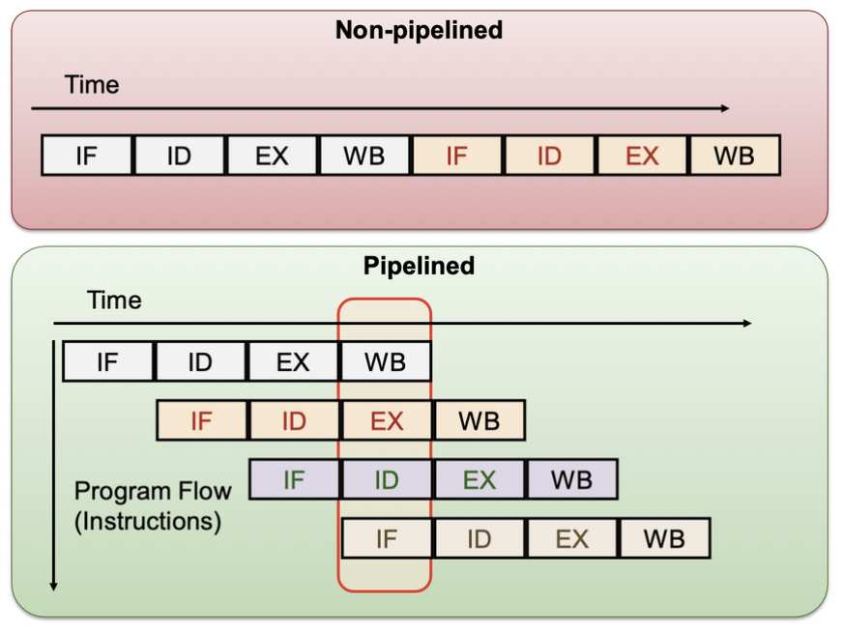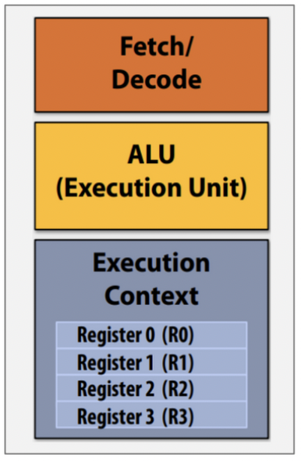

* Determine what instruction to run next
* Execution unit: performs the operation described by an instruction
* Registers: store value of variables used as inputs and outputs to operations

Superscalar (parallelism across space)

* Allow multiple instructions to pass through the same stage
* Scheduling is challenging (decide which instructions can be executed together):
  + Dynamic (Hardware decision)
  + Static (Compiler decision)
* most modern processors are superscalar

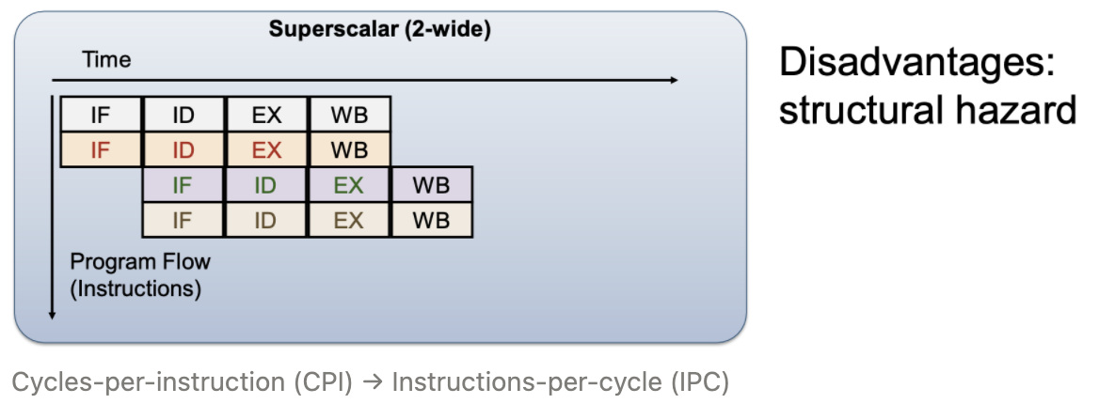

* Processor automatically finds independent instructions in an instruction sequence and can execute them in parallel on execution units
* Instructions come from the same execution flow (thread)

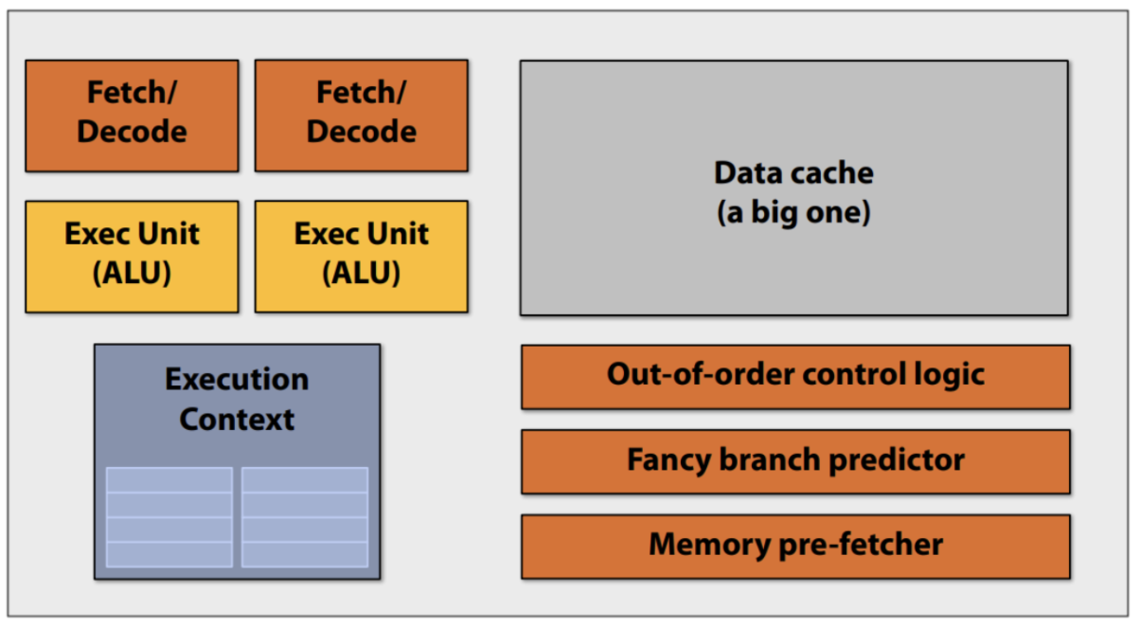

### **Thread Level (Single Processor)**

* Processor can provide hardware support for multiple “thread contexts”
  + aka simultaneous multithreading (SMT)
  + Information specific to each thread, e.g. PC, Registers, etc
  + Software threads can then execute in parallel

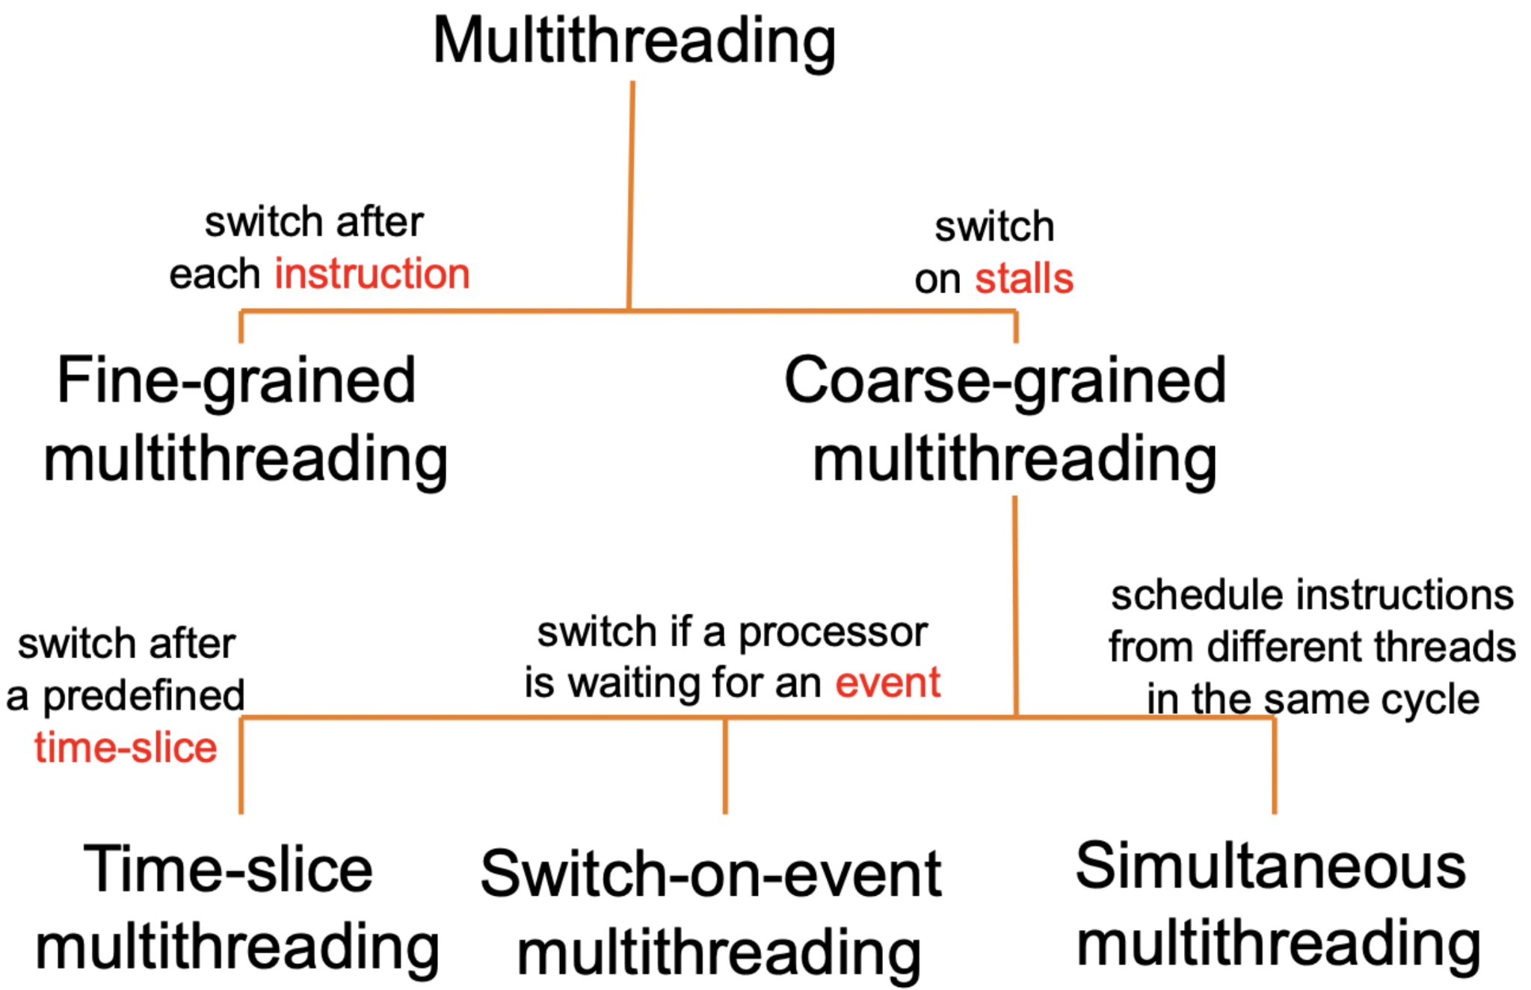

### 

### **Processor Level (Multiprocessors)**

* Add more cores to the processor
* The application should have multiple executions flows
* Each process/thread needs an independent context that can be mapped to multiple processor cores

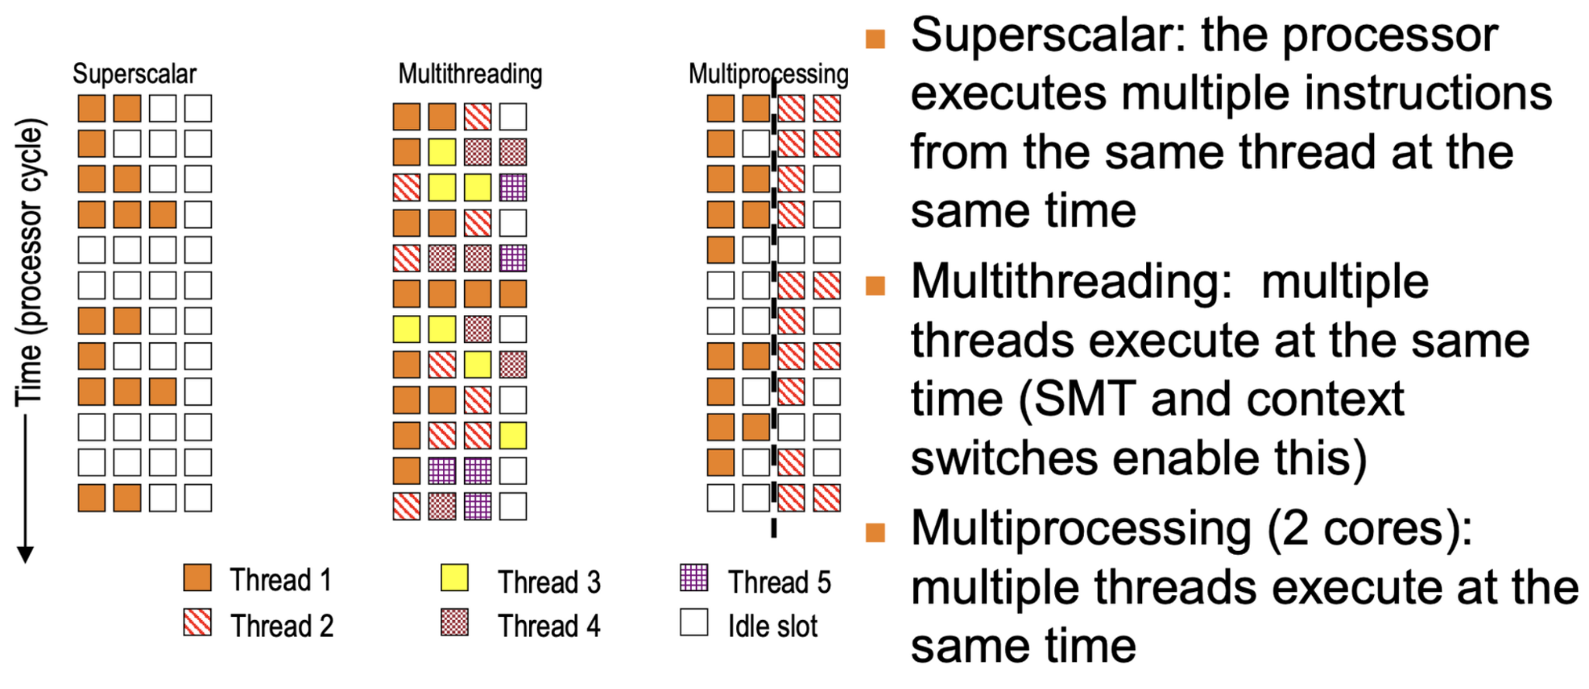

### **Flynn’s Parallel Architecture Taxonomy**

* Instruction stream: A single execution flow, i.e. a single PC
* Data stream: Data being manipulated by the instruction stream
* E.g. 60 assignments 3TAs:
  + Each TA marks 20 scripts → data parallelism
  + Each TA marks 1/3 questions for all scripts → task parallelism: execute independent parts of the program, need all TAs to get the total score for each student

Single Instruction Single Data (SISD)

* A single instruction stream is executed
* Each instruction work on single data
* Most of the uniprocessors fall into this category

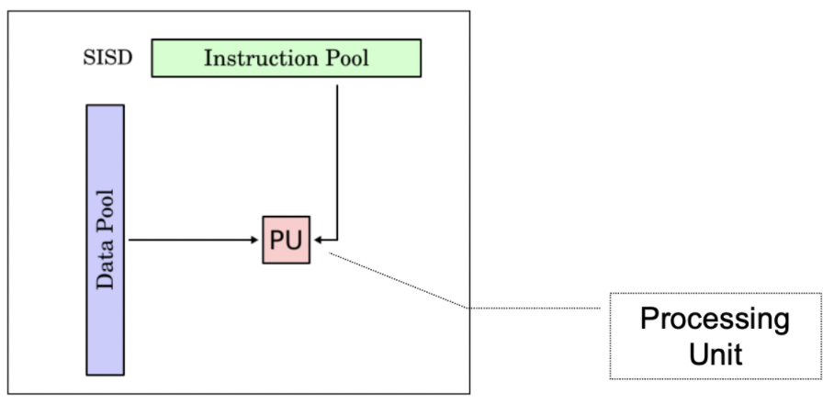

Single Instruction Multiple Data (SIMD)

* single stream of instructions
* Each instruction works on multiple data
* Popular model for supercomputer during 1980s:
  + Exploit data parallelism, commonly known as vector processor
* Modern processor has some forms of SIMD:
  + E.g. the SSE, AVX instructions in intel x86 processors
* Data parallel architectures
  + AVX instructions, GPGPUs
* Same instruction broadcasted to all ALUs
* AVX: Intrinsic functions operate on vectors of four 64-bit values (e.g., vector of 4 doubles)
* Not great for divergent executions

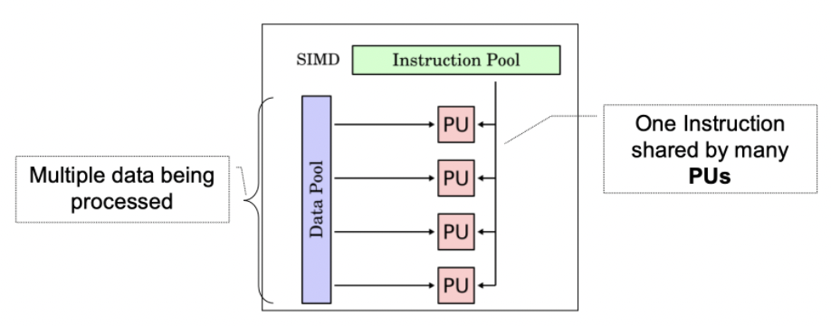

Multiple Instruction Single Data (MISD)

* Multiple instruction streams
* All instruction work on the same data at any time
* No actual implementation except for the systolic array

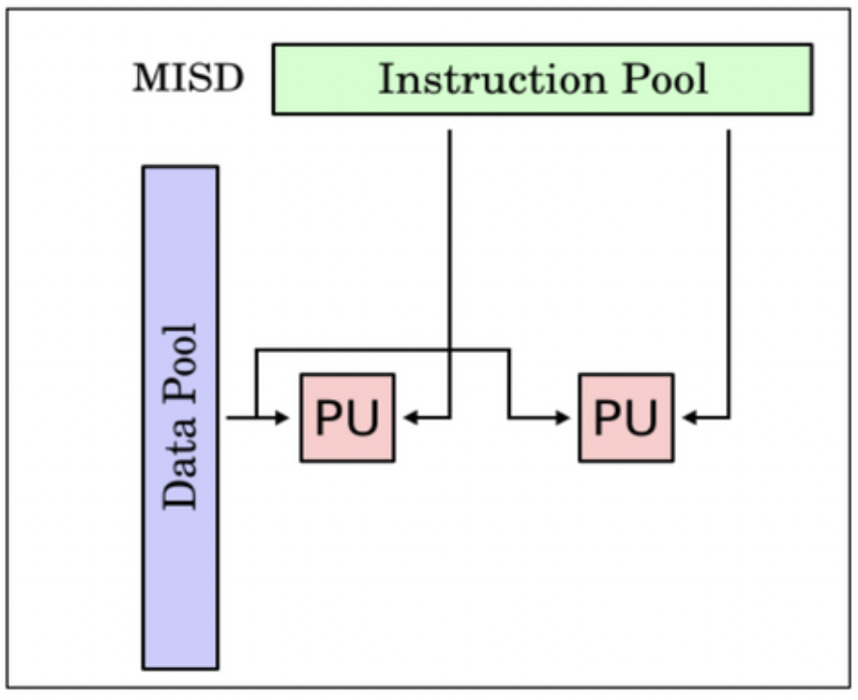

Multiple Instruction Multiple Data (MIMD)

* Each PU fetch its own instruction
* Each PU operates on its data
* Currently the most popular model for multiprocessor

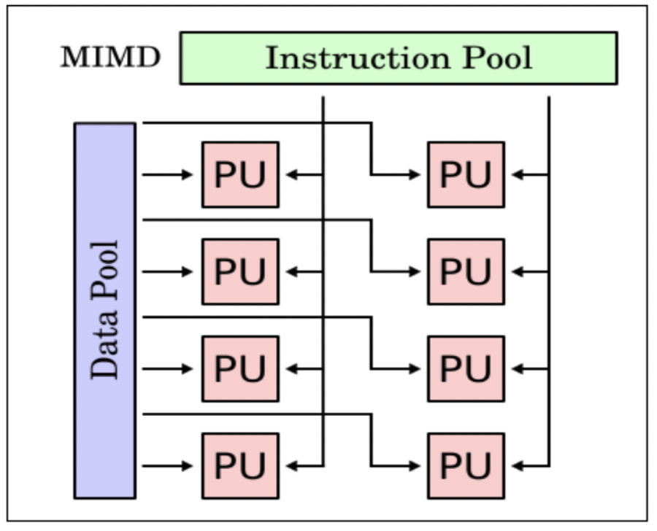

Variant - SIMD + MIMD

Stream processor (nvidia GPU)

* A set of threads executing the same code (effectively SIMD)
* Multiple set of threads executing in parallel (effectively MIMD at this level)

**Multicore Architecture**

Hierarchical Design

* Multiple cores share multiple caches
* Cache size increases from the leaves to the root
* Each core can have a separate L1 cache and shares the L2 cache with other cores
* All cores share the common external memory

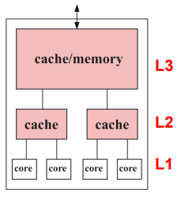

Pipelined Design

* Data elements are processed by multiple execution cores in a pipelined way
* Useful if same computation steps have to be applied to a long sequence of data elements

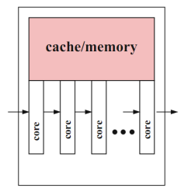

Network-Based Design

* Cores and their local caches and memories are connected via an interconnection network

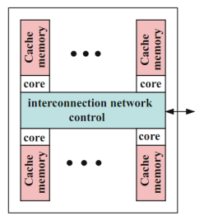

**Memory Organisation**

Parallel Computer Component

* Typical uniprocessor components
  + Processor
  + One or more level of caches
  + Memory module
  + Other (e.g. I/O)
* These components are similarly present in a parallel computer setup (but more and diff arrangements!)
* Processors in a parallel computer systems is also commonly known as processing element

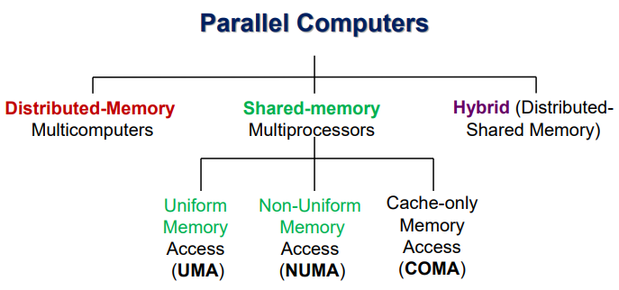

Distributed-Memory Systems

* Node == a machine in a network
* Each node is an independent unit
* Physically distributed memory module
  + Memory in a node is private
* Data exchange between nodes: message-passing
* More scalable (better performance with large problem size)
  + Communication overhead < page fault overhead
  + Independent tasks in MPI → no synchronization needed
  + In MPI, processor can exploit code (data) locality, while in OpenMP, the computatioon is interrupted by the I/O
  + OpenMP performance is limited by the performance of the shared memory machine used. In MPI, cores can be added to solve the problem faster
* Communication cost (especially for problem size is small)
* Cache coherence problem if file system was shared → cache files in main memory
  + Network substitutes for the system bus
  + If file system not shared → no shared memory → updating the cache is done based on explicit messages

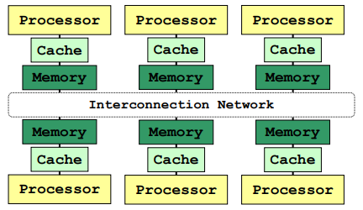

Shared Memory System (similar to shared address space)

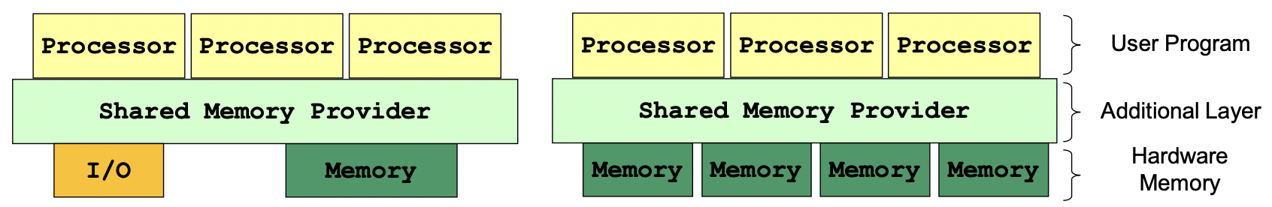

* Parallel programs / threads access memory through the shared memory provider → illusion of shared memory
* Program is unaware of the actual hardware memory architecture (Cache coherence and memory consistency)
* Data exchanges between nodes → tasks communicate by reading from/writing to shared variables
* No need to partition code or data
* No need to physically move data among processors → communication is efficient
* Special synchronization constructs are required (memory consistency)
* Lack of scalability due to contention
  + Any processor can load and store from any address
  + Costly to scale
* Issues with large input problem (input) sizes
  + Excessive hard-disk thrashing as there will be multiple page-faults when the memory is unable to hold the huge data
  + Cache misses: traversing elements on different cache lines resulting in poorer performance due to cache write policies
    - Especially noticeable for matrix multiplication as one matrix is traversed in column-major order → likely for consecutive column not to be on the same cache line
* Cache coherence problem
* Further differentiate shared memory sys
  + Process to memory delay (UMA / NUMA): whether delay to memory is uniform
  + Presence of a local cache with cache coherence protocol (CC/NCC):
    - Same shared variable may exist in multiple caches
    - Hardware ensures correctness via cache coherence protocol

Cache Coherence Problem

* Multiple copies of the same data exists on different caches
* Local update by processor → Other processors may still see the unchanged data

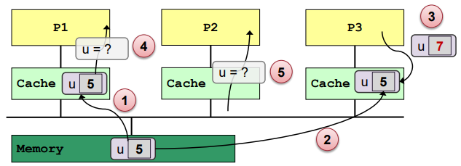

Uniform Memory Access (Time) (NUMA)

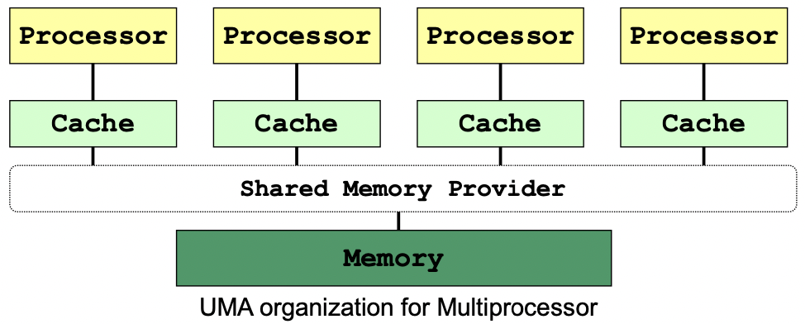

* Latency of accessing the main memory is the same for every processor → Uniform access time
* Suitable for small number of processors – due to contention
  + Related: Symmetric Multiprocessing (SMP)

Non-Uniform Memory Access (NUMA)

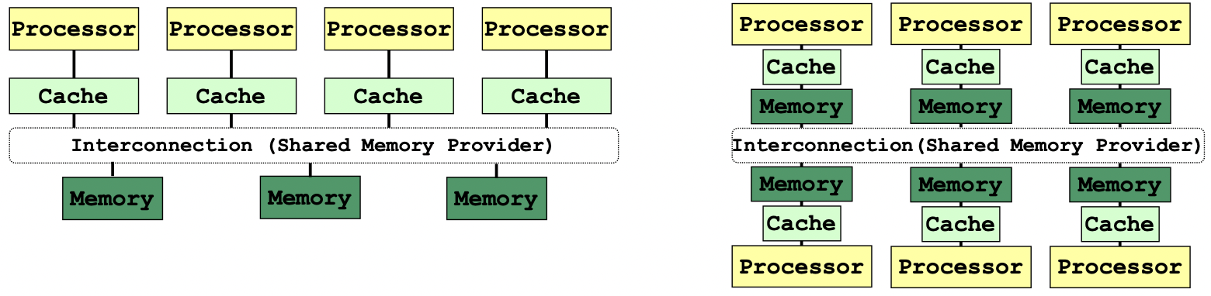

* Physically **distributed memory** of all processing elements are combined to form a global shared-memory address space (aka distributed shared-memory)
* Accessing local memory is faster than remote memory for a processor
* Non-uniform access time
* Each processor can be multicore
* Reduce memory contention

ccNUMA

* Cache Coherent Non Uniform Memory Access
  + Each node has cache memory to reduce contention

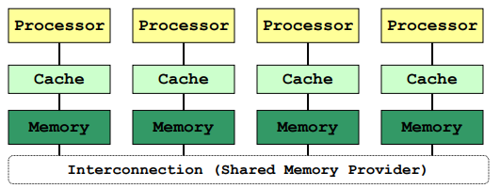

Cache Only Memory Architecture (COMA)

* Each memory block works as cache memory
* Data migrates dynamically and continuously according to the cache coherence scheme
* Data not in cache will be in hard disk

**Lecture 4: Parallel Programming Model**

* Work = tasks + dependencies
  + Program dependencies (data, control)
  + Runtime (memory contention, communication, synchronisation)

**Data Parallelism**

* Partition the data used in solving the problem among the processing units; each processing unit carries out similar operations on its part of the data
* Same operation is applied to different elements of a data set
  + If operations are independent, elements can be distributed among cores for parallel execution

Data Parallelism on SIMD computers

* E.g. loop parallelism: independent iterations can be executed in arbitrary order and in parallel on different cores
* E.g. #pragma parallel for num_threads(n) shared(...) private(...)

Data Parallelism on MIMD computers

* Common model: Single Program Multiple Data (SPMD)
  + One parallel program is executed by all cores in parallel (both shared and distributed address space)

**Task (Functional) Parallelism**

* Partition the tasks in solving the problem among the processing units
* Independent program parts can be executed in parallel e.g. functions
* Tasks: Single Statement, series of statements, loops or function calls
* Further decomposition:
  + A single task can be executed sequentially by one PU, or in parallel by multiple PUs

Task Dependence Graph

* A directed acyclic graph
  + Node: Represent each task
  + Node value: Expected execution time
  + Edge: Control dependency between task
* Properties
  + Critical path length: Maximum (slowest) completion time
  + Degree of concurrency (avg) = max speed up with infinite resources = Total work / critical path length
    - An indication of amount of work that can be done concurrently
  + Max degree of concurrency = max processes at a given time (can draw dependency graph to see)

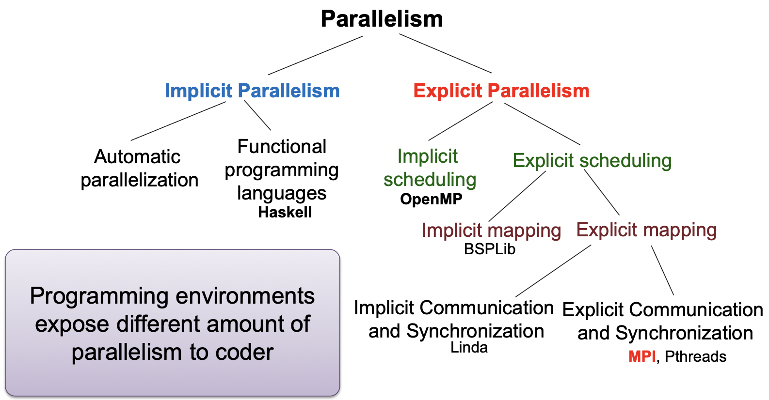

**Models of Coordination**

* Shared address space (see shared mem sys)
* Data parallel
* Message passing (see distr mem sys/L10)

Overheads of Parallelism

* Given enough parallel work, overheads are the biggest barrier to getting desired speedup
  + cost of starting a parallel task e.g. creating a process
  + manage and coordinate large number of inter-processor/task interactions

Data Parallel

* Basic Structure: map a function onto a large collection of data
  + Functional: side-effect free execution
  + No communication among distinct function invocations
    - Allow invocations to be scheduled in parallel
  + Stream programming model
* CUDA, OpenCL, ISPC does not strictly enforce this structure

Message Passing

* Tasks operate within their own private address spaces → communicate by explicitly sending/receiving messages
* E.g. MPI
* Hardware does not implement system-wide loads and stores
  + Can connect commodity systems together to form large parallel machine

Correspondence with Hardware Implementation

* Common to implement message passing abstractions on machines using shared address space (shared buffer)
  + “Sending message” = copying data into message library buffers (shared)
  + “Receiving message” = copy data from message library buffers
* Possible to implement shared address space abstraction on machines that do not support it in hardware
  + Less efficient software solutions
  + Modify a shared variable: send messages to invalidate all (mem) pages containing the shared variable
  + Reading a shared variable: page-fault handler issues appropriate network requests (messages)

Program Parallelization

* Granularity (fine-grain to coarse-grain):
  + A sequence of instructions
  + A sequence of statements where each statement consists of several instructions
  + A function/method which consists of several statements
* Small granularity
  + A lot of parallelism overhead (creation and merging threads/process, use of shared resources or communication overhead)
* Large granularity:
  + Difficult to exploit parallelism
  + E.g. some tasks take too long and take longer than the rest, not enough tasks to run on all cores

Foster’s Design Methodology

1. Partitioning: partition problem into smaller tasks (of roughly the same size)
   1. Data parallelism (data centric - domain decomposition)

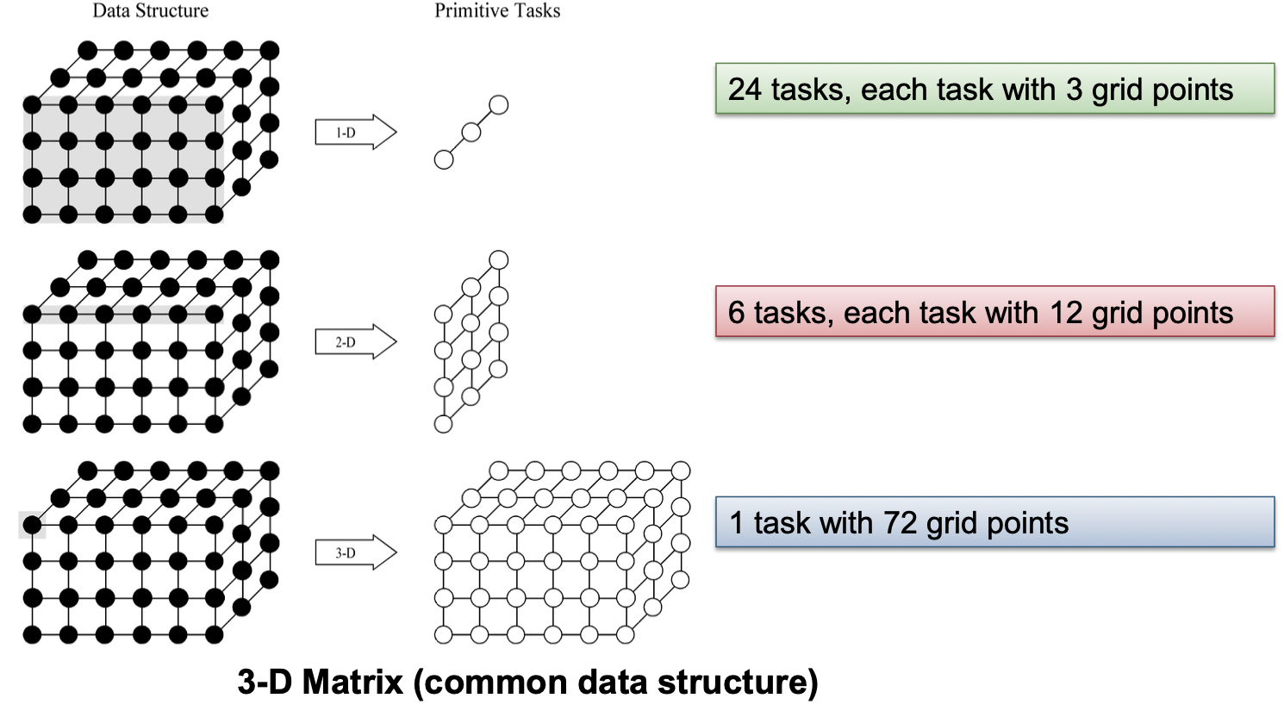

* 1. Task parallelism (computation centric - function decomposition)

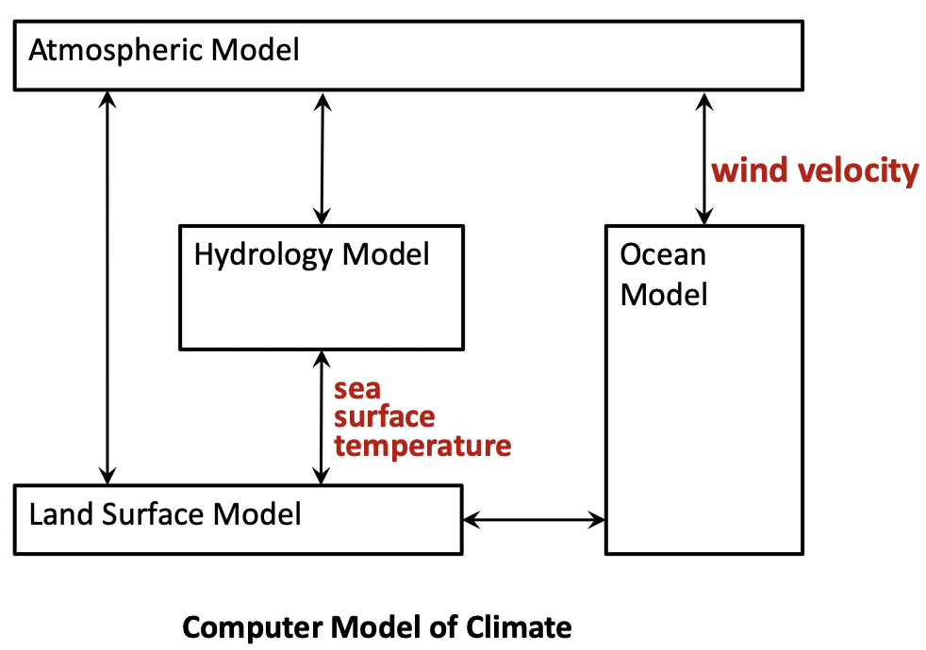

1. Communication: provides data required by the partitioned tasks (cost of parallelism)
2. Agglomeration: decrease communication and development costs while maintaining flexibility
3. Mapping: map tasks to processors (cores), aim to minimize total execution time

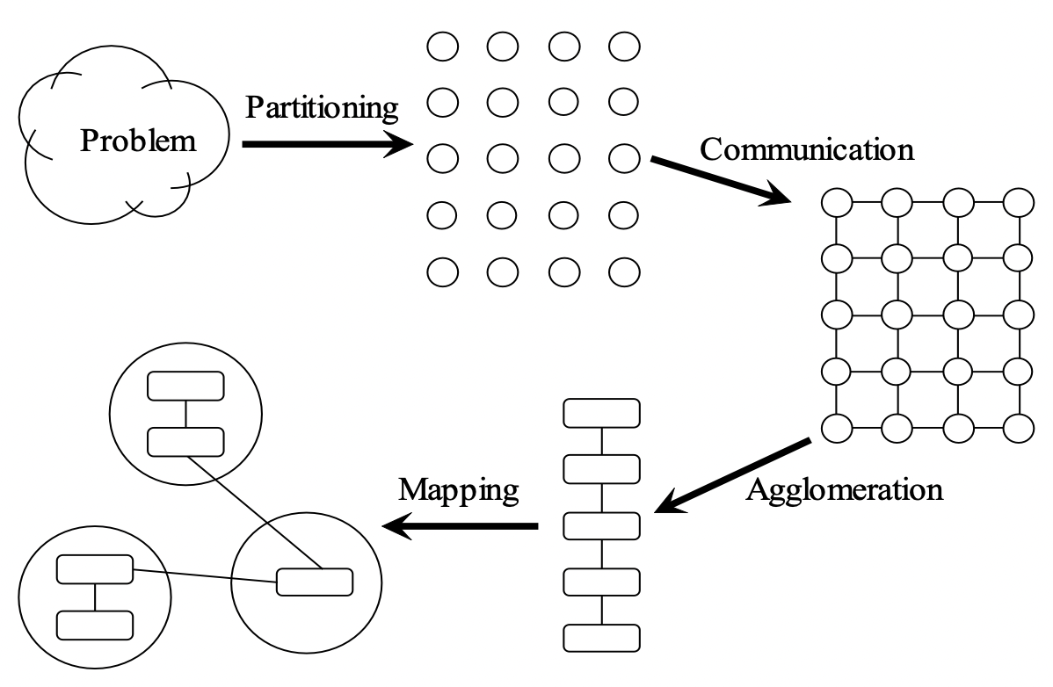

2. Communication (Coordination)

Local Communication

* Task needs data from a small number of other tasks (“neighbors”)
* Create channels illustrating data flow

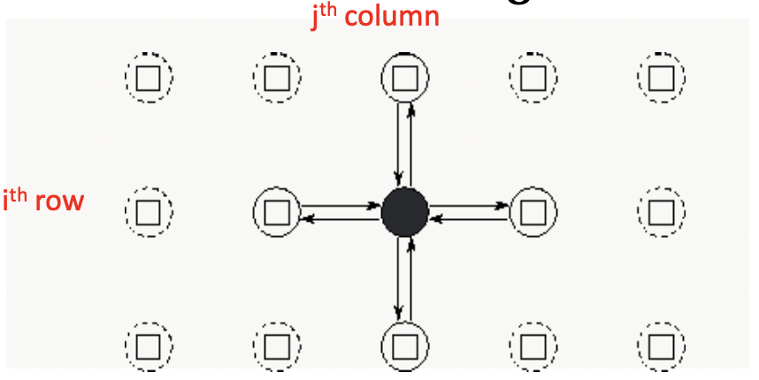

Global communication

* Significant number of tasks contribute data to perform a computation
* Don’t create channels for them early in design

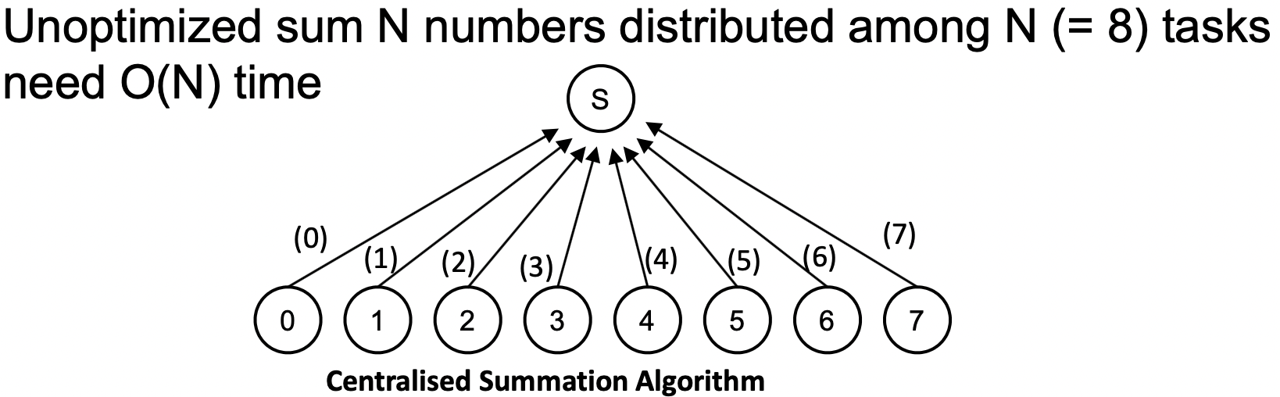

* Centralised – does not distribute computation and communication
* Sequential – does not allow overlap of computation and communication operations

3. Agglomeration

* Combine tasks into larger tasks → eliminate communication between primitive tasks
  + Number of tasks >= number of cores
    - Keep cores busy
* Goals:
  + Improve performance (cost of task creation + communication)
  + Maintain scalability of program
  + Simplify programming

4. Mapping

* Assignment of tasks to execution units
  + If dynamic task allocation chosen, task allocator should not be a bottleneck to performance
  + If static task allocation chosen, ratio of tasks to cores is at least 10:1
* Conflicting goals:
  + Maximize processor utilization – place tasks on different processing units to increase parallelism
  + Minimize inter-processor communication – place tasks (of similar size) that communicate frequently on the same processing units to increase locality
* Mapping may be performed by:
  + OS for centralized multiprocessor
  + User for distributed memory systems

**Parallel Programming Pattern**

Fork-Join

* Task T creates a number of child tasks T1,..., Tm with a fork statement
* Child tasks work in parallel and execute a given program part or function
* Task T can execute the same or a different program part or function
* E.g. Pthreads, OpenMP (shared mem), MPI

Parbegin-Parend

* Programmer specifies a sequence of statements to be executed by a set of cores in parallel
* Tasks should be roughly the same size to prevent stalling
  + When an executing thread reaches a parbegin–parend construct, a set of threads is created and the statements of the construct are assigned to these threads for execution

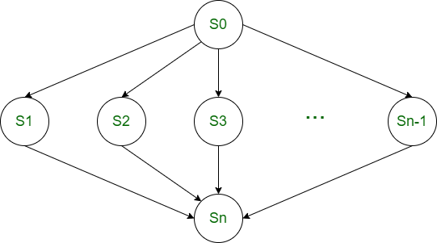

SIMD and SPMD

* **SIMD:** Single instructions are executed **synchronously** by the different threads on different data
  + E.g. AVX/SSE Instruction on Intel processor
* **SPMD:** Same program executed on different cores but operate on different data
  + All threads have equal rights and diff threads work **asynchronously** with each other
  + Diff threads may execute different parts of the program (due to diff speed of execution, control statement)
  + No implicit synchronization
  + E.g. MPI

Master-Worker (Master-Slave): MPI

* A single program (master) controls the execution of the program
* Master executes the main function, and responsible for coordination and perform initialization (assign work to workers), timings and output operations
* Worker task: wait for instruction from master task → depends on master!
* If execution time of different tasks differ → workers have to wait for other tasks to finish before master distribute the next set of tasks → wasted
* Termination: no more tasks, all workers are idle, master sends a termination message to workers
* Data parallelism: Suitable for relatively simple and homogeneous (same amount of work) worker threads, and a master thread to organize them
* Best for star interconnect: worker only need to communicate with the master

Client-Server (MPMD)

* Server computes requests from multiple client tasks concurrently
  + Each request may involve >= 1 thread
* Useful in heterogeneous systems
  + e.g. cloud and grid computing
  + A server provide multiple services (as clients)
* Client is independent! → does work without server’s instructions
* Client is spawned to fulfil a request

Pipelining

* Data in the application is partitioned into a stream of data elements that flows through the each of the pipeline tasks one after the other to perform different processing steps
* A form of functional (task) parallelism: Stream parallelism
* Best in cases where each stage (task) takes similar time

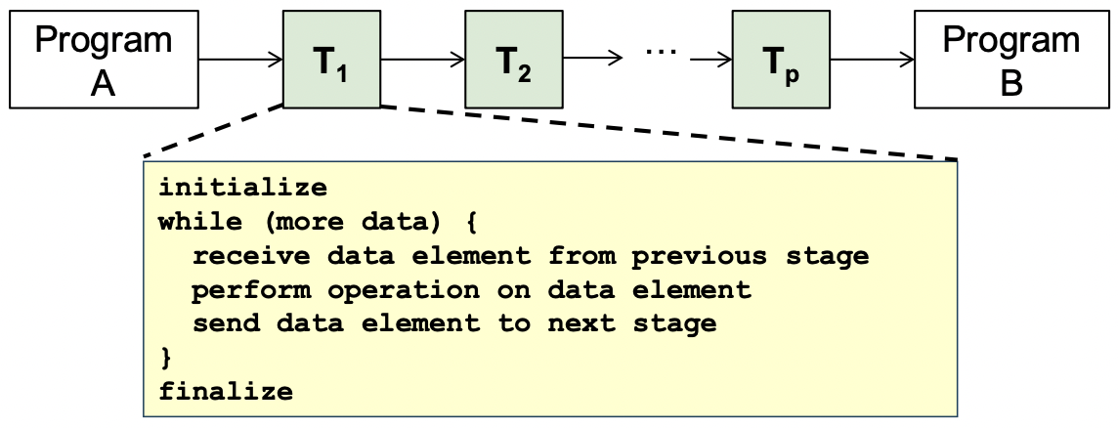

Task pool

* A common data structure from which threads can access to retrieve tasks for execution

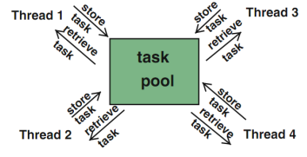

* Number of threads is fixed → threads statically created by main thread
* Thread generate tasks and insert them into task pool
* NO MASTER/SERVER
* Threads are not destroyed after they are done executing ⇒ reduce overhead of creating threads all over again
* Buffer to store result
* access to task pool must be synchronised to avoid race conditions
* Completed when:
  + Task pool is empty
  + Each thread has terminated the processing of its last task
* Useful for adaptive and irregular applications (hetereogenous tasks / diff timings)
  + Tasks can be generated dynamically
* Overhead for thread creation is independent of the problem size and the number of tasks
* For fine-grained tasks, the overhead of retrieval and insertion of tasks becomes important

Producer-consumer (shared buffers)

* Producer threads produce data which are used as input by consumer threads
* Each thread has a clear role - either producer or consumer
* Synchronization to ensure a correct coordination between producer and consumer threads

**Lecture 5: Performance**

Performance Goals

* Users: reduced response time
  + termination time - start time
* Computer manager: high throughput
  + Average number of work units executed per unit time, e.g. jobs/sec, transactions/sec

**Response time in sequential programs**

* Wall-clock time
* Includes
  + **User CPU time:** time CPU spends for executing program
  + **System CPU time:** time CPU spends executing OS routines
  + **Waiting time:** I/O waiting time and the execution of other programs because of time sharing
* Considerations:
  + waiting time: depends on the load of the computer system
  + system CPU time: depends on the OS implementation

User CPU Time

* Depends on translation of instructions by compiler and execution time for each instruction

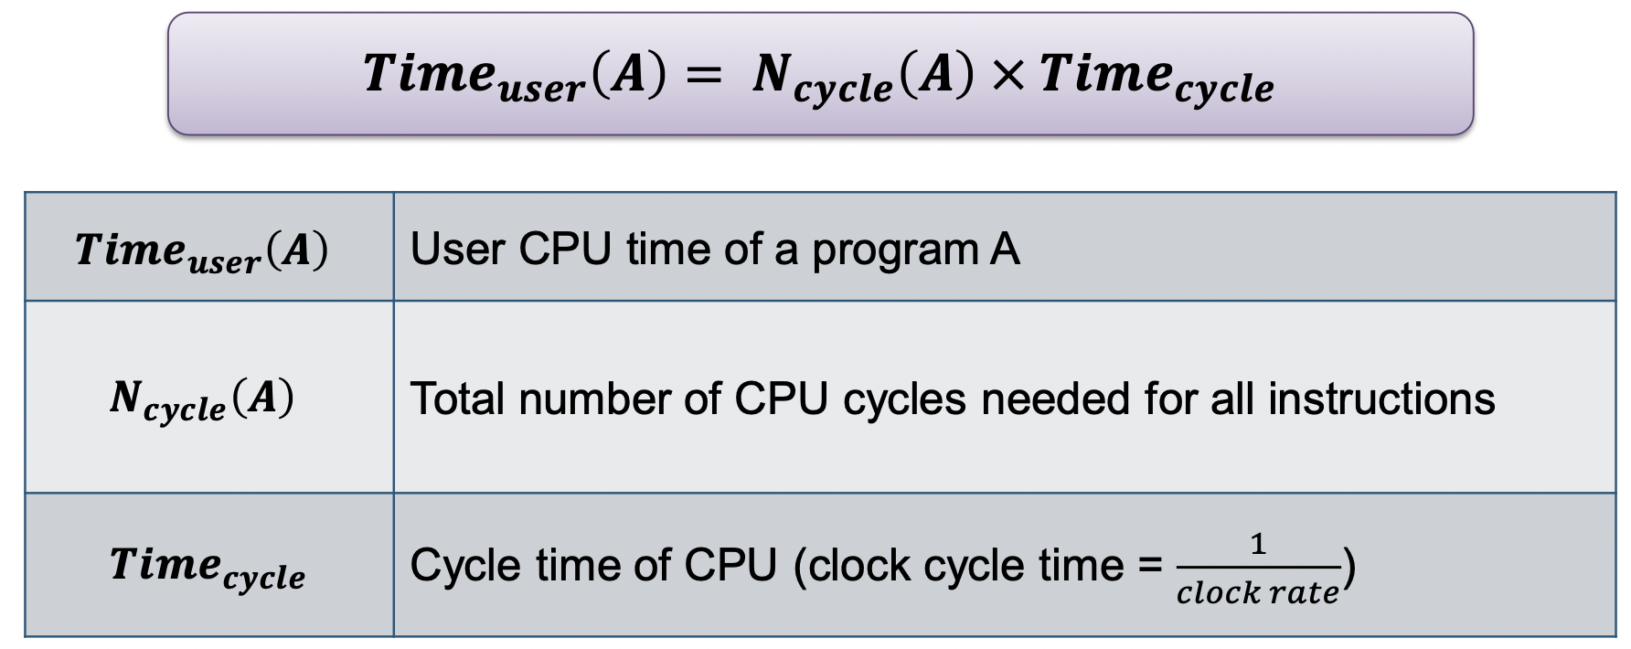

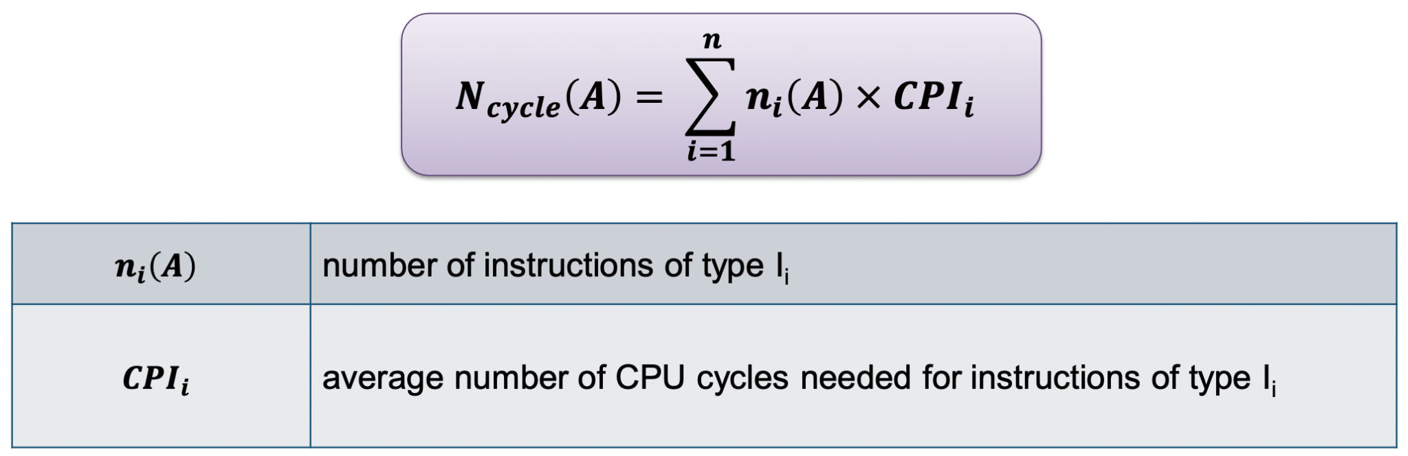

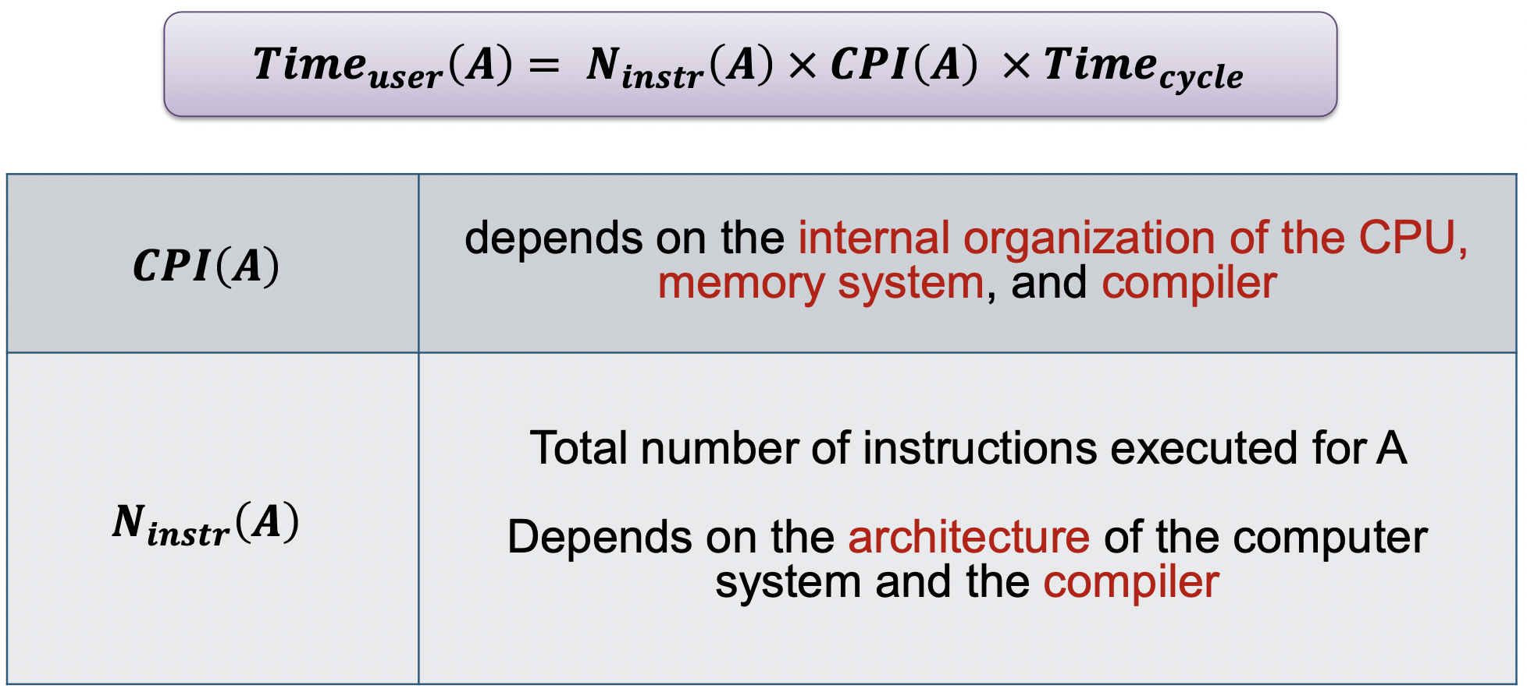

* Include memory access time
* Nmm_cycle(A) : number of additional clock cycles due to memory accesses

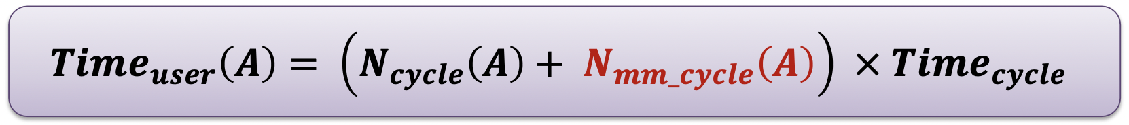

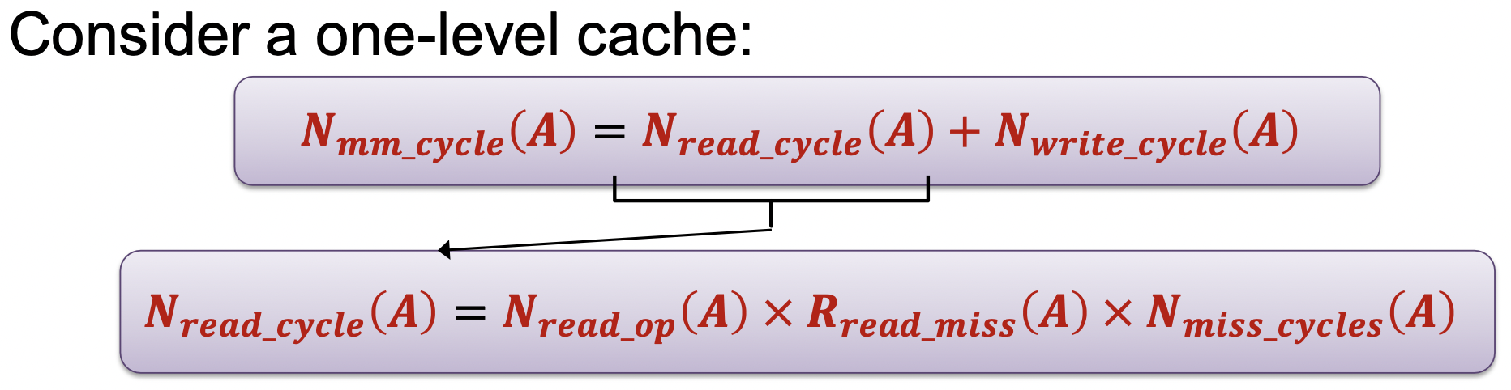

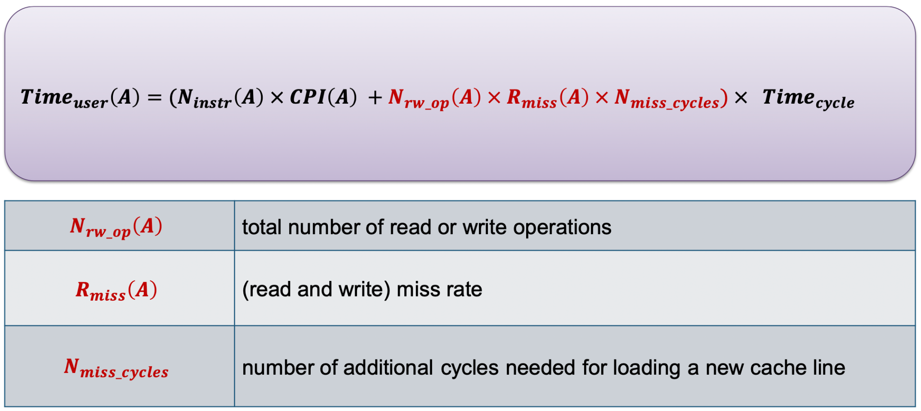

Terminology:

* LLC: Last level cache
* Cache line/block: each block of memory content in cache
* Mapping: mechanism used to store and locate a memory block in cache

**Memory Access Workflow**

Read access (load) workflow

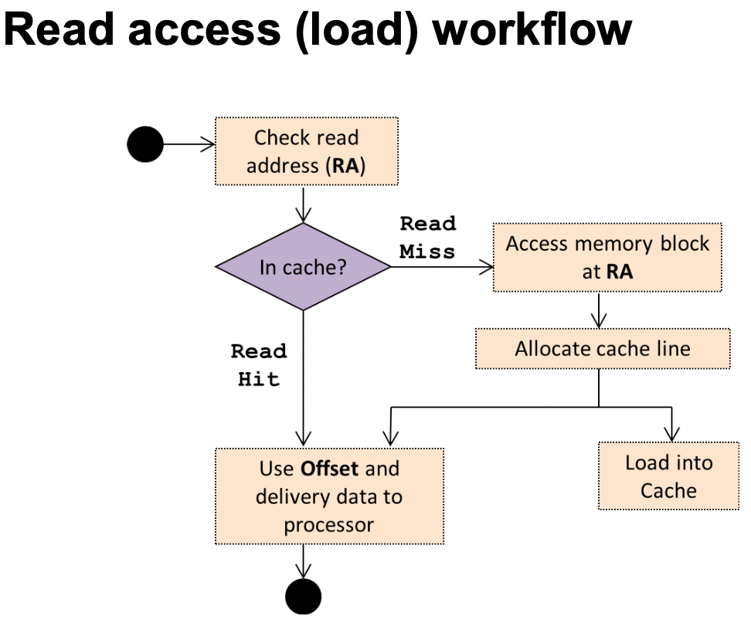

Write access (store)

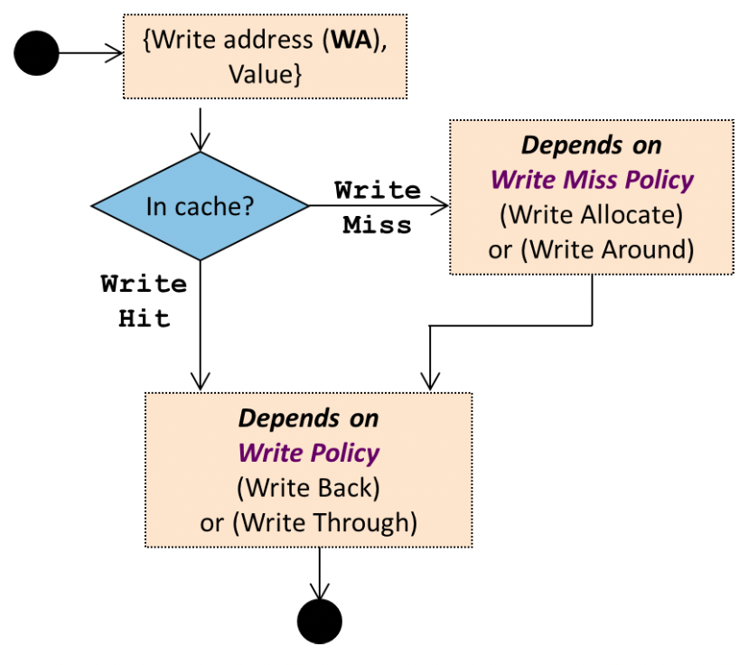

Average Memory Access Time

* Can be applied to multilevel cache and virtual memory

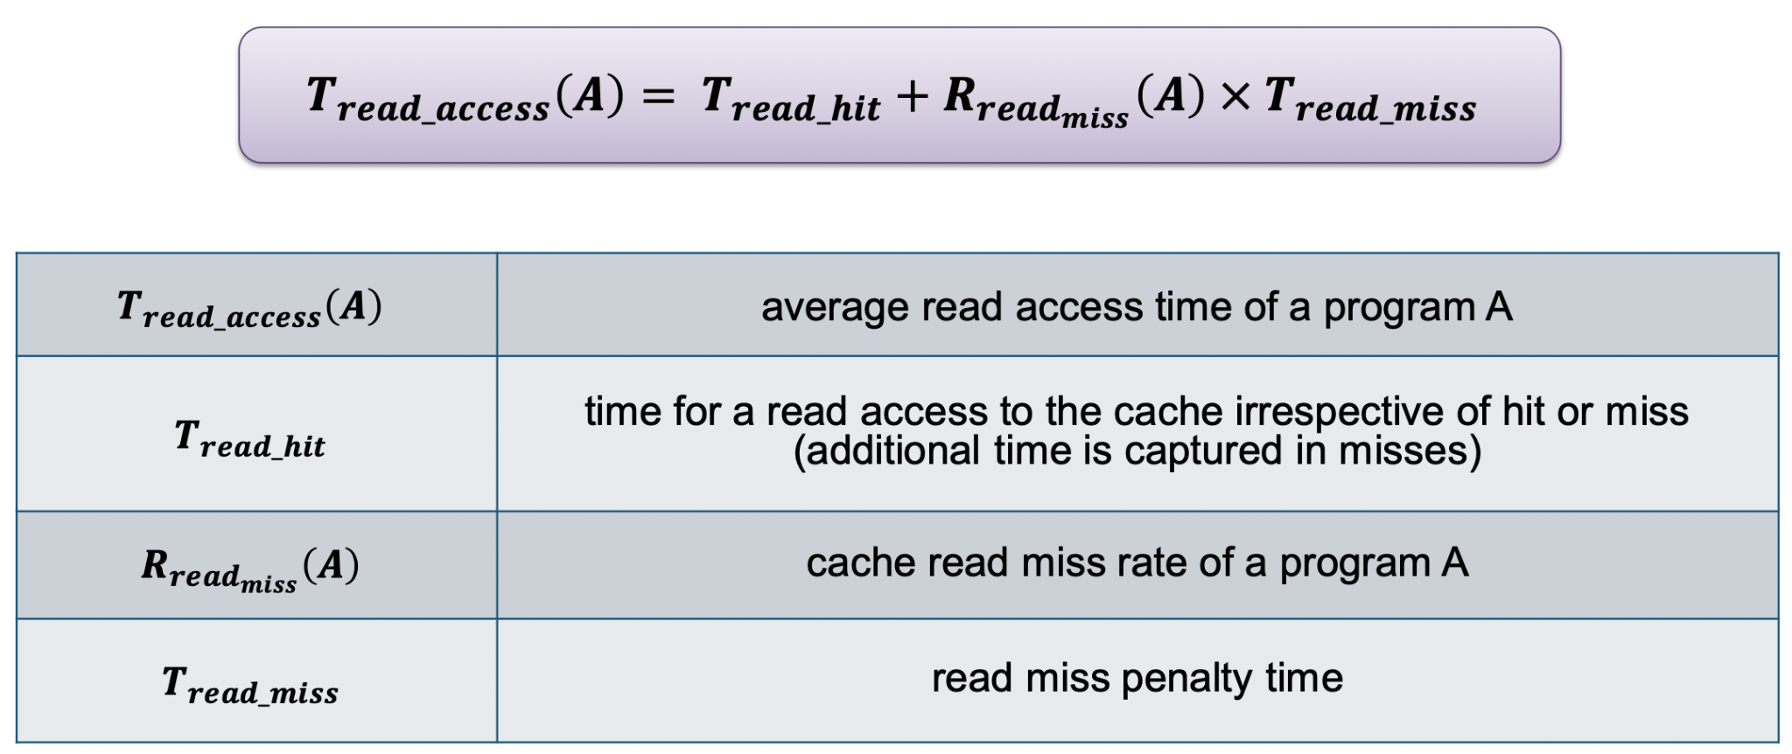

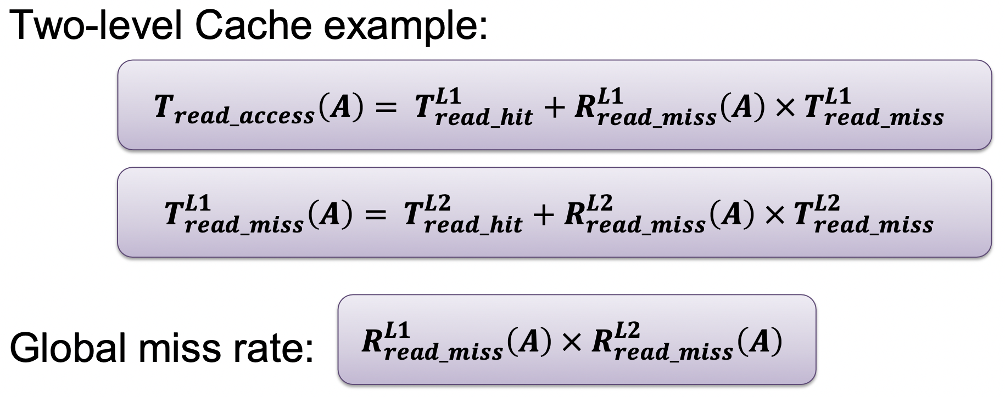

Example:

* Processor for which each instruction takes two cycles to execute (CPI = 2; IPC = 0.5)
* The processor uses a cache for which the loading of a cache block takes 100 cycles (Time taken to read from cache, Tcache = 100)
* Program A for which the (read and write) miss rate is 2% and in which 33% of the instructions executed are load and store operations (Rmiss = 0.02, Nrw = 0.33N(A))
* Scenarios – Execution time when
  + No cache (every mem access goes to the memory)
  + Double clock rate while loading a cache block doubles (200 cycles)

Tno_cache = (CPI * Ninstr + Nrw * CPIread ) * Tcycle

= (CPI * Ninstr + Nrw * CPIread ) * 1/clock rate

= (2 * N + 0.33N * 100) * 1/f = 35N/f

Tdouble = (CPI * Ninstr + Nrw * Rmiss * CPIread ) * Tcycle

= (2 * N + 0.33N * 0.02 * 200) * 1/2f = 1.66N/f

**Throughput**

Million-Instruction-Per-Second (MIPS)

* Consider only the number of instructions
* Easily manipulated: more instructions that do less work so more instructions executed (but technically same throughput)

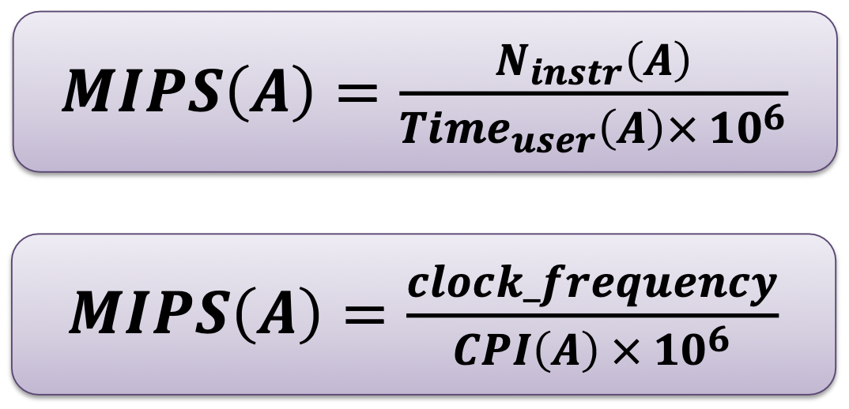

Million-Floating point-Operation-Per-Second (MFLOPS)

* No differentiation between different types of floating-point operations

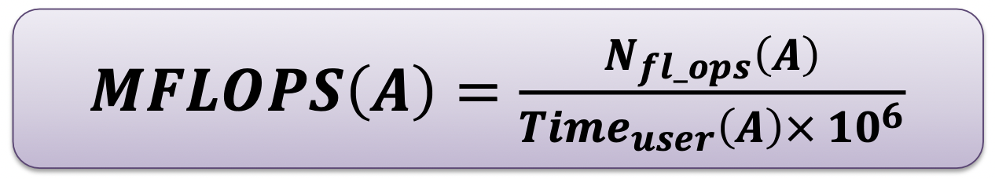

**Parallel Execution Time**

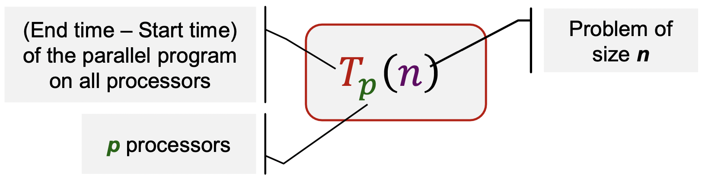

* + Time for executing local computations
* + Time for exchange of data between processors
* + Time for synchronization between processors
* + Waiting time
  + Unequal load distribution of the processors
  + Wait to access a shared data structure

Cost

* Cost of a parallel program with input size n executed on p processors: **Costp(n) = p * Tp(n)**
* A parallel program is cost-optimal if it executes the same total number of operations as the fastest sequential program

Speedup

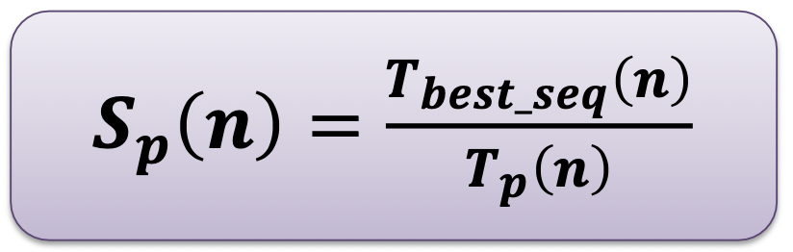

* Theoretically, Sp(n) ≤ p
* In practice, Sp(n) > p (superlinear speedup) can occur (e.g. due to smaller task size fitting into cache)
* However, best seq algo may be unknown
  + same asymptotic time but diff execution time in actual

Efficiency

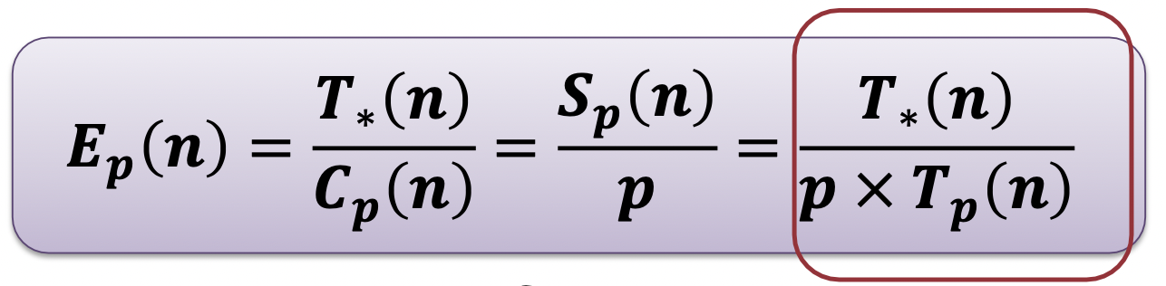

* Actual degree of speedup performance achieved compared to the maximum
* T*: Tbest_seq
* Ideal speedup: Sp(n) = p ⇒ Ep(n) = 1

**Scalability**

* Impact on load balancing, overhead, arithmetic intensity, locality of data access
* Application dependent
* Small problem size:
  + Parallelism overhead > benefit
  + Size may be appropriate for a small machine but not for larger ones
* Large problem size:
  + Key working set may not fit in small machine ⇒ thrashing to disk, cannot fit cache or cannot run at all
* Constraints
  + Application-oriented scaling properties: Problem size is a combination of parameters, not just one number
  + Resource-oriented scaling properties
    - Problem constrained scaling (PC): use a parallel computer to solve the same problem faster
    - Time constrained scaling (TC): completing more work in a fixed amount of time
    - Memory constrained scaling (MC): run the largest problem possible without overflowing main memory

**Amdahl’s Law**

* Speedup of parallel execution is limited by the fraction of the algorithm that cannot be parallelized (f).
* Sequential fraction (aka fixed-workload performance), f: 0 <= f <= 1
* Use when #cores unspecified, i.e. infinite resources
* Use when problem size is fixed OR f increases with problem size

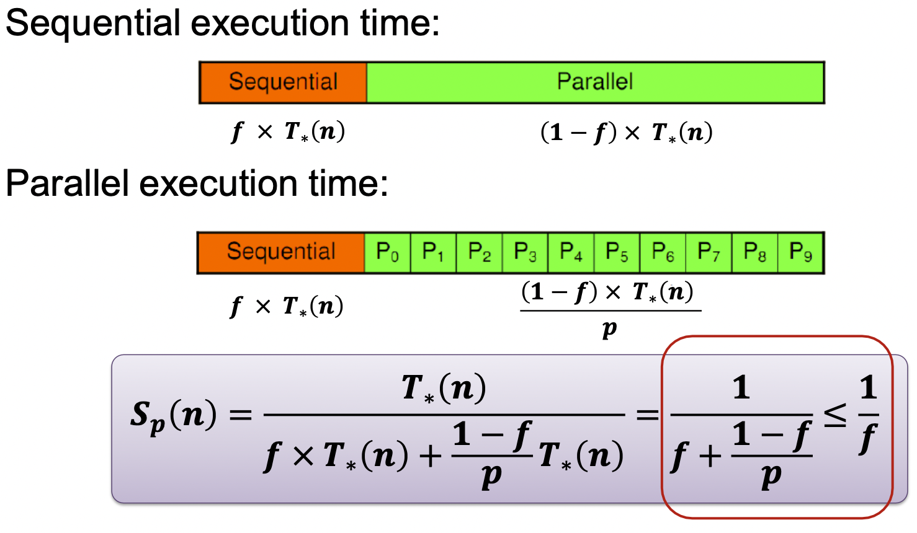

Sp(n) = p/[1 + (p - 1)f]

Problem:

* f is not a constant
* computation commonly dependent on problem size n
  + f is a function of n, f(n)

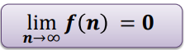

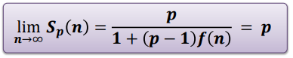

* Amdahl’s law can be circumvented for large problem size

**Gustafson’s Law**

* Applicable for when main constraint is execution time
  + Higher computing power is used to improve accuracy/better result
* If f is not a constant but decreases when problem size increases, then Sp(n) <= p
* Use when #cores specified
* Use when problem size can be varied AND f does not increase much

Tf = constant execution time for sequential part

Tv(n, p) = execution time of the parallelizable part for a problem of size n and p processors

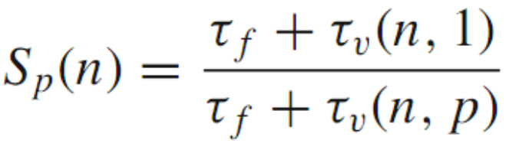

Assume parallel program is perfectly parallelizable (without overheads), then

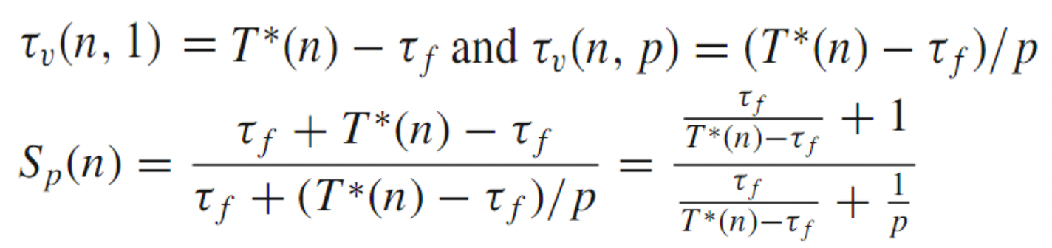

So as T*(n) tends to infinity, Sp(n) = p

**Communication Time**

Message Transmission: Sender

* To send a message:
  + Message is copied into a system buffer
  + A checksum is computed
  + A header is added to the message
  + A timer has started and the message is sent out
* After sending the message
  + if acknowledgment message arrives, release the system buffer
  + If the timer has elapsed, the message is re-sent
    - Restart timer, possibly with a longer time

Message Transmission: Receiver

* Message is copied from the network interface into a system buffer
* Compare computed checksum and received checksum
  + Mismatch: discard the message; re-sent after the sender timer has elapsed
  + Identical: message is copied from the system buffer into the user buffer; application program gets a notification and can continue execution

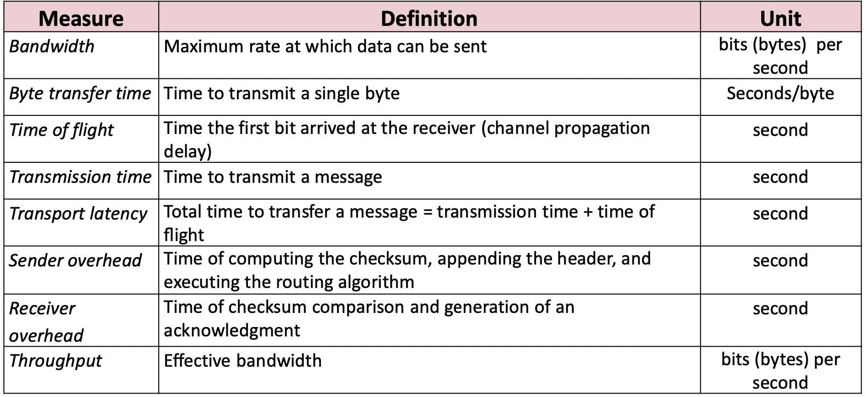

**Total Latency of a Message of Size m**

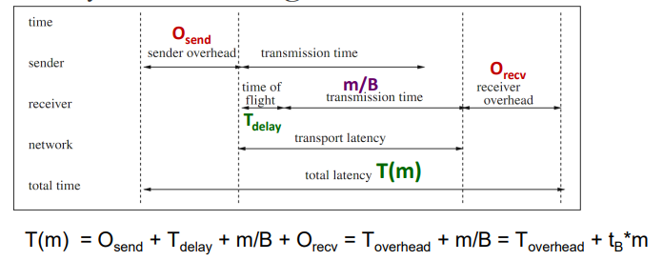

B - network bandwidth

Tdelay = time first bit to arrive at receiver no checksum error and network contention and congestion

tB  = Byte transfer time

**Quiz 2**

**Assume a program X has a constant sequential fraction value regardless of problem size. Amdahl's and Gustafson's Laws predict different maximum speedup values.**

* False

**Given a program with 95% arithmetic instructions and 5% memory instructions, Amdahl's Law instructs the programmer to optimize the arithmetic calculation before looking into memory accesses.**

* False (should speed up mem access)

**PYP**

**Is it possible to solve a problem of variable size (increasing size) to obtain a fixed speedup, provided that an unlimited number of processing units is available? Explain your answer.**

* Possible if we apply Gustafson’s law
* If the sequential fraction f decreases with the increase in problem size, a required speedup can be achieved

**Lecture 6: GPGPU**

GPU Architecture - Multiple Streaming Multiprocessors (SMs)

* 1 GPU consists of multiple compute cores
* Connecting interface (PCI Express)
* Memories (reg, L1 cache and shared mem)
* Logic for thread and instruction mgt (scheduler, load/store, diff units for processing diff types of instr)

Compute Unified Device Architecture (CUDA) Programming Model

* Distributed + shared memory model
  + Distributed: registers, local mem, cache
  + Shared: global mem, constant mem, texture mem, shared mem (between threads in a block)
* Massively hardware multithreaded
* Device: GPU
* Host: CPU
* Kernel: function that runs on the device
* CUDA threads are grouped in warps and it is advisable for threads in the same warp to have the same control flow
* CUDA threads are extremely lightweight → uses thousands of threads (much larger computational units to exploit parallelism)
* CUDA threads are faster to create/destory
* CUDA threads have restricted resources to use (registers, shared memory)
* Parallel portions execute on device as kernels
  + A kernel is executed by an array of threads
  + all threads in a kernel runs the same code - SPMD model
  + Threads in the array need not be completely independent
    - share results to save computations
    - Share memory accesses
  + Works more efficiently when instructions are the same e.g. no branching
  + So keep threads simple and avoid if/else
* Thread blocks
  + Shared memory, atomic operations, barrier synchronisation
  + Threads in diff blocks cannot cooperate
  + Transparent scalability: Hardware is free to schedule thread blocks to any processor at any time
    - A kernel scales across any number of parallel multiprocessors

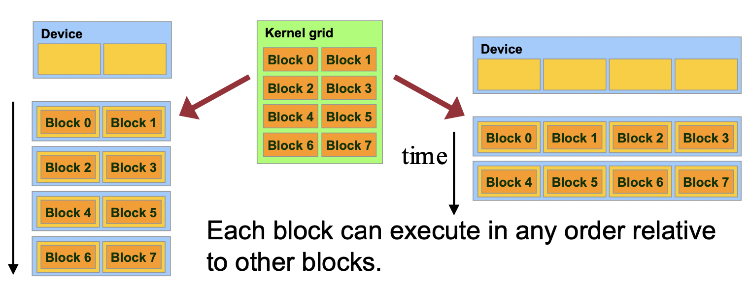

Left: 4 blocks on 1SM, Right: 2 blocks on 1SM

* Cannot communicate between blocks since they might be on different SMs

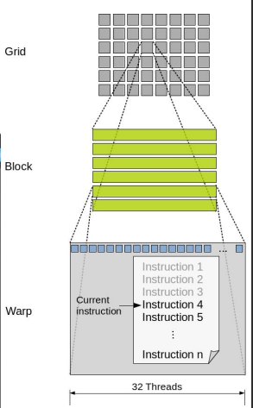

Execution Model Mapping to Architecture

* Kernels launched in grids: one or more (newer archi) kernel executes at a time
* A block executes on 1SM
  + Does not migrate
  + GPUs usually have multiple SMs
* Several blocks can reside concurrently on 1SM
  + Number of blocks is limited by capability (of control) and SM resources
  + Register file is partitioned among all resident *threads*
  + Shared mem is partitioned among all resident *thread blocks*

Thread Execution Mapping to Architecture

* Single-instruction, multithread (SIMT)
* Multiprocessor creates, manages, schedules and executes threads in SIMT warps (groups of 32 parallel threads)
* Threads in a warp start together at the same program address
  + Each thread has indiv instruction PC and register state
* A block is always split into warps in the same way
  + Each warp contains threads of consecutive, increasing thread IDs
* Warp executes one common instruction at a time

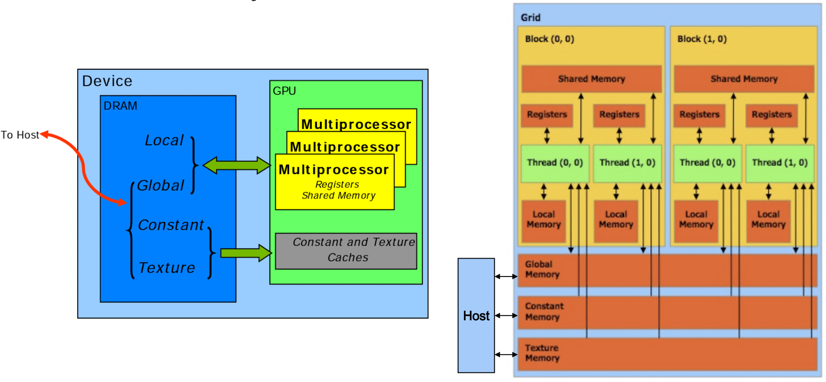

CUDA Memory Spaces

* Data must be explicitly transferred from CPU to device
* Global memory is cached, shared memory is not
  + Unnecessary to cache shared memory since physical memory is already partitioned
* Local, constant, texture memory for convenience/performance (all cached)
  + Local: automatic array variables allocated by compiler
  + Constant: useful for uniformly-accessed read-only data
  + Texture: useful for spatially coherent random-access read-only data
* Simultaneous accesses to global memory by threads in a warp (32 threads) coalesce into a number of transactions equal to the number of 32-byte transactions necessary to service all the threads of the warp
* The k-th thread access the k-th word in a 32-byte aligned array

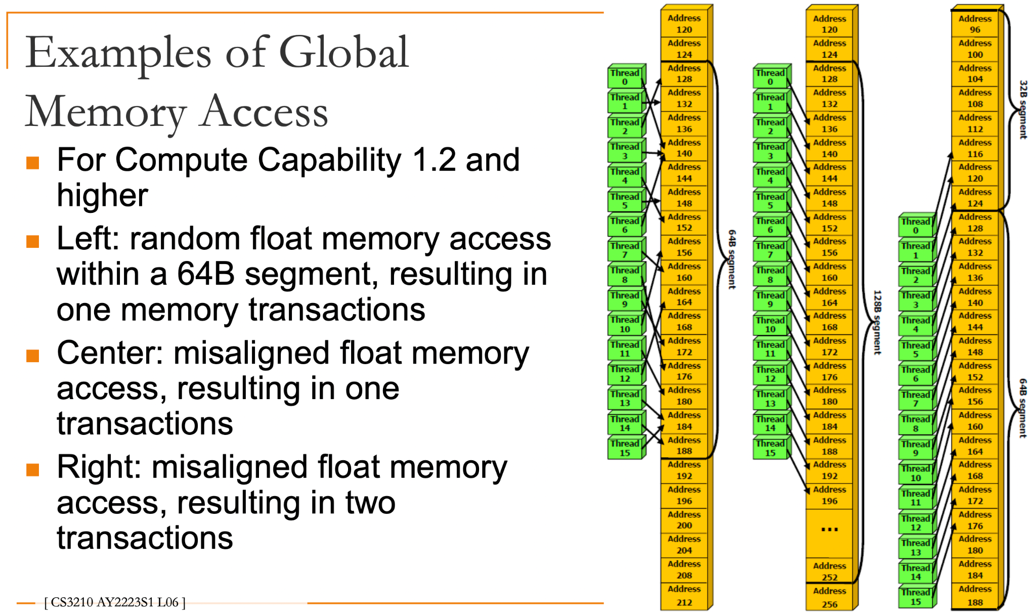

Shared Memory

* As fast as registers if there were no bank conflicts
* Higher bandwidth and lower latency than local or global memory
* Divided into equal size memory modules (banks)
  + Addresses from diff banks can be accessed simultaneously
  + e.g. 1 accessing 0 and another accessing 64

Bank | 1 | 2 | 3 |...

Address | 0 1 2 3 | 4 5 6 7 | 8 9 10 11| ...

Address | 64 65 66 67 | 68 69 70 71 | 72 73 74 75|...

* No bank conflict:
  + Access different banks
  + Access the same address in the same bank → broadcast
* Bank conflict: two addresses of a memory request fall into the same memory bank
  + mem access has to be serialized
  + i.e. sequential execution of threads if they access diff address in the same bank
* Broadcast: Multiple threads in warp access the same shared memory location/bank
  + only 1 thread will read from bank and broadcast it to rest of the threads
* Each bank has a bandwidth of 32 bits every clock cycle and successive 32-bit words are assigned to successive banks
  + Warp size = num banks = 32
* Threads within a warp access words in memory with a stride of 2 → 50% load/store efficiency

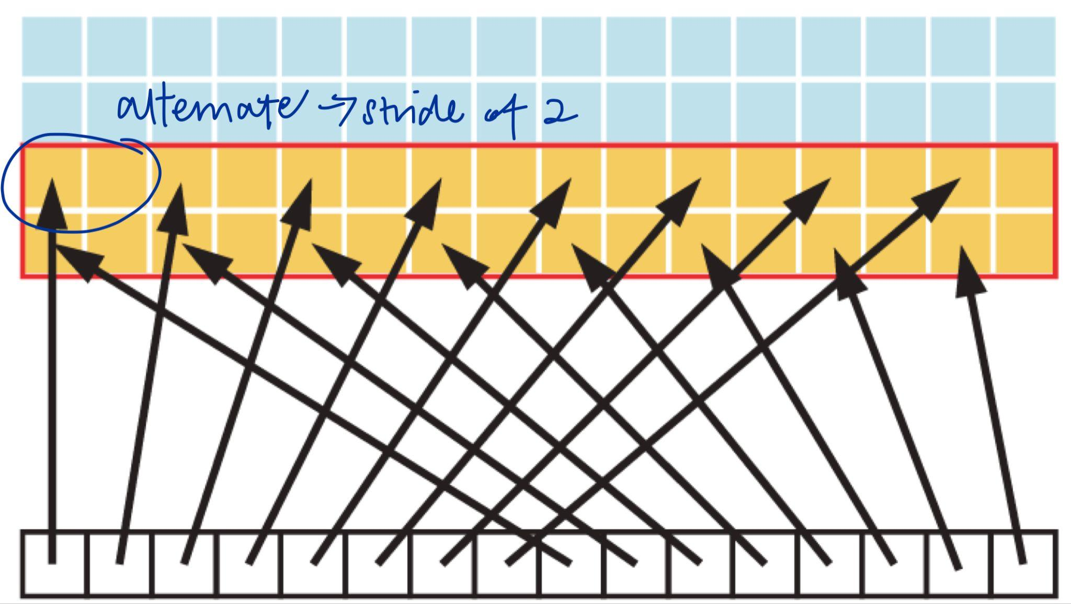

(half the elements in the transactions not used → wasted bandwidth)

* Data too large to fit into shared memory → split the multiplication into multiple iterations (multiple calls to the kernel)
  + Each call to the kernel copies a subset of the data to shared memory

Memory Optimization

1. Minimise data transfer between host and device
   * Peak bandwidth between device memory and GPU (between SMs) is much higher than that between host and device memory (connecting interface)
   * Batching many small transfers into one larger transfer
   * Use page-locked (or pinned) mem transfer (not cached)
     + Use the zero-copy feature that allows the threads to directly access the host mem
2. Ensure global memory accesses are coalesced whenever possible
   * Warp are coalesced into a number of transactions = 32 byte transactions
3. Minimise global memory accesses by using shared memory
   * Shared memory lower latency
4. Minimise bank conflicts in shared memory accesses

Concurrent data transfers and executions

* cudaMemcpyAsync() instead of cudaMemcpy() when possible
  + CPU computation while data transfers, followed by device code is executed

Execution Configuration

* Strike a balance between occupancy and resource utilization
* Improve occupancy
  + Num warps should be larger than num multiprocessors → so all multiprocessors would have at least 1 warp to run
  + no idling during synchronization
* Threads per block should be multiple of warp size, minimum of 64 threads
  + Avoid mem bank conflicts, facilitate coalescing
  + Several smaller thread blocks rather than 1 large thread block per processor
* 1 multiprocessor can have multiple concurrent blocks
* Block size limited by registers and shared mem used → ensures >= 1 thread can run on 1 SM
  + When a thread block allocates more registers than are available on a multiprocessor, the kernel launch fails
* Avoid multiple contexts per GPU w/i the same CUDA app
  + i.e. avoid having multiple CUDA apps accessing the same GPU concurrently

Maximize Instruction Throughput

* Integer division and mod operations are costly → replace with bitwise operations
* Use signed loop counters
* Functions operating on char or short generally need to be converted to an int

Control flow

* Minimise divergent warps (if else)
* Reduce num instructions

Programming in CUDA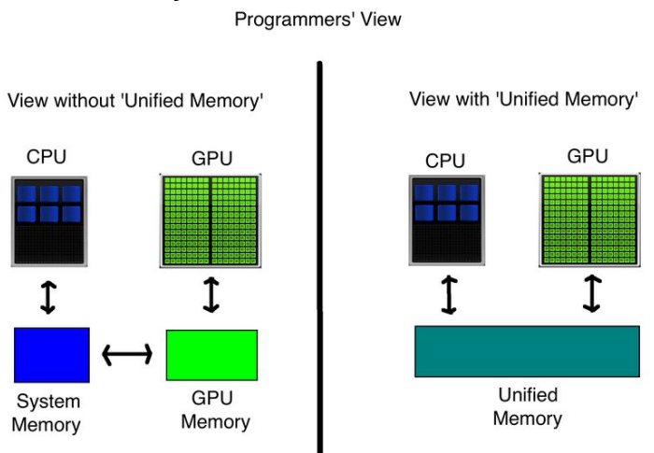

Device code

* Can only access GPU mem
* No variable number of arguments (varargs)
* No static var
* No recursion

Function types

* __host__
* __device__
  + __host__ and __device__ can be used tgt
* __global__
  + Function is a kernel
  + Must have a void return type
  + A call to function must specify execution config (“<<<>>>”)
  + Function params are passed via shared mem
* Launching Kernels
  + kernel<<<dim3 grid, dim3 block, int smem, int stream>>>(...)
* All global and device functions have access to
  + dim3 gridDim
  + dim3 blockDim
  + dim3 blockIdx
  + dim3 threadIdx

**Lecture 7: Cache Coherence, Mem Consistency**

Shared Address Space Model

* Communication abstraction
  + Tasks communicate by reading/writing to shared variables
  + Mutual exclusion using locks
  + Logical extension of uniprocessor programming
* Requires hardware support to implement efficiently
  + Any processor can load and store from any address
  + Even with NUMA, costly to scale
  + Matches shared memory systems – UMA, NUMA, etc.
  + Speed of caches/mem
    - Registers > L1 > L2 >> Main memory > Secondary storage

Cache Properties

* ↑ Cache size ↓ cache miss ↑ cache access time (due to increased addressing complexity)
* Block size/Lines of Cache: data is transferred between main memory and cache in blocks of a fixed length
  + ↑ block size ↓ the number of blocks but ↑ replacement time ⇒ prefer smaller
  + ↑ block size ↑ the chance of spatial locality cache hit ⇒ prefer larger

Write Policy

1. Write-through: write access is immediately transferred to main memory
   * always get the newest value of a memory block
   * slow down due to many memory accesses → use write buffer
2. Write-back: write is performed to the main memory when the cache block is replaced (dirty bit), otherwise its only performed in cache
   * Less write operations
   * memory may contain invalid entries

Write-back Cache (uniprocessor)

1. If variable not found in cache, processor load from memory
2. Cache selects location to place line in cache, if there is a dirty line currently in this location, the dirty line is written out to memory (mem var updated)
3. Cache loads line from memory (“allocates line in cache”) and change to new val
4. Whole cache line is fetched
5. Cache line is marked as dirty

Memory Coherence for Shared Address Space

* Multiprocessor: global storage space (main mem) and pre-processor local storage (per-processor caches) → mem coherence problem

Memory Coherence

* Coherence ensures that each processor has consistent view of memory through its local cache
* All processors must agree on the order of reads/writes to the **SAME** memory location (address)
* Properties
  + Program order - reads latest value written
  + Write propagation - writes become visible to other processors
  + Write serialisation - All writes to a location are seen in the same order by all processors (if changed to v1 then v2, should not see v2 then v1 && once seen, v2 cannot see v1 anymore!)

Maintaining Memory Coherence

1. Software based → OS + Compiler BUT high overhead
2. Hardware based (more common now) → cache coherence protocols

Tracking Cache Line Sharing Status

* Snooping Based (Most common)
  + No centralized directory
  + Each cache keeps track of sharing status
  + Bus (shared medium): connection between memory and CPU
  + Cache monitors/snoops on the bus to update the status of cache line and take appropriate action (write propagation and serialisation)
* Directory Based (commonly used in NUMA)
  + Sharing status is kept in a centralized location & all cores have access to the directory

Cache Coherence Implications

* Overhead in shared address space
  + CC appears as increased memory latency in multiprocessor
  + CC lowers hit rate in cache
    - Caches share the same cache line → 1 modification on a cache will cause cache miss for other caches using the same cache line
* Cache ping-pong
  + Multiple processors read and modify the same global variable (same address)
  + Cache ping pong can occur for true sharing too
* False sharing (take note when distributing resources to different threads)
  + 2 processors write to different addresses (logically disjoint data) mapped to the same cache line
  + So if P1 writes to cache, P2 must load cache again to ensure cache coherence → cache line will bounce back and forth between the caches of the 2 processors → worst case: every write is a miss
  + False sharing results in a performance degradation only if the shared cache lines are **accessed concurrently (equal rate of accessing e.g. array)**; if the cache line exists in only one of the private caches, no invalidation of the (shared) line occurs!

Memory Consistency

* constraints the order in which memory operations performed by one thread become visible to other threads for **DIFFERENT** memory locations
* Coherence only guarantees that writes to address X will eventually propagate to other processors
  + Tactics to make multi-core caches faster
* Consistency deals with when writes to X propagate to other processors, relative to reads and writes to other addresses
  + Tactics to make multicore memory op sequences faster

Sequential Consistency (SC) Model

* Global result of all memory accesses of all processors appears to all processors in the same sequential order irrespective of the arbitrary interleaving of the memory accesses by different processors
* A sequentially consistent memory system maintains all four memory operation orderings (W→R, R→W, W→W, R→R)

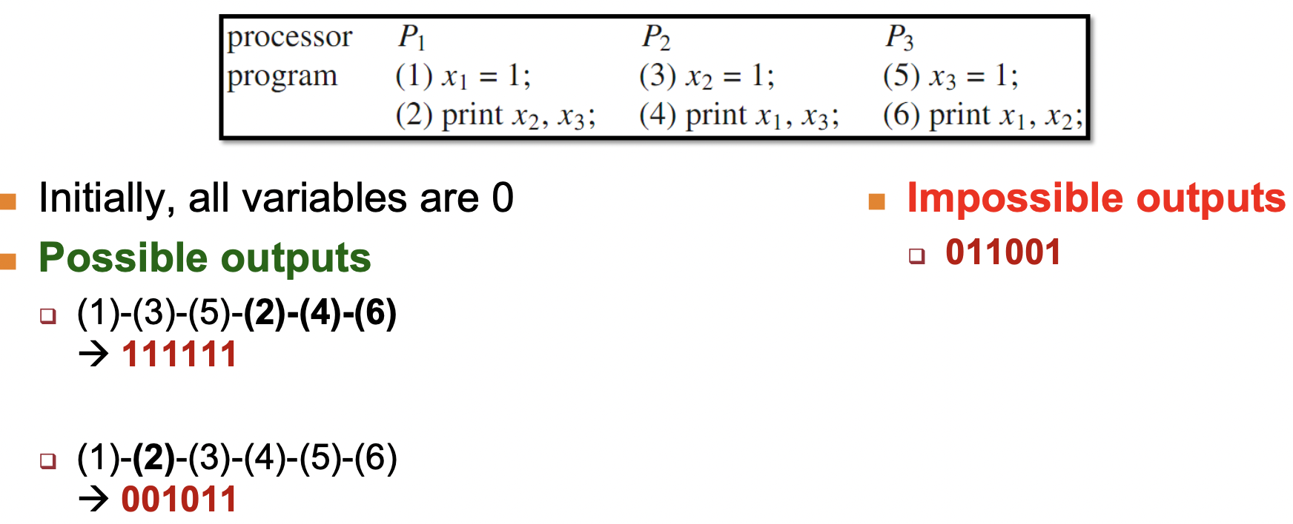

* Interleaving is possible; As long as all processors see the same value, interleaving is fine!

Relaxed Memory Consistency Models

* If two operations access the same memory locations, R → W, W → W, W → R must be preserved
* Program order relaxation:
  + W → R
  + W → W
  + R → R/W
* Hide latencies
  + Overlap memory access operations with other operations when they are independent

Total Store Ordering (TSO)

* Only for different memory locations!!
* Relax W → R: can switch WR order (puts writes into a store buffer and let them execute later when needed)
* Processor P can read B before its write to A is seen by all processors
* Reads by other processors cannot return new value of A until the write to A is observed by all processors

Processor Consistency (PC)

* Relax W → R
* Return the value of any write (even from another processor) before the write is observed by all processors

Partial Store Ordering (PSO)

* Relax W → R, W → W (to diff locations in write buffer)
  + A = X; B = X; Can swap

[R] while (A == 0);

[W] B = 1;

Cannot swap R → W in above example → changing control flow of program

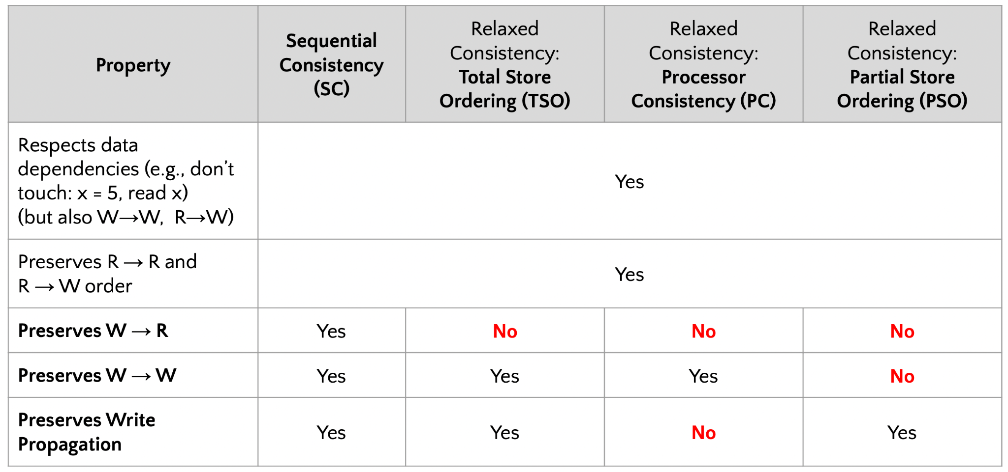

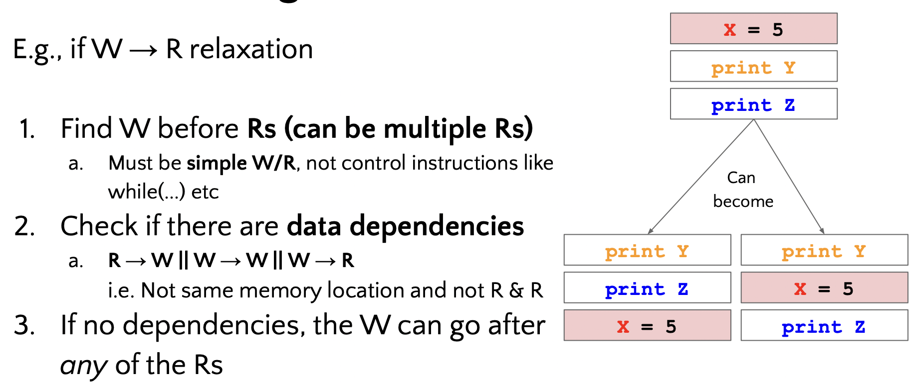

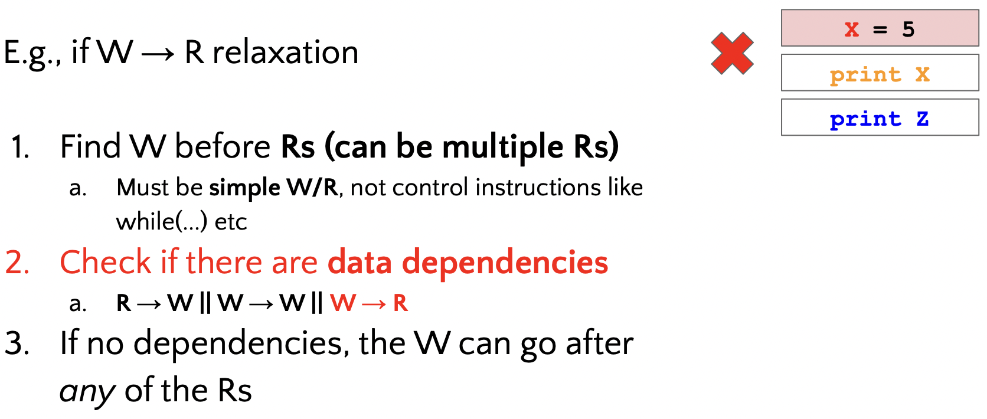

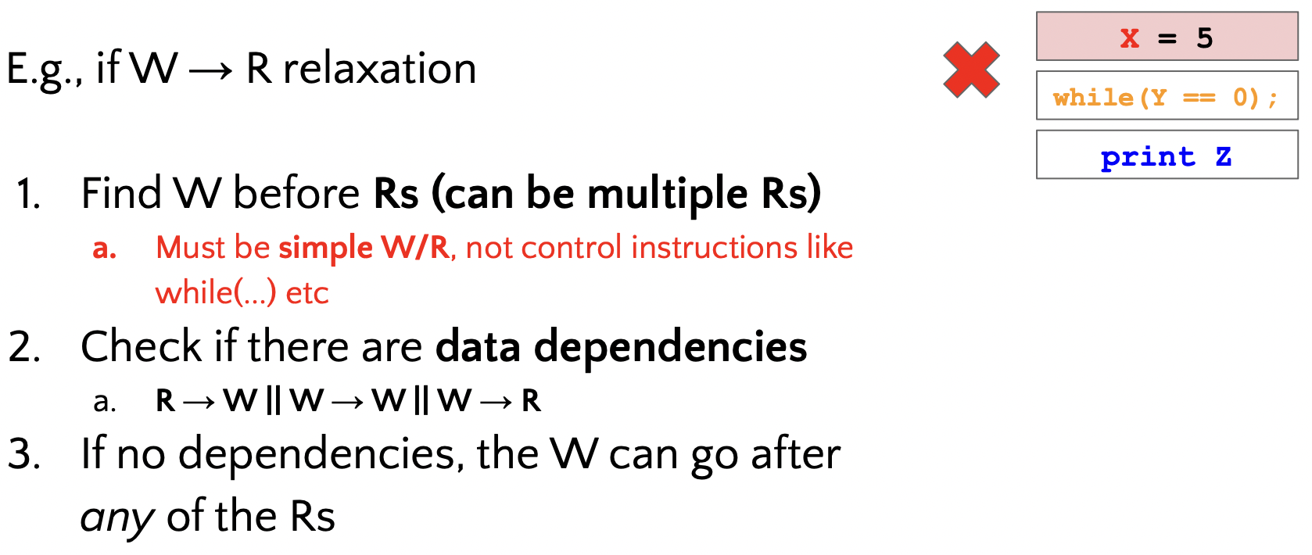

**Lecture 9: Parallel Programming Models - II**

Data Distribution (parallel strategy for data parallelism)

* How to decompose arrays for distribution on multiple processors e.g. data distribution/ work distribution/ decomposition/ partitioning

**1D Array**

Blockwise:

* Underlying assumption: n is known
* Locality: cache line more likely to contain all the data → decrease cache miss
* If n is small, some processors might not be used → wasted

Cyclic:

* Better load distribution (more even)

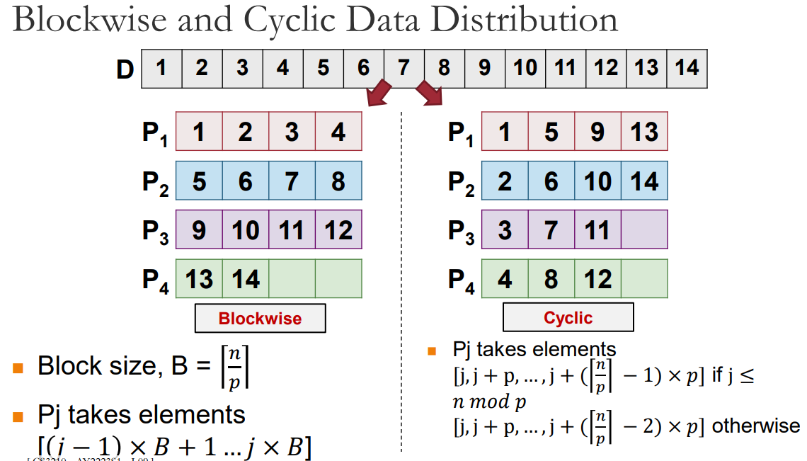

**2D Array**

* Combination or blockwise/cyclic distribution in one or both dimensions
* One dimension distributions (e.g. column dim)

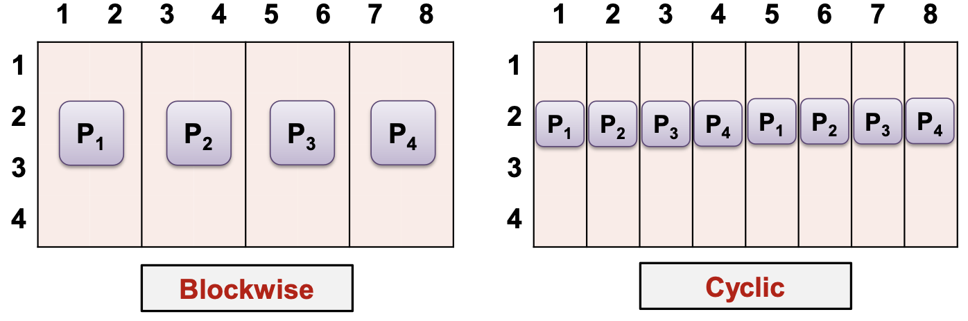

Block-Cyclic

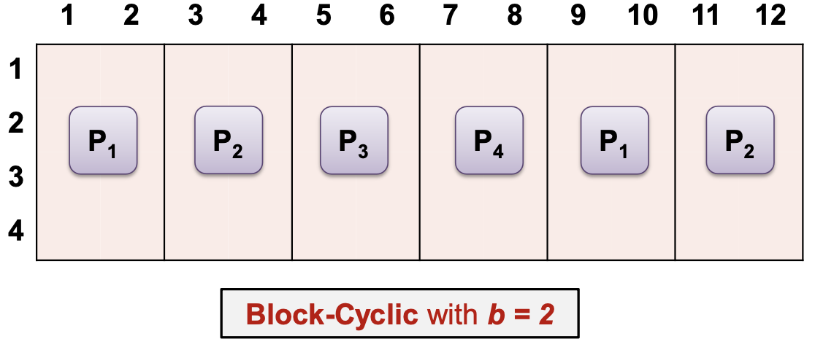

* From blocks of size b, perform round robin allocation
* Processors are virtually organized into a 2D mesh of RxC
* Checkerboard distribution: blockwise/cyclic/block-cyclic (b1*b2 blocks)

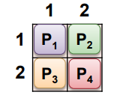

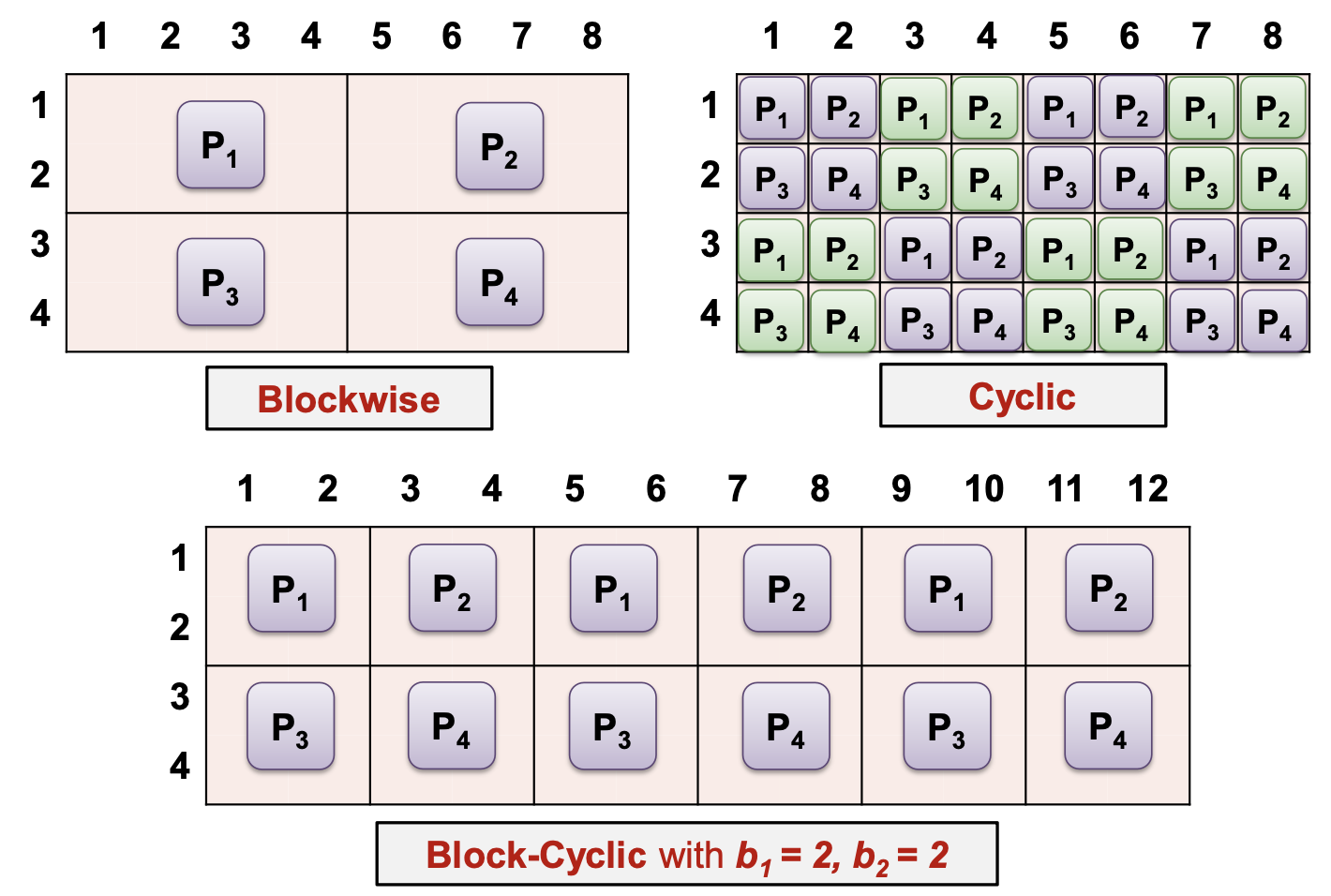**Information Exchange**

* Necessary for controlling coordination of different parts of a parallel program
* Shared address space:
  + use Shared variables
* Distributed address space
  + use Communication operations

Shared Memory Programming Model (Shared var)

OMP!!

assume a global memory accessible by all processors

* Information exchange through shared variables
* Need synchronization operations for safe concurrent access

Flow of control abstractions

* processes or threads

Each thread:

* executed by one processor or one core in multicore processors
* Have shared variables and may have private variables

Synchronized access

* Data race: multiple threads accessing the same shared variable
  + Computation result depends on the execution order of threads (race cond)
  + Non-deterministic behaviour
  + Avoided using CS

Distributed Memory Programming Model (Communication Operations - MPI)

* Assume a disjoint memory space
  + Exchange of data through communication operations
* Common: message-passing programming model
  + Loosely synchronous paradigm: Tasks or subsets of tasks synchronize to perform interactions
  + Between these interactions, tasks execute completely asynchronously
* 2 main types of data exchanges:
  + Point-to-point
  + Global communication
* Data explicitly partitioned for each process
* All interaction requires both parties to participate → programmer has to explicitly express parallelism

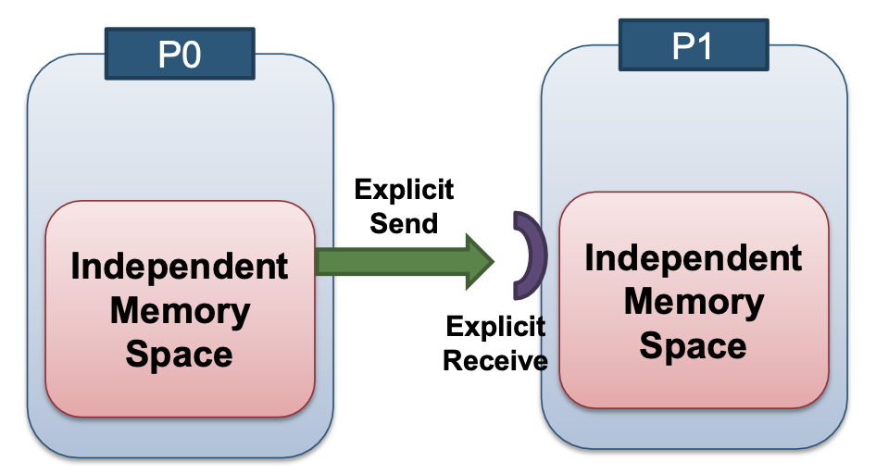

**Communication Protocol**

Point-to-point communication (Buffered)

* Distributed memory system: source node (output buffer) → network (serialised message) → destination node (input buffer)

Send and Receive Protocols Possibilities

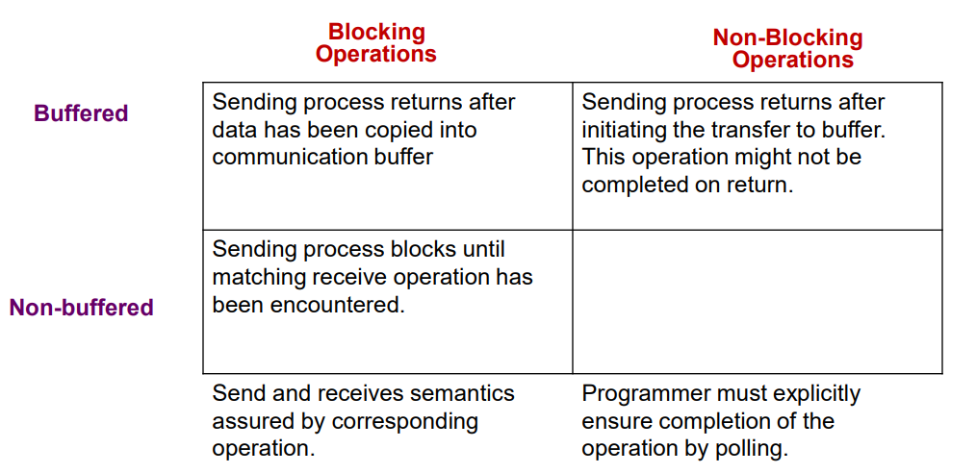

Blocking Operations

* blocks until it is safe to reuse the input (send) / output (rev) buffer
  + "Safe": the integrity of the data to be sent
* Non-buffered blocking send:
  + blocks until the matching receive has been performed by the receiving process
  + Idling (mismatch in timing between sender & receiver)
  + Deadlocks

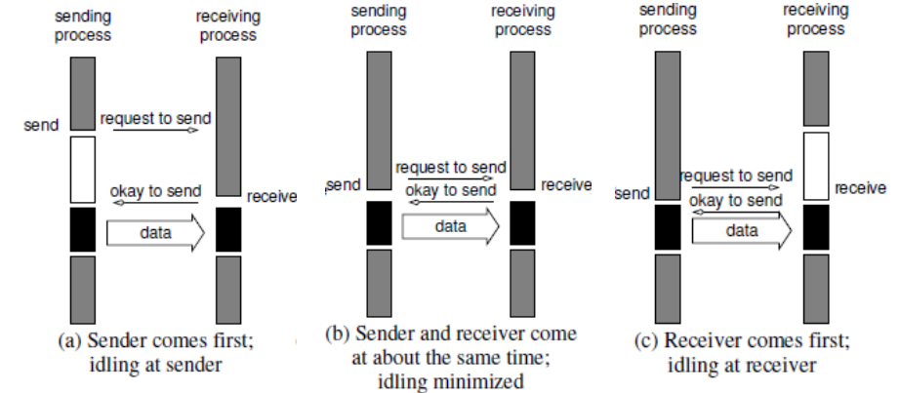

1. Sending process idle, waiting for receiving process to signal
2. No idling
3. Receiving process idling, waiting for sending process to send something

* Buffer at both ends:
  + Sender copies data into the send buffer and returns after the copy operation has been completed
  + Receiver buffers the incoming data into recv buffer
  + reduce idling overhead
  + Buffer copying overhead
  + Deadlock (both processes recv/send first)

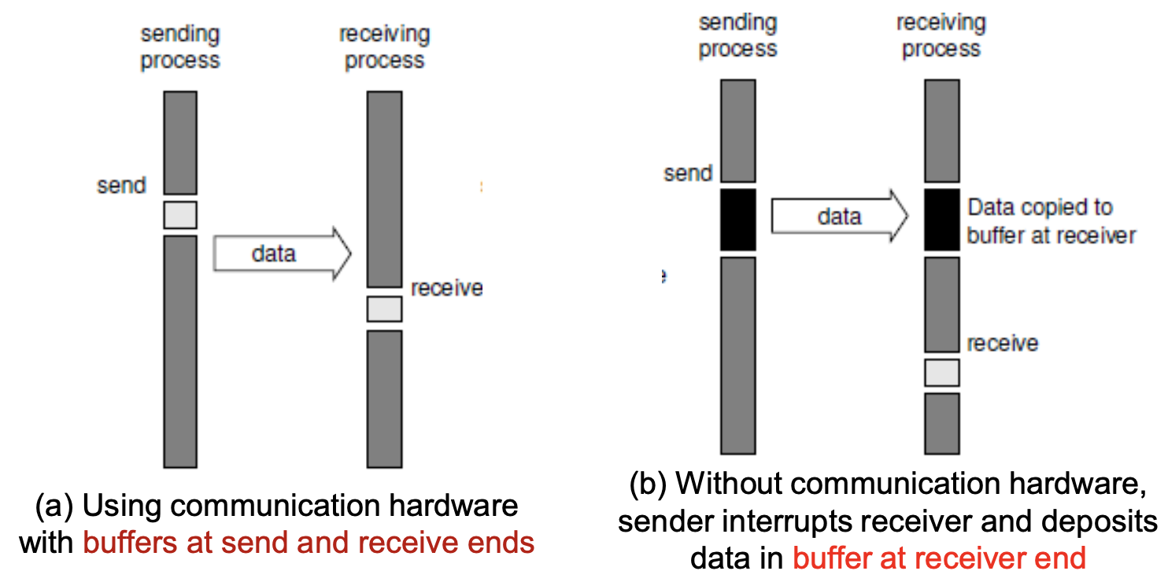

* Note: (b) black section → CPU is busy; utilises CPU to compute and get info

Bounded Buffer Size

* If buffer becomes full == No buffer
* So always assume no buffer

Non-Blocking Operations

* Send/Recv returns before it is semantically safe to use the data transferred
  + Send returns immediately but the send buffer should not be touched until send is completed (check status)
  + generally accompanied by check status operation
  + Programmer must ensure the semantics of the operations
* When used correctly, these primitives are capable of overlapping communication overheads with useful computations
* Message passing libraries typically provide both blocking and non-blocking primitives

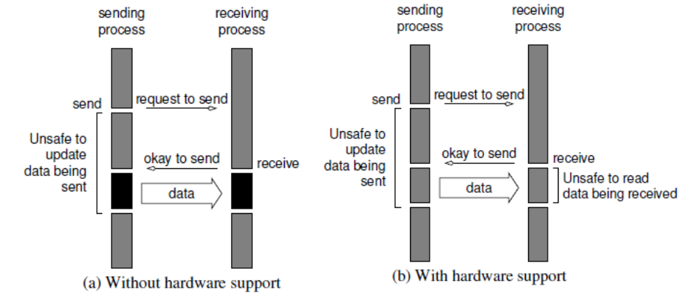

Note: Unsafe to update data being sent sections → process can do other computations but should not touch buffer

* Hardware support (direct memory access, DMA) does the copying and sends interrupt to CPU to notify that it is ok to be reused.
* No hardware support: CPU do the copying itself

| **Local View** | **Global View** |
| --- | --- |
| **Blocking**  Return from a library call indicates the user is allowed to reuse resources specified in the call | **Synchronous**   * Communication operation does not complete before both processes have started their communication operation * Send completes after matching receive and source data sent * Receive completes after data transfer complete from matching send |
| **Non-blocking**  A procedure may return before the operation completes, and before the user is allowed to reuse resources specified in the call | **Asynchronous**   * Sender can execute its communication operation without any coordination with the receiver * Send completes after input buffer may be reused |

Synchronous Communication

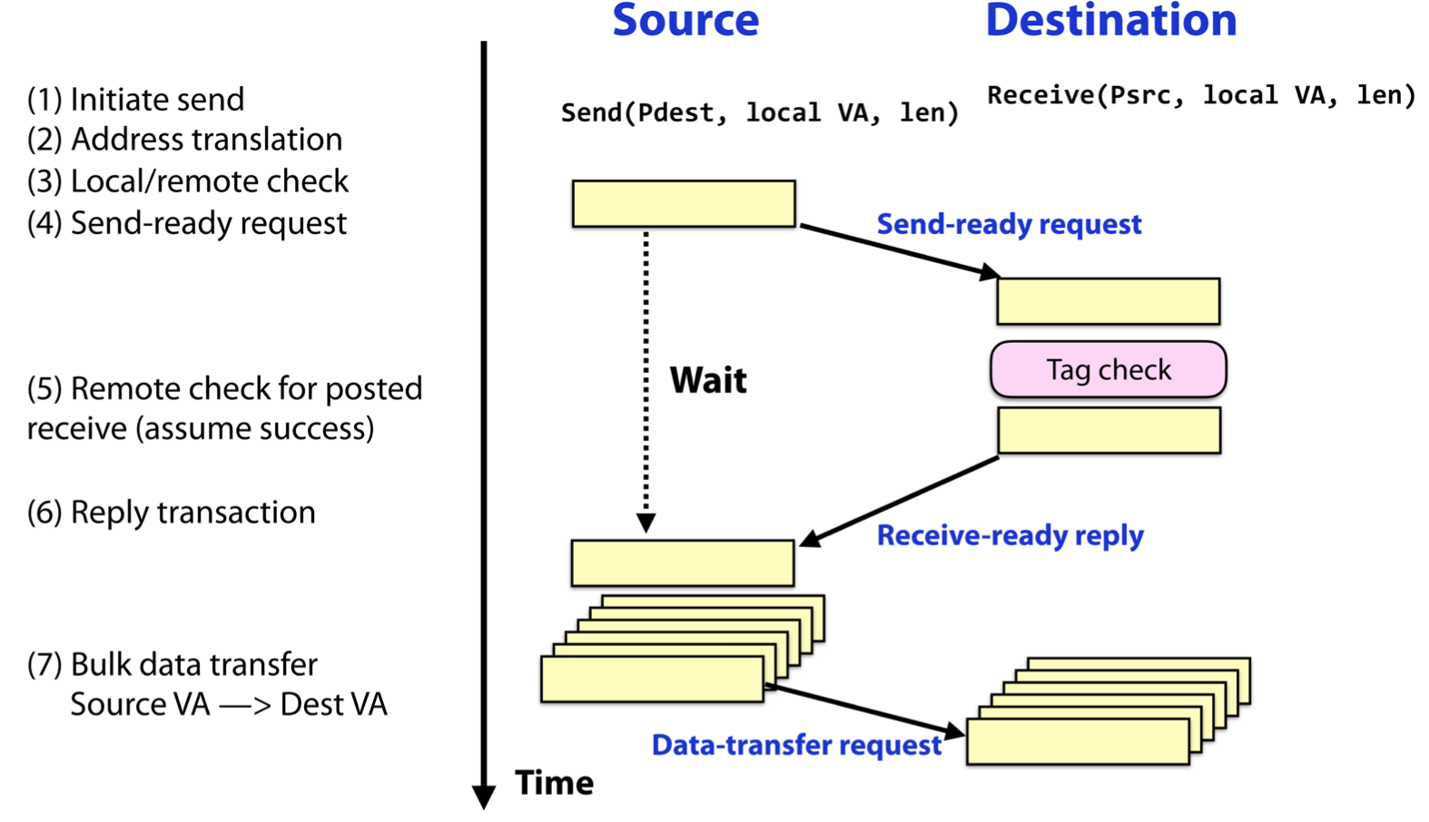

Asynchronous Communication

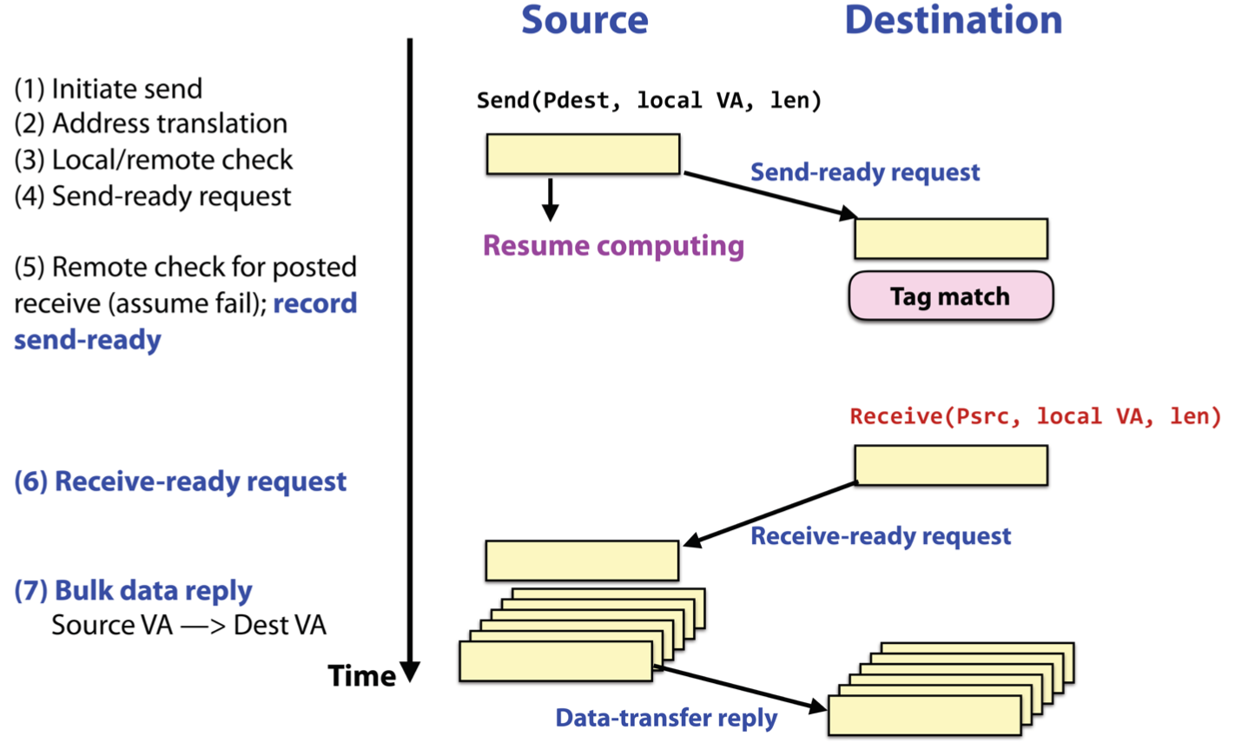

**Lecture 10: Message Passing Interface (MPI)**

* An MPI program is called secure if the correctness of the program does not depend on assumptions about specific properties of the MPI runtime system

MPI program structure

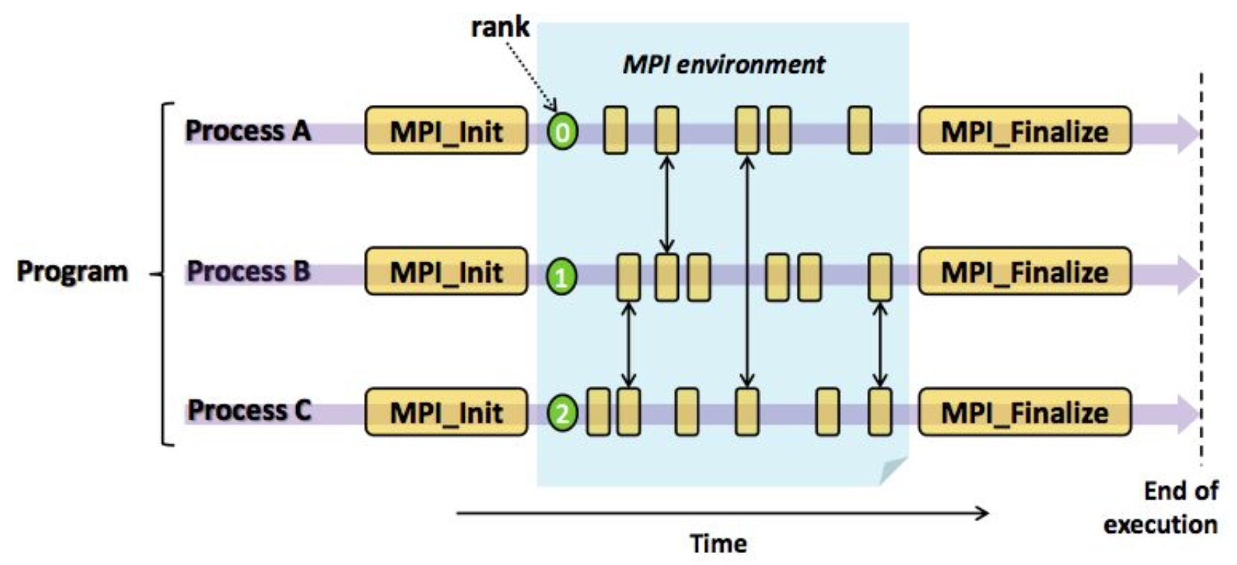

* int MPI_Init(int* argc, char** argv[])
  + Initialize the MPI program
  + Must be called only once and before any other MPI routines
* int MPI_Finalize(void)
  + Terminate all MPI processing
  + Must be the last MPI call
* int MPI_Abort(MPI_Comm comm, int errorCode)
  + Force all processes to terminate
  + Return the errorcode to mpirun
* int MPI_Send(const void *buf, int count, MPI_Datatype datatype, int dest, int tag, MPI_Comm comm)
* int MPI_Recv(void *buf, int count, MPI_Datatype datatype, int source, int tag, MPI_Comm comm, MPI_Status *status)
* Blocking and non-blocking operations can be mixed

MPI Message Format

* Message = data (actual data that you want to send/receive) + envelope (how to route the data)
* Data = start-buffer (address where data starts) + count (number of elements of data in the message) + datatype (type of data to be transmitted)
* Envelope = destination or source (address where data starts) + count (number of elements of data in the message) + communicator (send/recv must specify the same communicator)

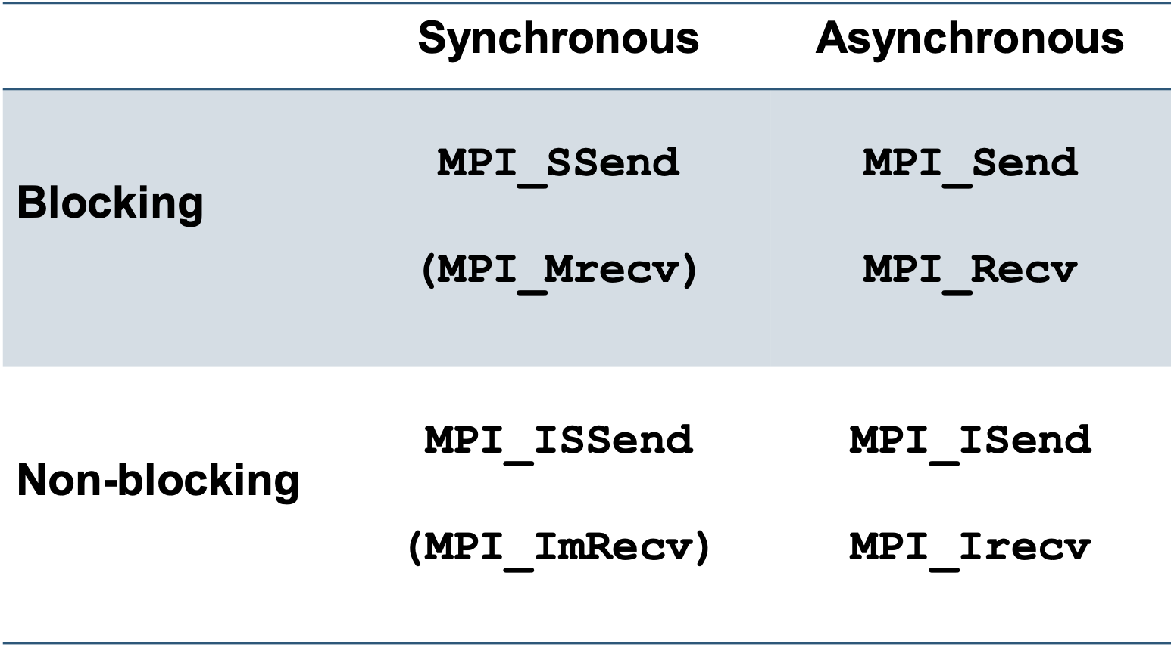

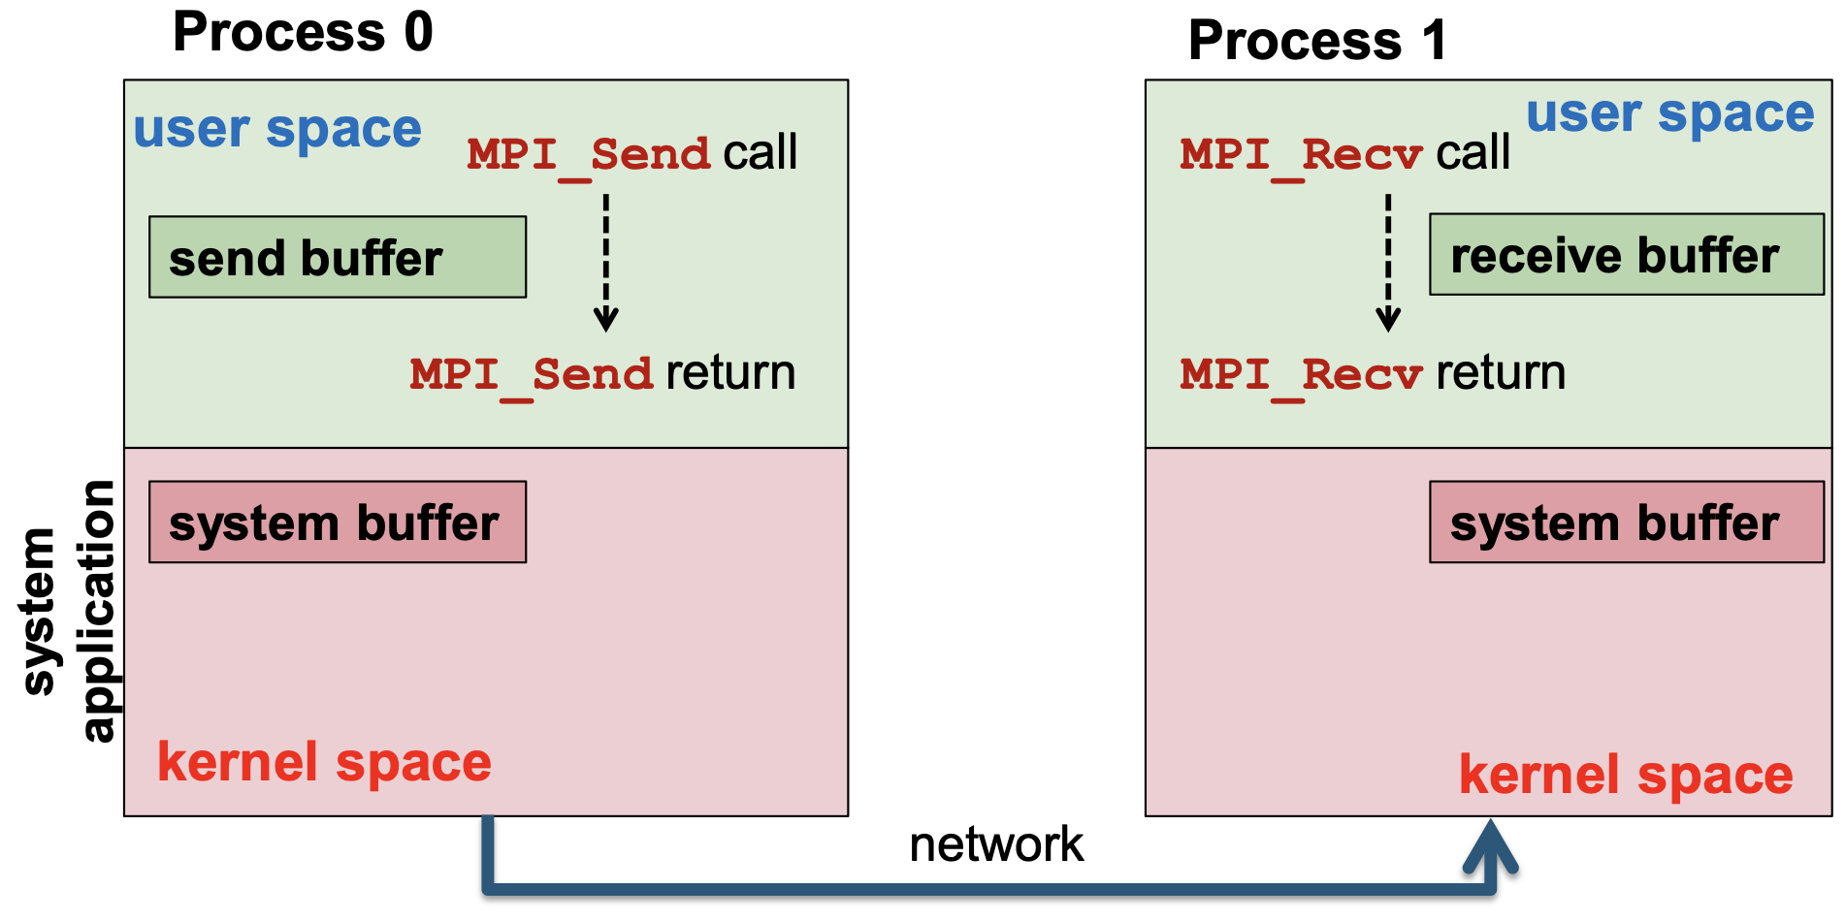

* If a send message arrives before the receiver is ready → enter buffer if ready else block
* Multiple send messages arrive at the receiver

Order of Receive Operations

* Two processes (one sender, one receiver)
  + A sender sends two or more messages to the same receiver, messages delivered in the order which they have been sent
* If > 2 processes: order not guaranteed
  + E.g. m0 is passed from P0 → P1 → P2; m1 is passed from P0 → P2 ⇒ m1 may arrive at P2 before m0

Deadlocks

* Both recv (blocking) first
* If both send first
  + if the runtime system does not use system buffers or if the system buffers used are too small
  + Both sends cannot complete
* Deadlock-Free logical ring: communication is done via point-to-point message passing in a clockwise manner (or use buffers to avoid deadlock)
  + Blocking async operations as sends are needed to be paired with receives
  + Processes with even rank: send → receive
  + Processes with odd rank: receive → send

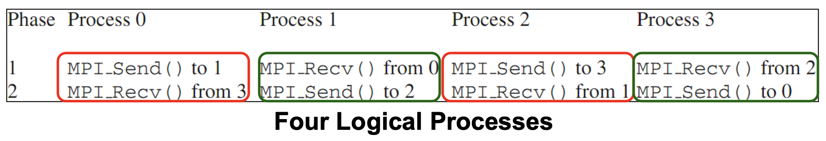

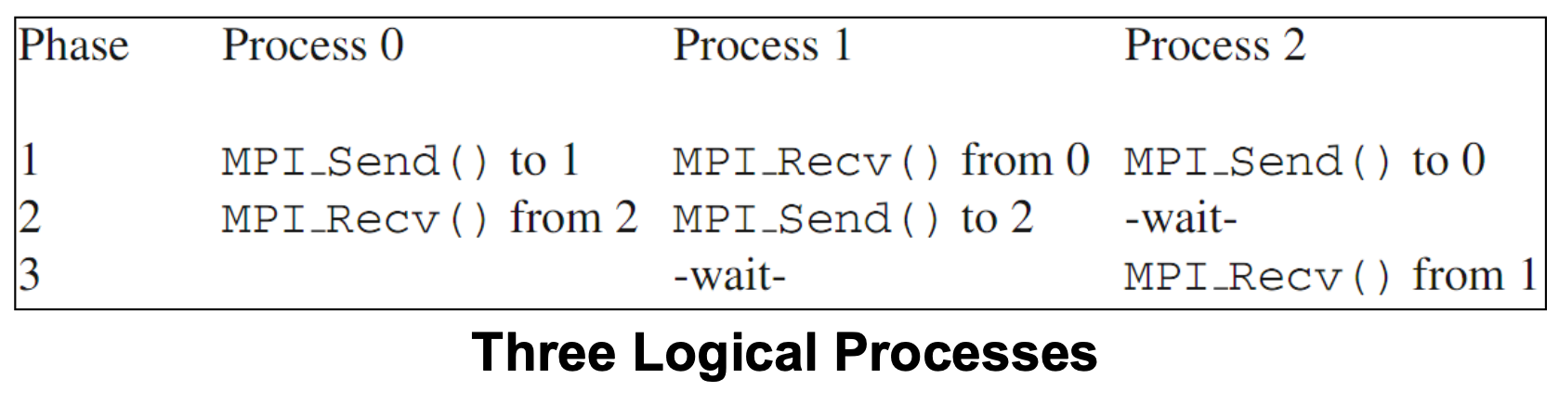

* Termination:
  + When each process is done processing (no more tasks to complete/generate), the process sends a Completion message to its right neighbour along with the Completion message it receivers from the left neighbours
  + When the process sees again its initial message → all processes have ended and no more tasks → send Finalize message
  + MPI rank 0 calls MPI_Finalize once N Finalize messages are received
  + If a process still has tasks to execute when a completion message reaches, that process will not forward the completion messages

**Process Groups and Communicators**

Process Group

* An ordered set of processes
  + Each process has a unique rank
* A process may be a member of multiple groups
  + May have different ranks in each of these groups
* MPI system handles the representation and management of process groups

Communicator

* Communication domain for a group of processes
* Two types
  1. **Intra-communicators**: Support the execution of arbitrary collective communication operations on a single group (Default: MPI_COMM_WORLD)
  2. **Inter-communicators**: support point-to-point communication operations between two process groups

Motivation:

* Allow us to organise task, based on functions into task groups
* Enable collective communication operations across a subset of related tasks
* Provide basis for user-defined virtual topologies
  + Optimise how communication happens
  + create topologies where neighbours are easily addressable
  + E.g. if only communicate with neighbour in a mesh pattern

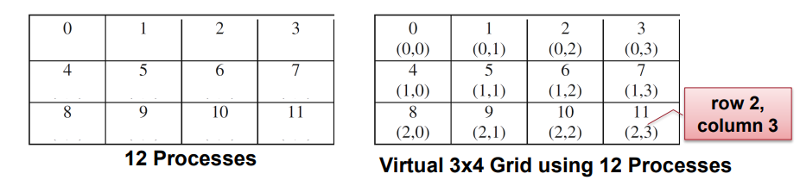

* Provide for safe communication

**Collective Communication (Blocking)**

* Operations involve all processes in a communicator, otherwise deadlock

Single transfer

* Point-to-point communication
* Send: specifies send buffer, receiving (dest) processor rank
* Receive: receive buffer, sending (src) processor rank

Scatter

* from 1 process to many processes

Gather

* from many processes to 1 process
  + With accumulation (reduction) using an arithmetic operation
  + Without accumulation

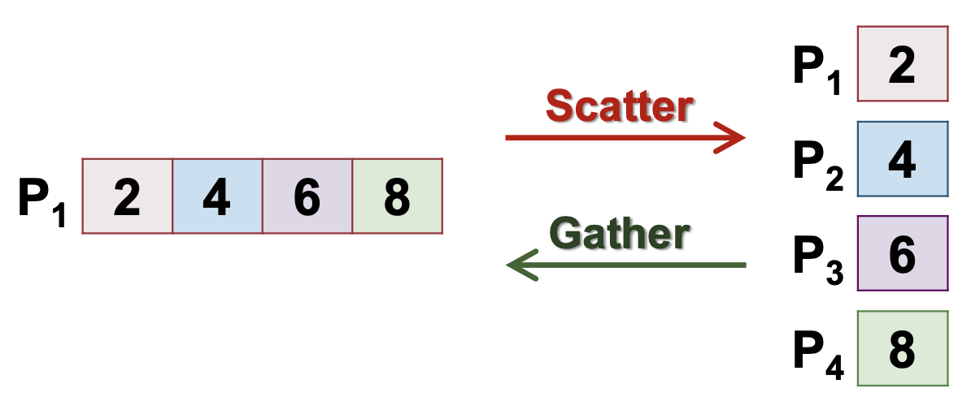

Single Broadcast

* Sender (the "root" processor) send the same data block to all other processors

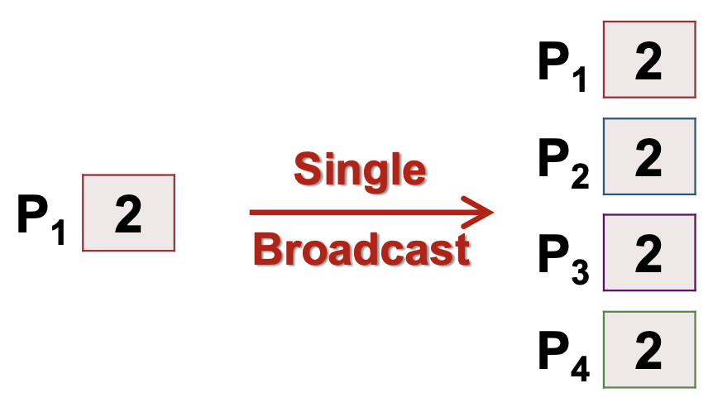

Multi-Broadcast (No root processor)

* Each processor sends the same data block to every other processor
* Data blocks are collected in rank order
* More specialised than single broadcast

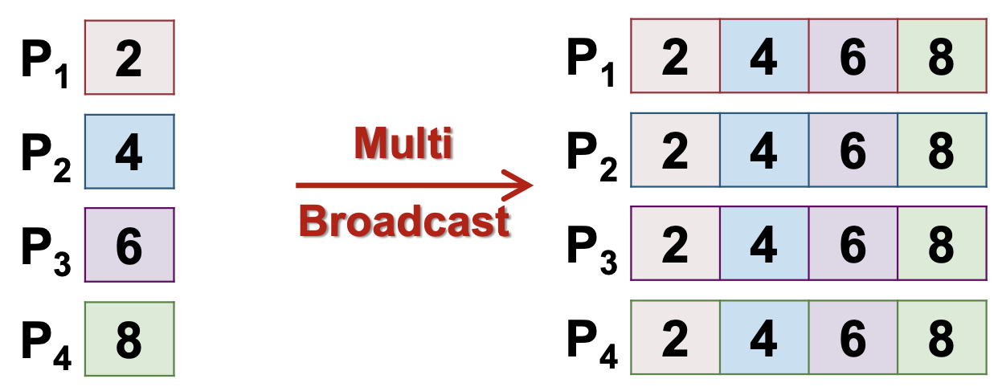

Single-accumulation (Gather with Reduction)

* Each processor provides a block of data with the same type and size
  + A reduction operation (binary, associative, commutative) is applied element by element to the data blocks
* results in root processor

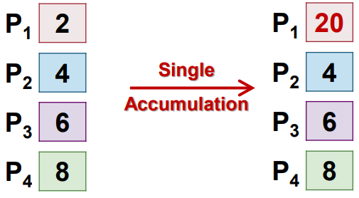

Multi-accumulation (No root processor)

* Each processor provides for every other processor a potentially different data block
* Data blocks for the same receiver are combined with a given reduction operation

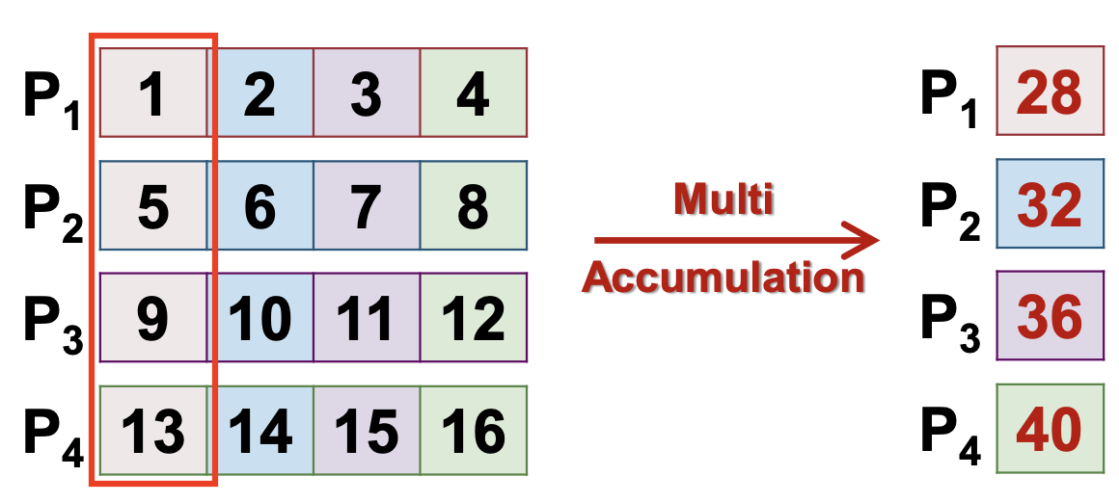

Total Exchange (No root processor)

* Each processor provides for other processors a potentially different data block
  + Effectively “multi-scatter”
* E.g.

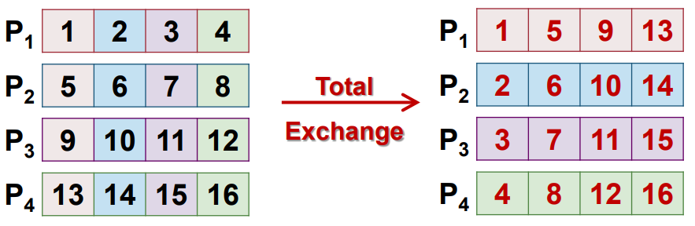

Duality of Communication Operations

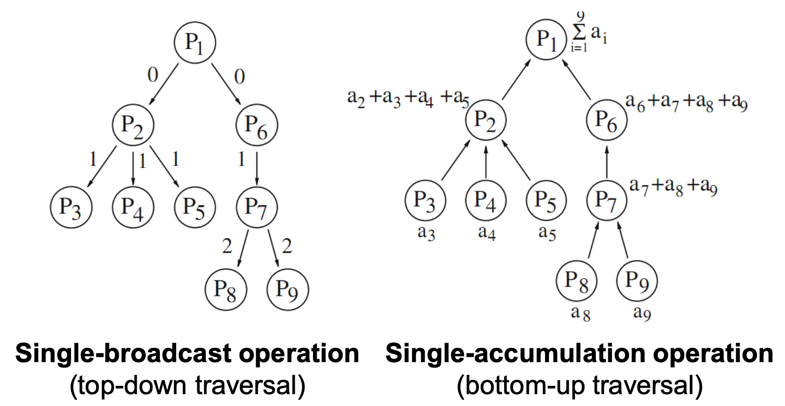

* A communication operation can be presented by a spanning tree graph
* 2 communication operations are a duality if:
  + the same spanning tree can be used for both operations

Stepwise Specialization

* Communication operations can be ordered into a hierarchy (Most general → most specific)
* Operations that resulted from stepwise specialisation are placed near to each other

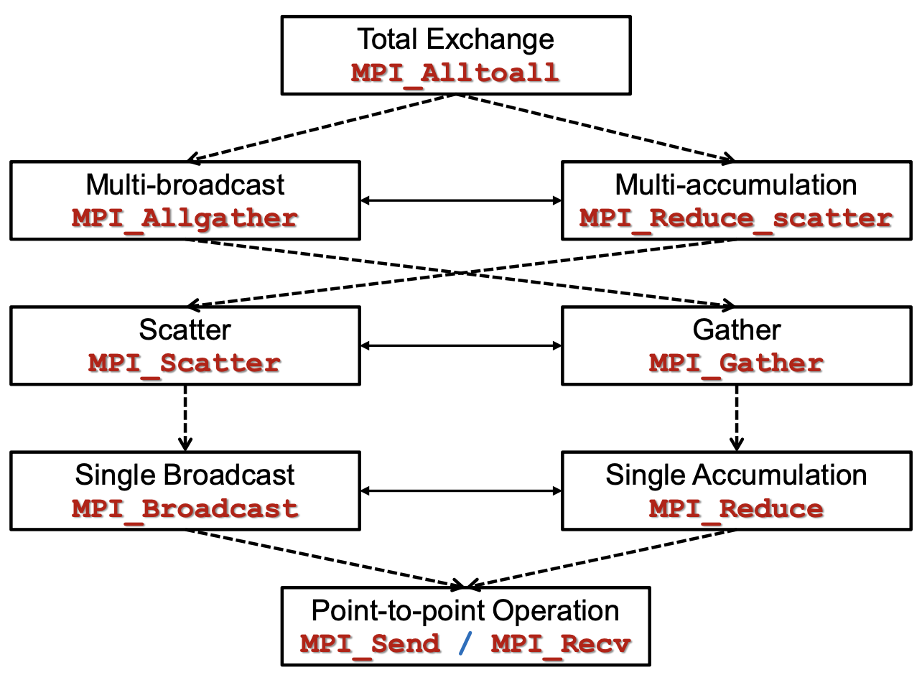

───: duality; ------: specialization

**Lecture 11: Interconnection Networks**

Example: Sort N numbers on N-Processor Elements (PEs) linear array → O(n log n)

* Good when number of elements to be sorted = number of PEs

PEs have different number of communication links:

* PE at the corners = 2 links
* PE on the edges = 3 links

If we wrap the left to right; top to bottom

* All PEs have four links (for 2D) → Torus

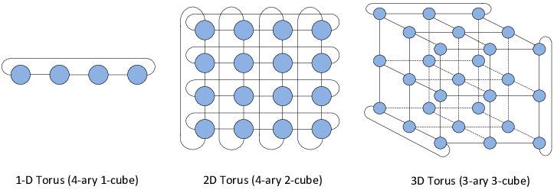

Sort N elements on N-PEs 2D Mesh

* Each PE has one number initially
* N-PEs arranged in a 2D Mesh:
  + √N rows
  + √N columns
* Sorted into “Snake-Like” order in the end:

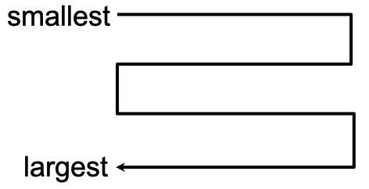

**Shear Sort**

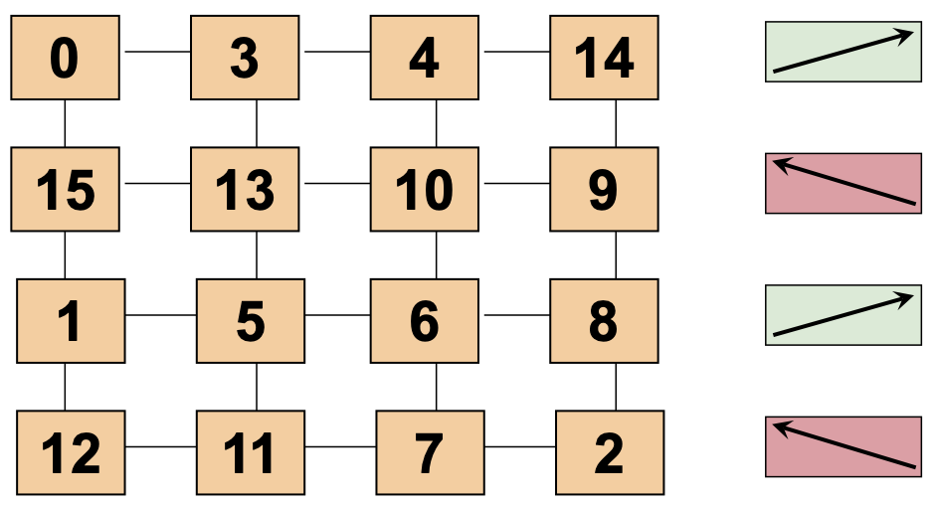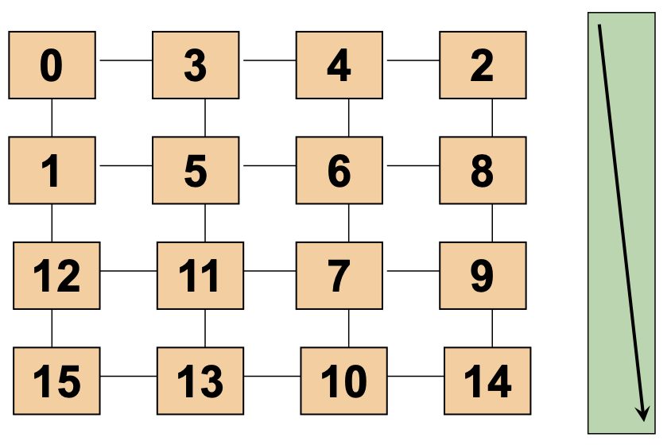

1. Row Sorting
   * Odd rows sort in ascending order
   * Even rows sort in descending order
2. Column Sorting
   * All columns sort in ascending order (top to bottom)
3. Repeat until sorted

#phases (#row & col sortings) = log2 n + 1

* odd-even transposition sort
* T(n) = O(log2 n + 1)(√n)

**Topology**

| **Direct interconnection** | **Indirect interconnection** |
| --- | --- |
| * Aka static or Point-to-Point * Usually endpoints are of the same type (core, memory) * Switch is collocated at processing element/memory → controller to send/recv msg * harder to scale | * Aka dynamic * Interconnect is formed by switches * normally for elements of different type * Flexible * Preferred for heterogenous connnection (e.g. CPU → memory) * High cost |

Direction interconnection

* Can be modelled as graph G(V, E)
* But some general cases are hard to determine → can only study specific subcases
* Diameter δ(G): max distance between any pair of nodes
  + Small diameter ensures small distances for message transmission
* Degree g(v): number of direct neighbour nodes of node v
  + Degree g(G): maximum degree of a node in a network G
  + g(G) = max{g(v) | g(v) degree of v in V}
  + Small node degree reduces the node hardware overhead
  + High degree may not even be able to build the graph
* Bisection width B(G): minimum number of edges that must be removed in to divide the network into two equal halves
  + Min cut
  + Bisection bandwidth BW(G): Total bandwidth available between the two bisected portion of the network
  + BW(G): A measure for the capacity of a network when transmitting messages simultaneously
  + ↑ BW(G) better
* Connectivity
  + MST?
  + Node connectivity nc(G): min #nodes that must fail to disconnect the network
  + nc(G) determine the robustness of the network
  + ↑ nc(G) better resilience
  + Edge connectivity ec(G): min #edges that must fail to disconnect the network
  + ec(G) determine the number of independent paths between any pair of nodes

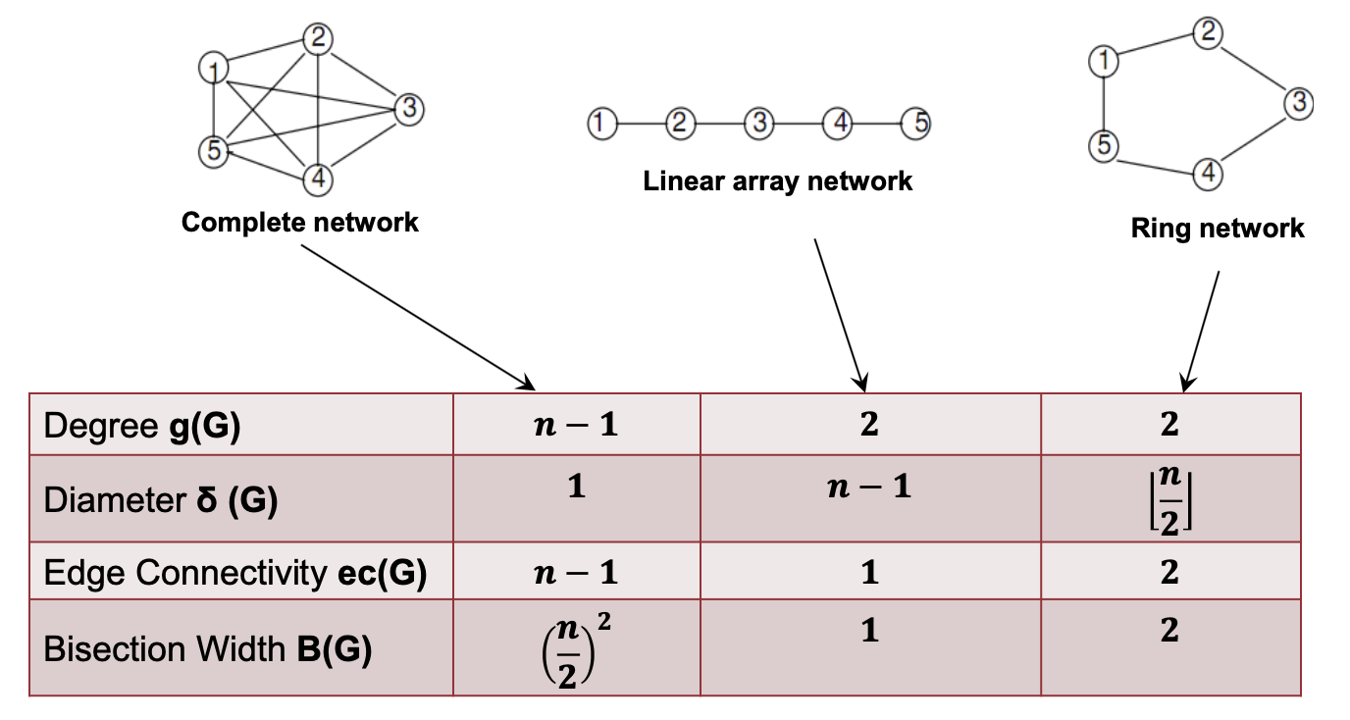

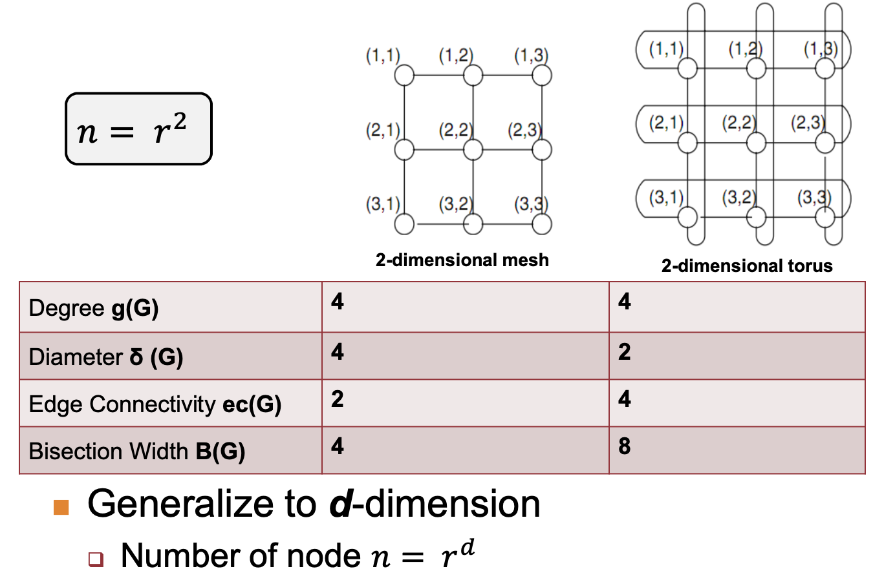

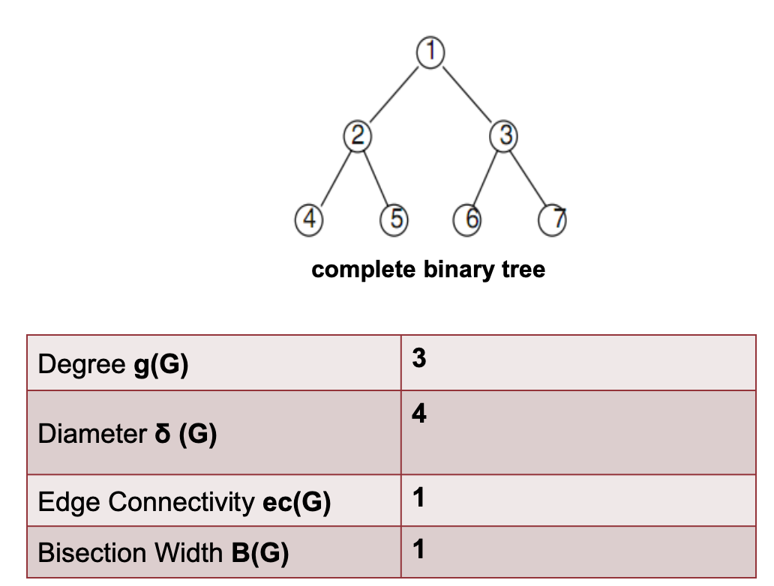

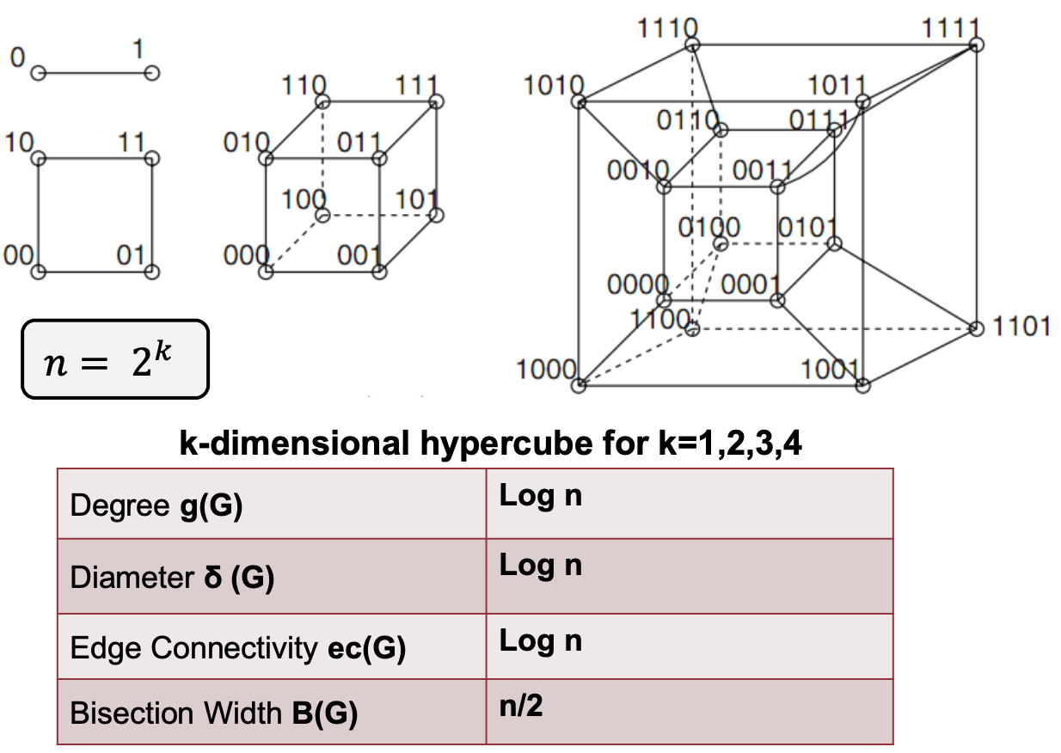

Hypercube: neighbouring nodes have one change in bit

**Cube-Connected-Cycles (CCC)**

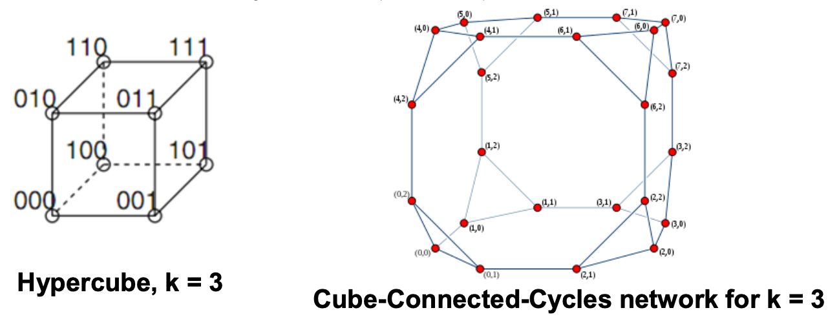

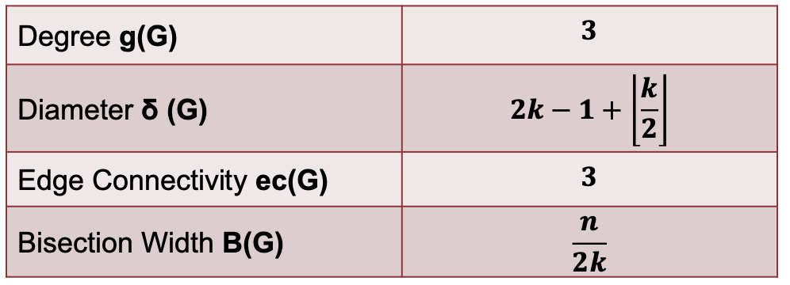

From a k-dimensional hypercube (k ≥ 3)

* Substitute each node with a cycle of k-nodes
* Each of the k-nodes take one of the original k links → Total nodes, n = 𝑘2k
* ↑ k ↑ degree ↑ overhead → CCC ensures that the corner nodes (split into rings) always have only 2 edges in the ring and 1 edge connected to outside of ring → limits overhead
  + degree = 3; degree constant so hardware overhead is constant
* E.g. 4D hypercube → 4 sided ring to replace corner nodes

Construction

* Each node in a k-dimensional CCC is labeled as (X, Y)
  + X = the corresponding node index in hypercube
  + Y = the position in the cycle, i.e. 0...k-1
  + Moving outside ring → change in 1st value
  + Moving inside ring → change in 2nd value

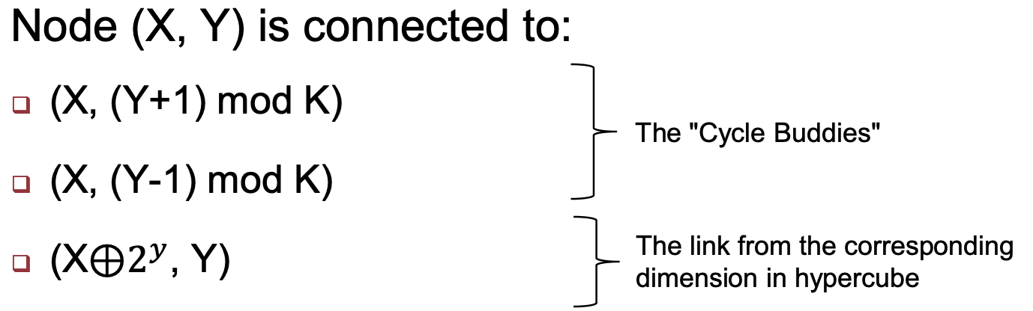

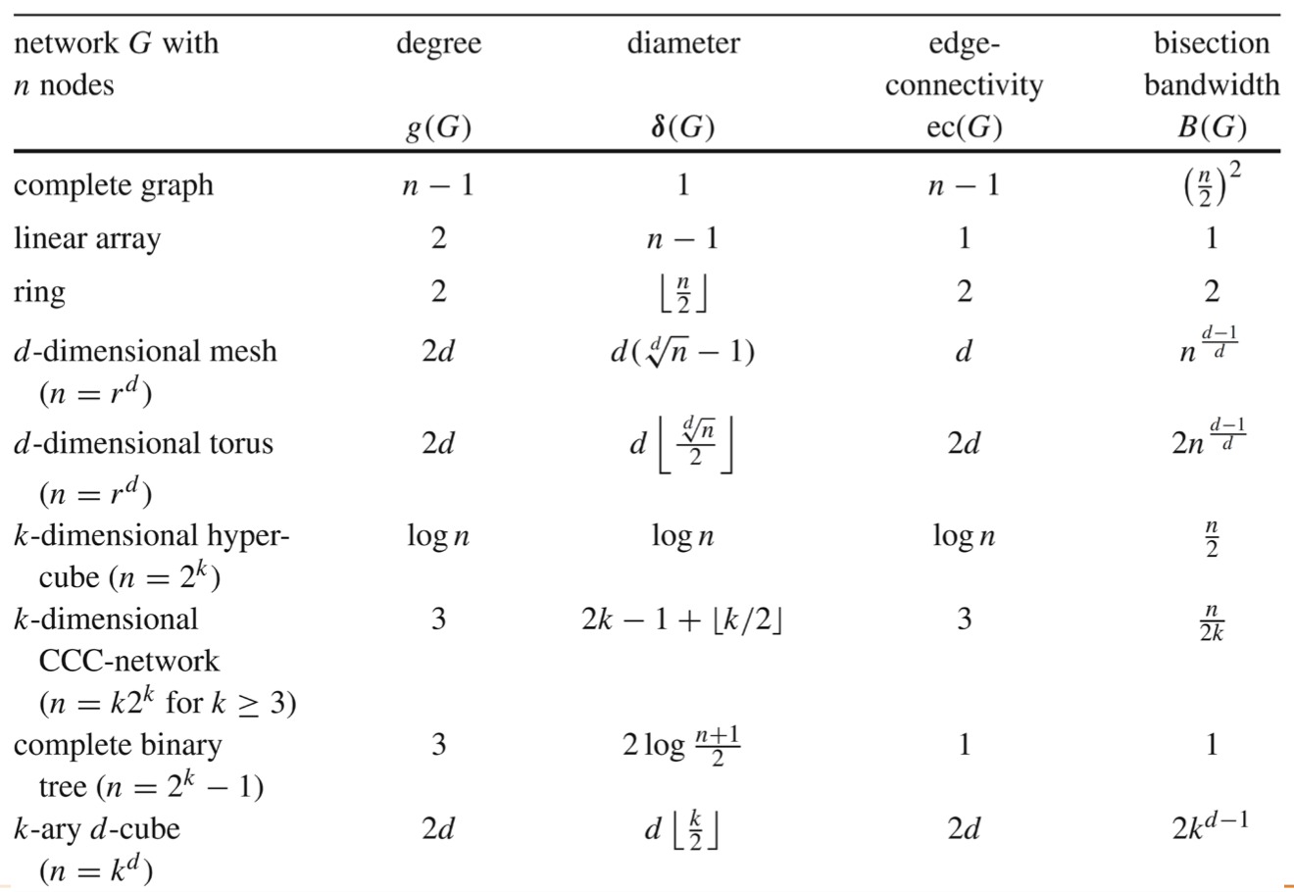

Indirect interconnection

* Switches provide indirect connection between nodes and can be configured dynamically
  + Reduce hardware costs by sharing switches and links
* Metrics:
  + Cost (number of switches / links)
  + Concurrent connections

**Bus network**

* A set of wires to transport data from a sender to a receiver
* Only one pair of devices can communicate at a time
  + A bus arbiter (judge) is used for the coordination
* Typically used for a small number of processors

**Crossbar Network**

* A n × m crossbar network has n inputs and m outputs
* Two states of a switch: straight or direction change
* Hardware is costly (n x m switches) small number of processors
  + Original: n + m

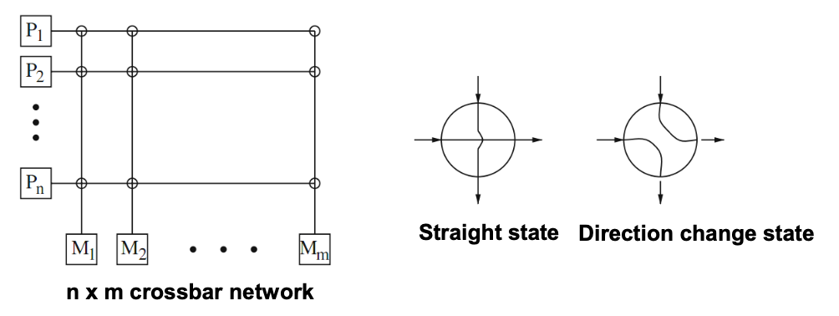

**Multistage Switching Network**

* Several intermediate switches with connecting wires between neighbouring stages
* Goal: obtain a small distance for arbitrary pairs of input and output devices

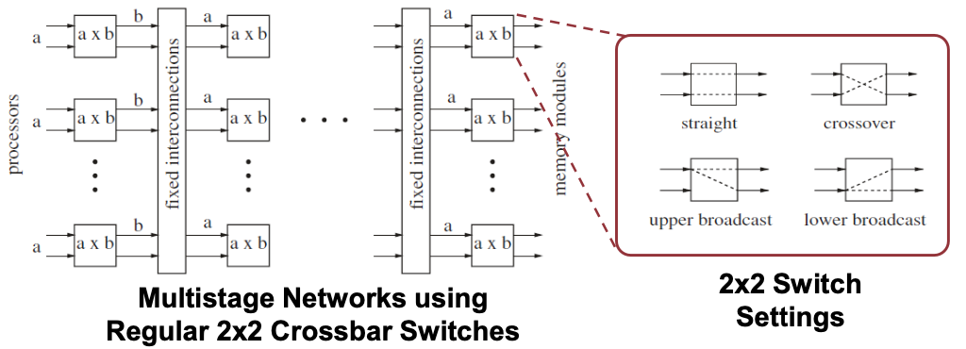

**Omega Network**

* One unique path for every input to output
* An n × n Omega network has log n stages
  + n/2 switches per stage
  + Connections between stages are regular
  + Each switch has 2 inputs and 2 outputs → last stage has n/2 switches * 2 outputs/switch = n outputs
  + aka (lg n – 1) – dimension Omega Network

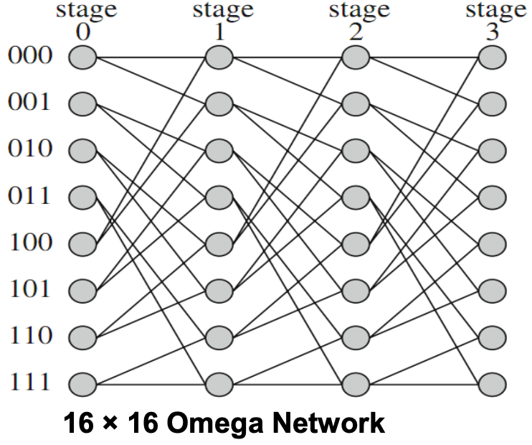

Construction

A switch position: (α, i)

* α: position of a switch within a stage;
* i: stage number

Edge from node (α, i) to two nodes (β, i + 1) where

* β = α by a cyclic left shift
* β = α by a cyclic left shift + inversion of the LSBit

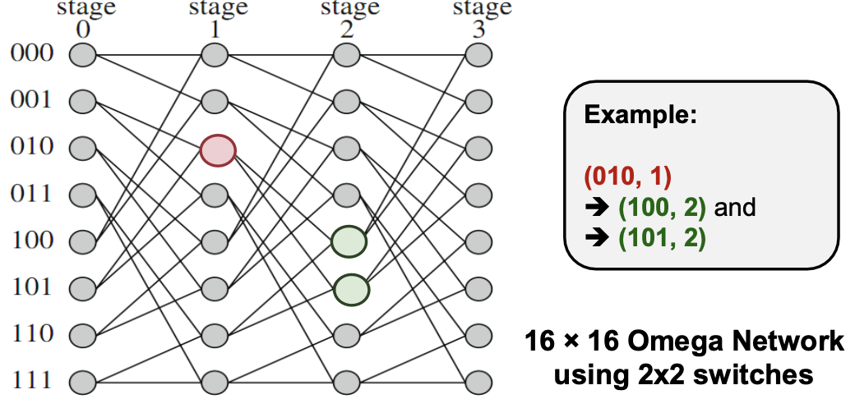

E.g. To connect 16 processor nodes to 16 memory nodes

* Crossbar = 16 * 16 = 256
* Omega: n = 16 and using 2x2 switch
  + Total number of switches = n/2 switches per stage x log(n) stages = 8 * 4 = 32 switches

**Butterfly Network**

Node (α, i) connects to

1. (α, i+1), i.e. straight edge
2. (α', i+1), α and α' differ in the (i + 1)th bit from the left, i.e. cross edge

E.g. (000, 0) connects to (000, 1) and (100, 1)

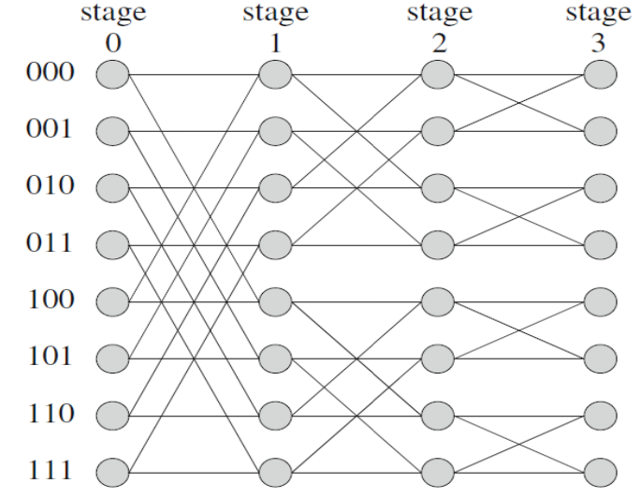

**Baseline Network**

Node (α, i) to two nodes (β, i + 1) where

1. β = cyclic right shift of last (k-i) bits of α
2. β = inversion of the LSBit of α + cyclic right shift of last (k-i) bits
3. k = last stage, e.g. 3 in the diagram

E.g. (001, 1) → (010, 2) and (000, 2)

(001, 0) → (000, 1) and (100, 1)

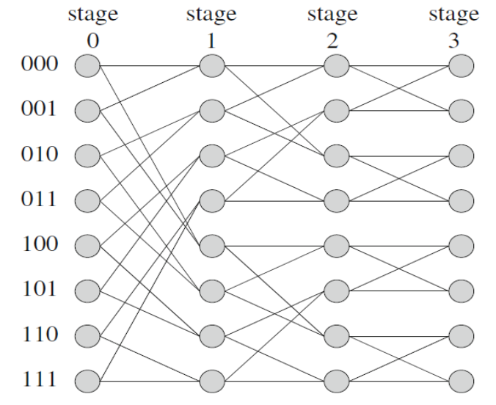

**Routing**

* Determines path(s) from source to destination within a give interconnection topology

Routing Algorithms classification

* Based on path length:
  + Minimal or non-minimal routing → whether the shortest path is always chosen
* Based on adaptivity
  + Deterministic: Always use the same path for the same pair of nodes
  + Adaptive: May take into account of network status and adapt accordingly
    - Avoid congested path, avoid dead nodes

Deterministic Examples

1. XY Routing for 2D Mesh

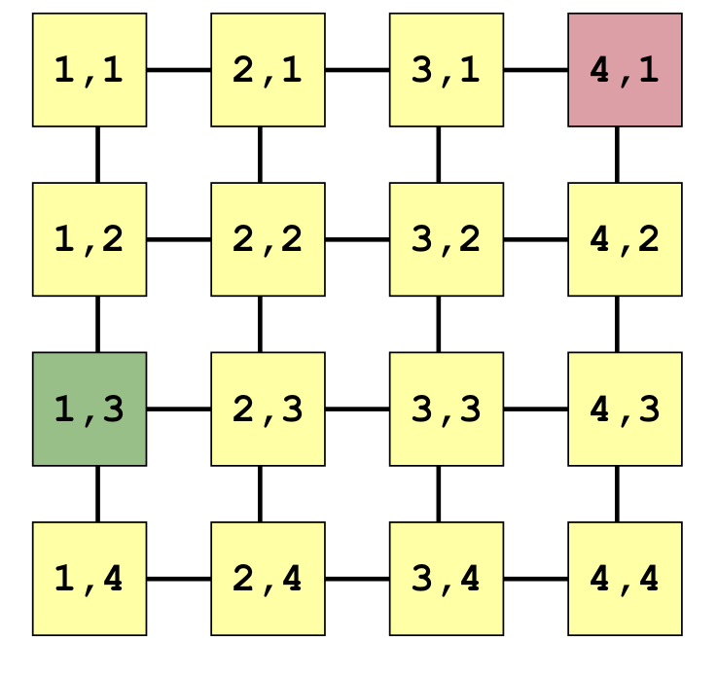

* (Xsrc,Ysrc) to (Xdst, Ydst):
* Move in X direction until Xsrc == Xdst
* Move in Y direction until Ysrc == Ydst
* Total edges = Xdst - Xsrc + Ysrc - Ysrc

1. E-Cube Routing for HyperCube

* Let (αn-1 αn-1 ... α1 α0) and (βn-1 βn-2 … β1 β0) be the bit representations of source and destination node address respectively:
  + Number of bits difference in source and target node address = number of hops
* Start from MSB to LSB
  + Find first different bit
  + Go to the neighbouring node with the bit corrected
* n bits so at most n hops

1. XOR-Tag Routing for Omega Network

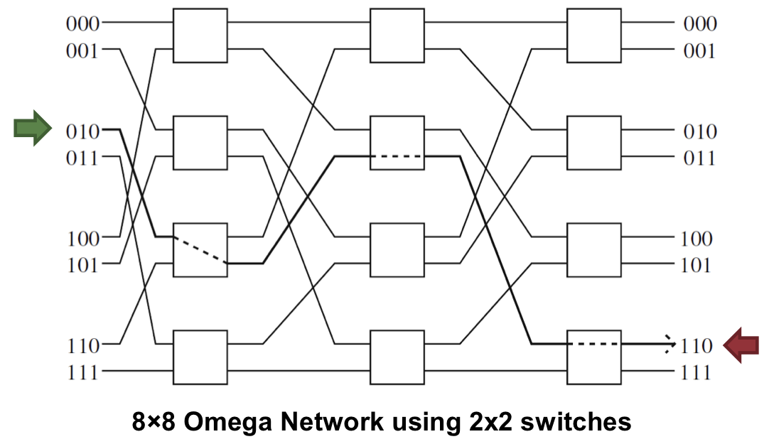

* T = Source ID xor Dest Id
* At stage-k:
  + If kth bit = 0; move straight (top-top, bottom-bottom)
  + If kth-bit = 1; crossover (top-bottom, bottom-top)
* E.g. 010 ^ 110 = 100 ⇒ crossover, str, str

Ethernet

* Support point-to-point and broadcast
* Commonly-used topologies: physical bus, physical star with a logical bus, etc

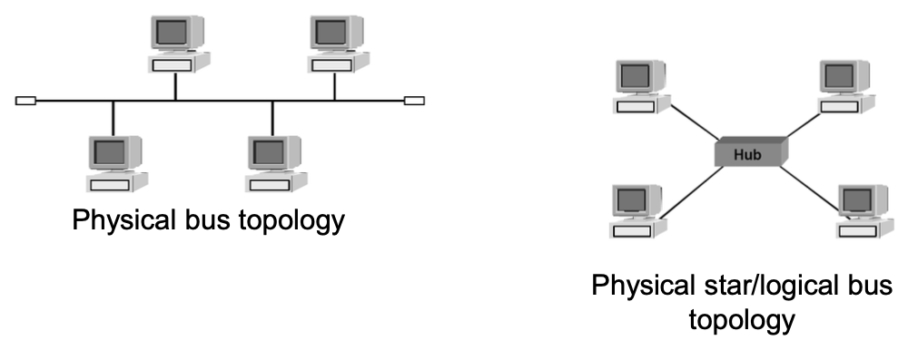

InfiniBand

* Support point-to-point and multicast (on top of point-to-point capabilities)
* Commonly-use topologies: Fat tree , torus, etc.

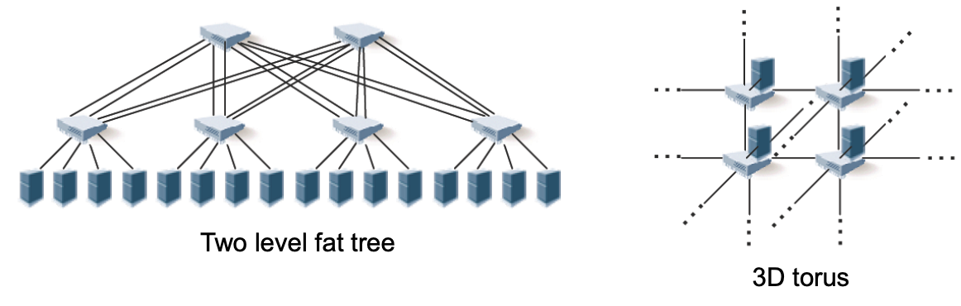

**Quiz 3**

**Relaxed consistency models address the concern that software complexity is increased by the need for unnecessary synchronization.**

* False
* Relaxed consistency configure the memory order for each variable for the benefit of latency hiding → increased performance during execution.
* Synchronization is needed with or without relaxed consistency.
* Relaxed consistency actually increases software complexity, whereas sequential consistency is default for atomic variables.
* (synchronisation only refers to parallel executions, sequential executions do not require synchronisation)

**Cache coherence is the property that multiple caches contain the same set of items.**

* False: Caches do not have to contain the same set of items
* We just need to make sure that the specific cache lines that is being accessed by multiple processors is in sync

**PYP**

**How energy consumption can be improved when using heterogeneous platforms?**

* Core performance can be adjusted based on the tasks that have to be completed
* E.g. turn off or decrease the performance of the big cores when phone is in the pocket or performing short, sequential background tasks

| **Data centers** | **Cloud computing** |
| --- | --- |
| Offer only infrastructure service | A data center with layer of software over it, offering services at different levels (platform, software, infrastructure) |
| A huge investment in the beginning | Pay-per-use model |

**For a large number of nodes, a CCC interconnection network is easier to physically construct than a hypercube**

* True: degree of a node in CCC is always constant, hence the hardware load on a node does not increase with the increase in size of the network

**We used our lab machines for OpenMP and MPI programming. Can these systems be categorized as a cloud or a data center?**

* None (past sems have no NFS): The system is just a collection of lab machines (computers) connected and accessible over a network. No special data center setup is in place
* Can be argued as data centers since we have NFS now → files on NFS are the data

**We used the SoC Computer Cluster machines for CUDA programming. Can these systems be categorized as a cloud or a data center?**

* Data centers

**Omp critical v.s. atomic:** atomic operations are faster than mutex operations (but operations are done sequentially)

**Omp reduction:** independent additions are done in parallel and dont need a CS in omp reduction (possibly using a binary tree)

**Performance metrics (except for execution time) to further understand the performance**

* Time spent waiting: waiting only happens for lock contention (CS)
* IPC: low → atomic instructions are contended
* Cache misses/page faults
* Call stacking (using perf)
* Other metrics: utilization of processes/resources

**Data distribution & Interconnection**

* 2D distribution: Checkerboard → 2D mesh
* 1D distribution: Blockwise → linear, ring

**Tutorial 1**

**Classify according to Flynn’s Taxonomy**

* A personal computer from the 1980s: SISD
* A laptop with a multi-core processor: MIMD
* Intel’s AVX instruction set: SIMD
* A uniprocessor (i.e. single core) with pipelining (ILP): SISD
* Students attempting the same exam in an exam hall: SIMD (exam paper is the data)

**In the hierarchical design of multicore architecture, the memory organization is hybrid (distributed-shared memory)**

* No, not hybrid: everyone just sees one shared memory
* Yes, hybrid: could see cache as its own memory that can be out of sync

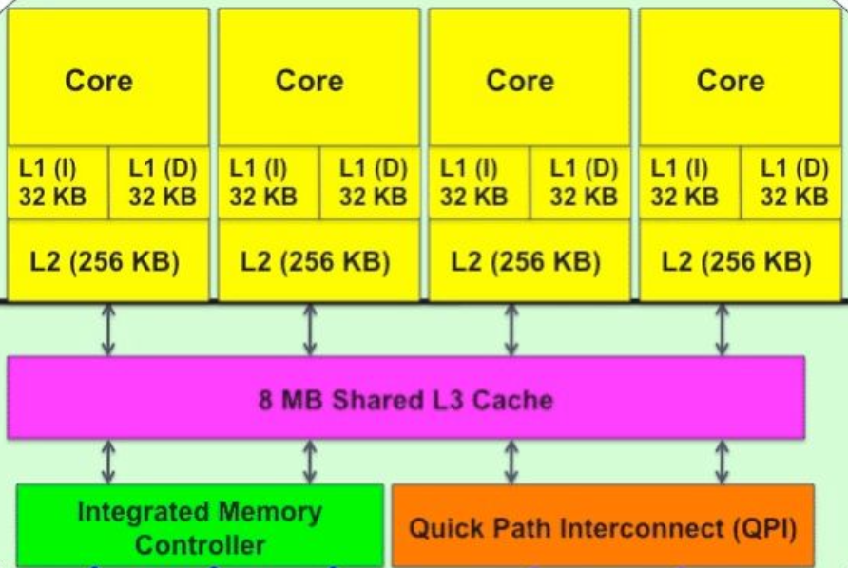

**Tutorial 3**

* A kernel uses 64 registers
* Each block uses 512 threads
* GPU device has 1024x64 registers total
* GPU has only 1 SM
* **How many resident blocks / warps on the SM?**
  + # of registers required per block: 512 threads x 64 registers
  + #resident blocks: (1024x64) / (512x64) = 2 blocks
  + #warps per block = 512 / 32 = 16
  + Total warps = 16 * 2 = 32 Warps

**Matrix-Vector Mul on GPU (Finals)**

Considerations

* Decomposition into independent tasks: each task as a row/multiple rows of A
* Dimensionality: For N tasks, 1D grid of B = (N/T) blocks, where each 1D block contains T threads
* T = 32i, for some i, to maximise usage of SM (warps are in 32s)
* Kernel code: just a for loop, write results into cells in C
* Bijective mapping from threads to (chunk of) rows in C
* Global memory: slow but cached in L1, transactions in a half-warp can be coalesced.
* Shared memory: fast usually, but slow if bank conflicts arise (esp for common matrix B). Requires Strided accesses
  + Have a “stride” between addresses made by threads in the same block
* if the data is too large to fit into shared memory
  + split the multiplication into multiple iterations
  + multiple calls to the kernel
  + Each call to the kernel copies a subset of the data to shared memory

**Less important content**

**Lecture 1: Introduction**

Processing units could be:

1. A single processor with multiple cores
2. A single computer with multiple processors
3. A number of computers connected by a network
4. Combinations of the above

**Computational Model Attributes**

Operation Mechanism

* The *primitive units* of computation or basic actions of the computer (data types and operations defined by the instruction set)

Data Mechanism

* The definition of *address spaces* available to the computation (how data are accessed and stored)

Control Mechanism

* The *schedulable units* of computation (rules for partitioning and scheduling the problem for computation using the primitive units)

Communication Mechanism

* The modes and patterns of communication among processing elements working in parallel, so that they can exchange needed information

Synchronisation Mechanism

* Mechanism to ensure needed information arrives at the right time

**Tasks**

* Scheduling: Assignment of tasks to processes or threads
  + Dictates the task execution order
* Mapping: Assignment of processes/threads to physical cores/processors for execution
* Tasks may depend on each other resulting in data or control dependencies → impose execution order of parallel tasks
* Memory organisations: shared-memory (threads) and distributed-memory (processes)

**Parallel Performance**

* execution time vs throughput
* Parallel execution time = computation time + parallelisation overheads
* Parallelisation overheads:
  + distribution of work (tasks) to processors
  + information exchange or synchronisation
  + idle time etc

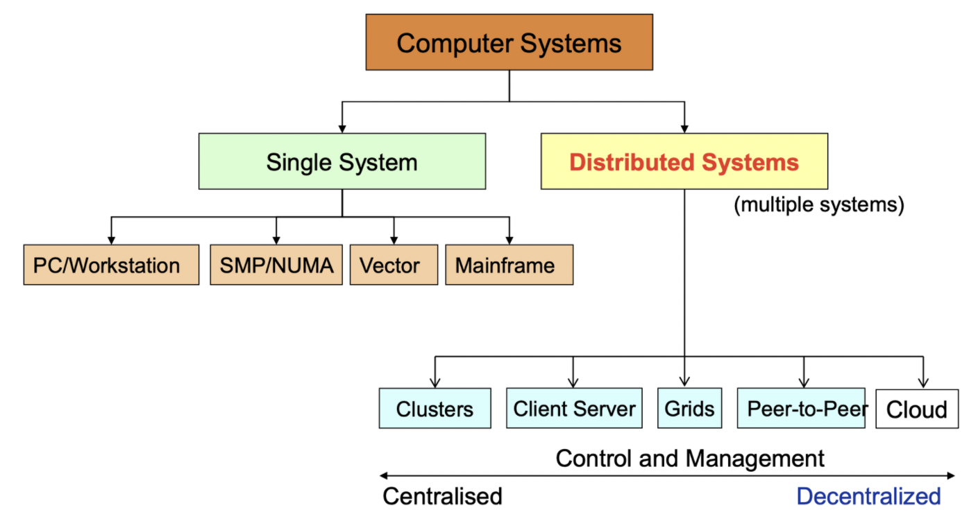

# 

# **Lecture 2: Processes, Threads and Synchronisation**

## **Program Parallelisation: Steps**

1. Decomposition of the computations
2. Scheduling (assignment of tasks to processes or threads)
3. Mapping of processes (or threads) to physical processors (or cores)

## 

## **Processes**

A program in execution

* **Identified by PID (process ID)**
* **Comprises:**
  + executable program (PC),
  + global data
    - OS resources: open files, network connections
  + stack or heap
  + current values of the registers (GPRs and Special)
* Own address space → exclusive access to its data
* Two or more processes exchange data → need explicit communication

### 

### Multiprogramming (Multitasking)

* need context switch
* states of suspended process must be saved → overhead
* 2 types of execution
  + time slicing execution - pseudo-parallelism
  + parallel execution of processes on different resources
* fork is very useful when the child
  + is cooperating with the parent
  + relies upon the parent’s data to accomplish its task
  + e.g. web server
* creating a new process is costly
  + overhead of sys calls
  + all data structures must be allocated, initialised and copied
* communication between processes is costly
  + communication goes through the OS
* process termination
  + Use **exit(status)** in the child process
  + **Wait for a process in the parent process**
    - wait
    - waitpid (pid)

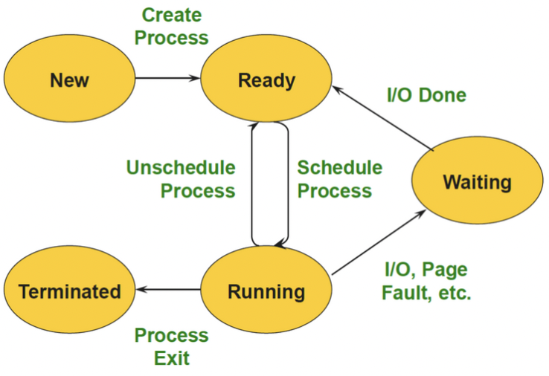

## Inter-Process Communication (IPC)

Cooperating processes have to share information

* **Shared memory:** Need to protect access when reading/writing with locks
* **Message passing**
  + Blocking & non-blocking
  + Synchronous & asynchronous
* **Unix specific:** Pipes & Signal

| **Exceptions** | **Interrrupts** |
| --- | --- |
| Executing a machine level instruction can cause exception | External events can interrupt the execution of a program |
| e.g. Overflow, Underflow, Division by Zero, Illegal memory address, misaligned memory access | Usually hardware related: Timer, Mouse Movement, Keyboard Pressed etc |
| **Synchronous**: Occur due to program execution | **Asynchronous**: Occur independently of program execution |
| Have to execute an exception handler | Have to execute an interrupt handler |

## **Threads**

* Extension of process model:
  + A process may consist of multiple independent control flows called threads
  + The thread defines a sequential execution stream within a process (PC, SP, registers)
* Threads share the address space of the process:
  + All threads belonging to the same process see the same value → shared-memory architecture
* thread generation is faster than process generation
  + no copy of the address space is necessary
* different threads of a process can be assigned to run on different cores of a multicore processor
* 2 types of threads: user-level and kernel threads

User-level threads

* Managed by a thread library – OS unaware of user-level threads so no OS support
* switching thread context is fast
* OS cannot map different threads of the same process to different execution resources → no parallelism
* OS cannot switch to another thread if one thread executes a blocking I/O operation
* Many-to-One Mapping
  + all user-level threads are mapped to one processor
  + thread library is responsible for the scheduling of user-level threads

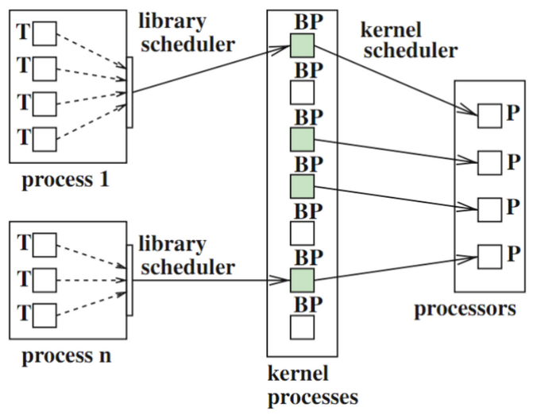

* One-to-One Mapping
  + each user-level thread is assigned to exactly one kernel threads - no library scheduler needed
  + OS is responsible for the scheduling and mapping of kernel threads

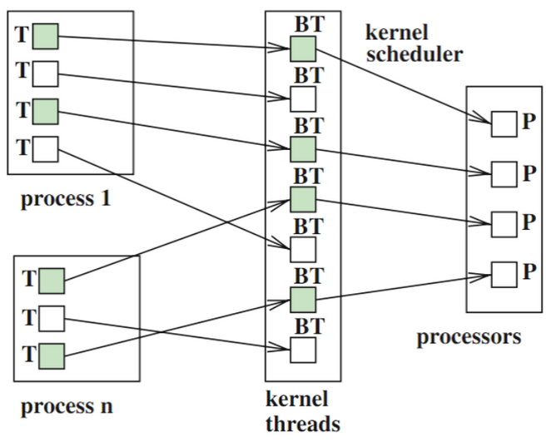

* Many-to-Many mapping
  + Library scheduler assigns the user-level threads to a given set of kernel threads
  + Kernel scheduler maps the kernel threads to the available execution resources
  + At different points in time, a user thread may be mapped to a different kernel thread

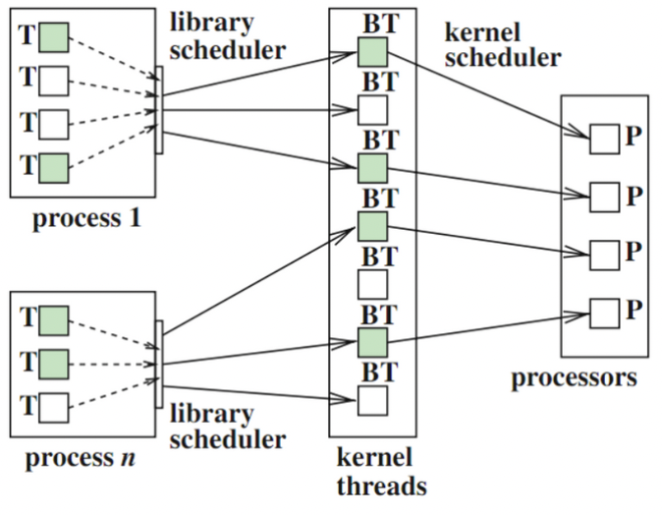

Kernel threads

* OS is aware of the existence of threads and can react correspondingly
* Avoid disadvantages of user-level threads
* Efficient use of the cores in a multicore system

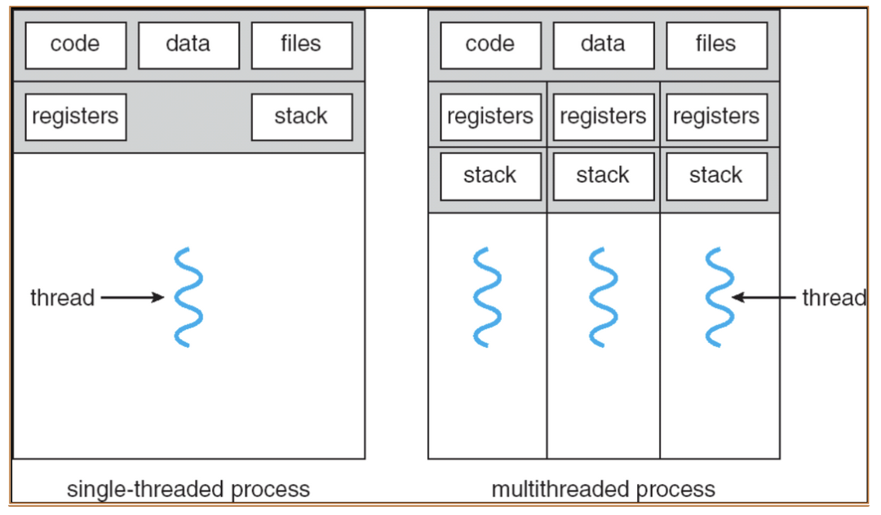

Visibility of Data

* Global variables of a program and all dynamically allocated data objects can be accessed by any thread of this process
* Each thread has a private runtime stack for function stack frames
* **Runtime stack of a thread exists iff the thread is active**

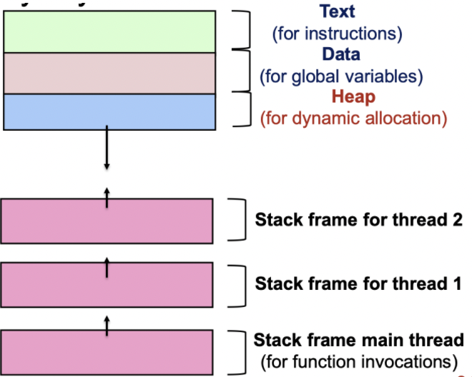

## **Synchronisation**

### Shared Resources (Coordinating access to shared resources)

* **Basic problem:** If two concurrent threads (processes) are accessing a shared variable, and that variable is read/modified/written by those threads, then access to the variable must be controlled to avoid erroneous behaviour
* **Mechanisms to control access to shared resources**
  + Locks, mutexes, semaphores, monitors, condition variables, etc.
* **Patterns for coordinating accesses to shared resources**
  + Bounded buffer, producer-consumer, etc.
* e.g. 2 people sharing a bank account withdraw from bank simultaneously

### Race Condition (satisfy both)

1. Two concurrent threads (or processes) access a shared resource without any synchronisation
2. At least one thread modifies the shared resource
   1. Solution: control access to these shared resources
   2. Necessary to synchronise access to any shared data structure, e.g.Buffers, queues, lists, hash tables, etc.

### 

### Mutual Exclusion

* Use mutual exclusion to synchronise access to shared resources → allows us to have large atomic blocks
* Code sequence that uses mutual exclusion is called **critical section**
  + **Mutual exclusion (mutex):** if one thread is in the CS, then no other is
  + **Progress:** if some thread T is not in the CS, then T cannot prevent some other thread S from entering the CS
  + **Bounded waiting (no starvation):** if some thread T is waiting on the CS, then T will eventually enter the CS
  + **Performance:** the over head of entering and exiting the CS is small wrt the work being done within it
* Only one thread at a time can execute in the critical section
  + All other threads have to wait on entry
  + When a thread leaves a critical section, another can enter

### Deadlock

* Deadlock exists among a set of processes if every process is waiting for an event that can be caused only by another process in the set.
* Deadlock is a problem that can arise:
  + When processes compete for access to limited resources
  + When processes are incorrectly synchronised
* Deadlock can exist if and only if the following four conditions hold simultaneously:
  + **Mutual exclusion** – At least one resource must be held in a non-sharable mode
  + **Hold and wait** – There must be one process holding one resource and waiting for another resource
  + **No pre-emption** – Resources cannot be pre-empted (critical sections cannot be aborted externally)
  + **Circular wait** – There must exist a set of processes [P1, P2, P3, …, Pn] such that P1 is waiting for P2, P2 for P3, etc.

### Starvation

* Starvation is a situation where a process is prevented from making progress because some other process has the resource it requires
* Starvation is a side effect of the scheduling algorithm
  + OS: A high priority process always prevents a low priority process from running on the CPU
  + One thread always beats another when acquiring a lock

### 

### **CS Mechanisms**

Locks

* acquire(): to enter a critical section
* release(): to leave a critical section
* Pair calls to acquire and release
  + Between acquire/release, the thread holds the lock
  + Acquire does not return until any previous holder releases
* Locks can spin (a spinlock) or block (a mutex)
* spinlock: thread spins waiting (busy waiting) for the lock to be released
  + wasteful: If a thread is spinning on a lock, then the thread holding the lock cannot make progress (on a uniprocessor)
  + give up CPU when the local holder calls yield or sleep, or involuntary context switch
* locks can be implemented with test-and-set (atomic)
  + Record the old value → Set the value to indicate available → Return the old value

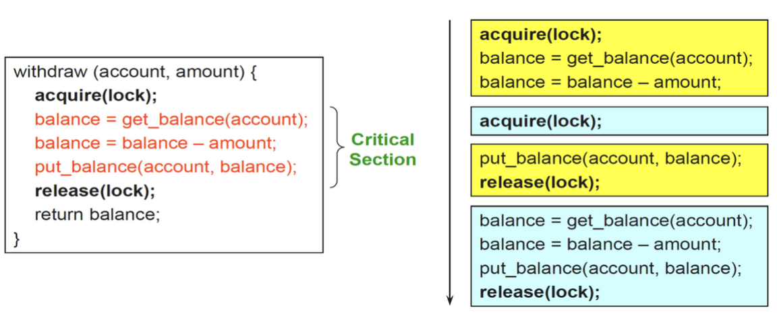

bool test_and_set(bool *flag) {

bool old = *flag;

*flag = True;

return old;

}

struct lock { int held = 0; }

void acquire(lock) {

while (test_and_set(&lock->held));

}

void release(lock) { lock->held = 0; }

Semaphores

* shared global variables
* wait() / P(): decrement, block until semaphore is open
* signal() / V(): increment, allow another thread to enter
* Semaphore safety property: the semaphore value is always ≥ 0
* Mutex semaphore (or binary semaphore)
  + Represents single access to a resource
  + Guarantees mutual exclusion to a critical section
* Counting semaphore (or general semaphore)
  + Multiple threads can pass the semaphore
  + Number of threads determined by the semaphore “count”
  + mutex has count = 1, counting has count = N
* no connection between the semaphore and the data being controlled by it
* used both for CS (mutual exclusion) and coordination (scheduling)

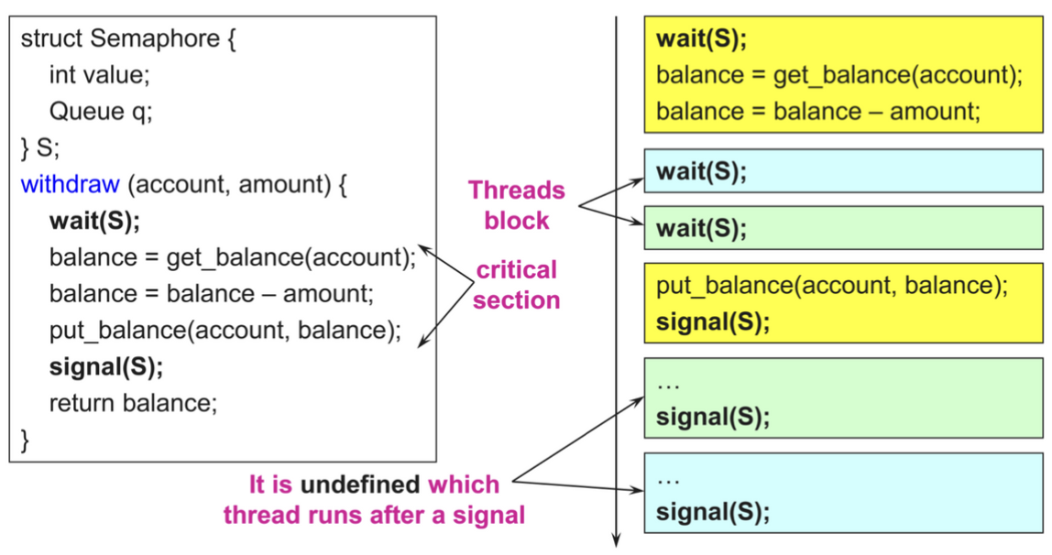

Monitors

* mutexes and condition variables locks as primitives

| **Conditional Variables** | **Semaphores** |
| --- | --- |
| To avoid busy waiting | To determine how many threads can access this resource |
| Will signal to thread once condition is met |  |

**Lecture 8: Performance Instrumentation**

* Latency: time an operation spends waiting to be serviced
  + Some refer to the entire time of an operations == response time
* Response time: time for an operation to complete, including
  + time spent waiting
  + time spent being serviced (service time)
  + time to transfer the result

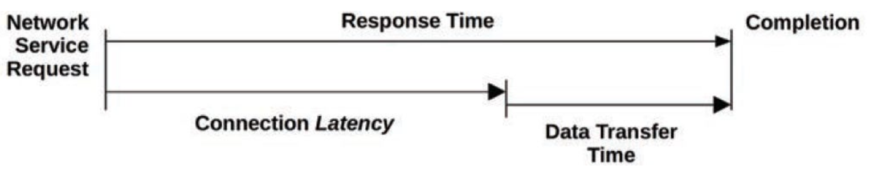

* Throughput: rate of work performed
  + In communications, throughput refers to the data rate (bits/s or bytes/s)
  + In some contexts (e.g. databases), throughput refers to the operation rate (operations/s or transactions/s)
* IOPS (input/output operations/sec): rate of data transfer operations
  + For disk I/O, IOPS refers to reads and write/sec
* Utilization: for resources that service requests, utilisation is a measure of how busy a resource is, based on how much time in a given interval it was actively performing work
* Saturation: The degree to which a resource has queued work it cannot service
* Bottleneck: In systems performance, a bottleneck is a resource that limits the performance of the system. Identifying and removing systemic bottlenecks is a key activity of systems performance.
* Workload: The input to the system or the load applied is the workload. E.g. For database, the workload consists of the database queries and commands sent by the clients.
* Cache: A fast storage area that can duplicate or buffer a limited amount of data, to avoid communicating directly with a slower tier storage, thereby improving performance. For economic reasons, a cache is often smaller than the slower tier. (i.e. cache is expensive)

Utilization

Time-based

* Avg amount of time the server/resource was busy: U = B/T
  + B: total time the sys was busy during T
  + T: observation period
* Commonly measure for devices in a computer system

Capacity-based

* A system or component (e.g. a disk drive) is able to deliver a certain amount of throughput
* Utilization is the proportion the system or component is working at
* 100% busy != 100% capacity

Workload analysis

* Targets
  + Requests: workload applied
  + Latency: response time
  + Completion: look for errors
* Metrics
  + Throughput
  + Latency

<https://www.brendangregg.com/linuxperf.html>

Interconnection Network Impact

* System scalability - size and extensibility
* System performance and energy efficiency
  + Communication speed
  + Memory latency
  + Energy spent to communicate

| **Topology** | What is the geometrical shape of the connection? |
| --- | --- |
| **Routing** | What is the path for a message to follow? |
| **Switching** | How to transfer a message along a path? |
| **Flow control** | How to handle concurrent messaging? |

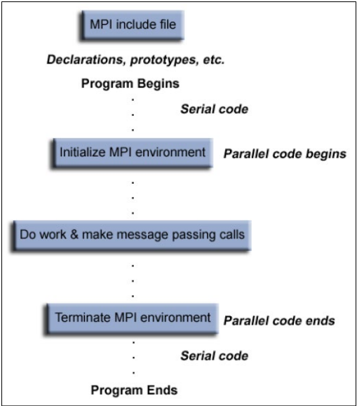

| Variable Qualifier(Device code) | Storage | Written by CPU via | Lifetime |
| --- | --- | --- | --- |
| __device__ | Stored in global mem (large, high latency, no cache)  read/wrote by all threads within grid | cudaMemcpyToSymbol() | application |
| __constant__ | Same as __device__, but cached and read-only by all threads within  grid | cudaMemcpyToSymbol() |
| __shared__ | Stored in on-chip shared memory (very low latency)  Read/write by all threads in the same thread block | | block |
| unqualified | Scalars and built-in vector types are stored in registers  Arrays of more than 4 elements or run-time indices stored in local memory  Read/write by thread only | | thread |